# Race: AQU | 2025-04-05 | Race #1 | Post: 12:10 | Track: AQUEDUCT

Track: AQUEDUCT

|  |  |  |  |  |  |
| --- | --- | --- | --- | --- | --- |
| Program # | Horse Name | Morn Odds | GCSF | Model Score | Win Prob (%) |
| 1 | Fly'n Frisbee | 9-2 | 100.0 | 0.54 | 8.01 |
| 2 | Solo Flight | 12-1 | 101.4 | 0.66 | 12.35 |
| 3 | True Connection | 5-2 | 94.2 | 0.86 | 20.86 |
| 4 | Belmont Union | 20-1 | 106.6 | 0.51 | 7.16 |
| 5 | Beach Blanket | 4-1 | 93.4 | 0.66 | 12.36 |
| 6 | Prairie Dunes | 10-1 | 93.4 | 0.63 | 11.21 |
| 7 | Dialbolico | 3-1 | 111.5 | 0.72 | 14.46 |
| 8 | Change Your Name | 10-1 | 106.6 | 0.49 | 6.71 |
| 9 | Henry's Hope | 20-1 | 93.4 | 0.50 | 6.89 |

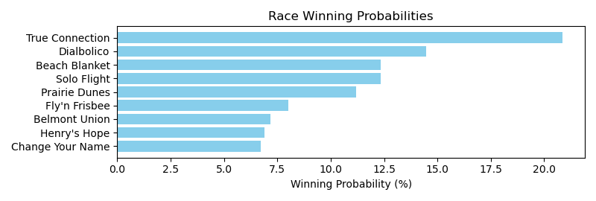

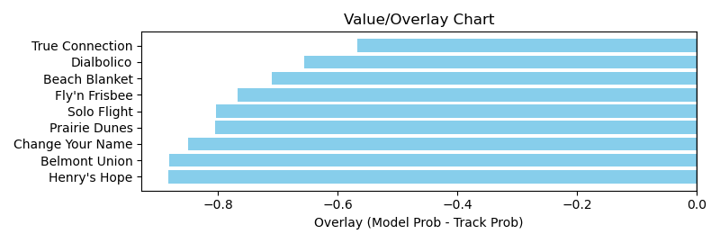

NOTE: GCSF - Global Combined Speed Figure

# Race: AQU | 2025-04-05 | Race #2 | Post: 12:45 | Track: AQUEDUCT

Track: AQUEDUCT

|  |  |  |  |  |  |
| --- | --- | --- | --- | --- | --- |
| Program # | Horse Name | Morn Odds | GCSF | Model Score | Win Prob (%) |
| 1 | Gun It | 15-1 | 94.4 | 0.93 | 15.17 |
| 2 | Toxic Gray | 9-2 | 117.8 | 1.05 | 19.40 |
| 3 | Victory Way | 7-2 | 95.9 | 1.07 | 20.44 |
| 4 | Bramito | 8-1 | 96.4 | 0.78 | 10.78 |
| 5 | Twenty Four Mamba | 6-1 | 107.0 | 0.99 | 17.17 |
| 6 | General Partner | 4-5 | 95.0 | 0.98 | 17.04 |

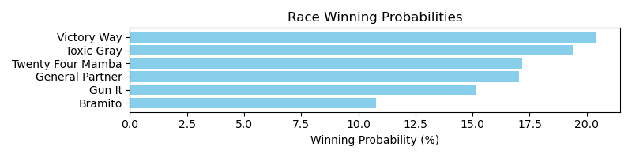

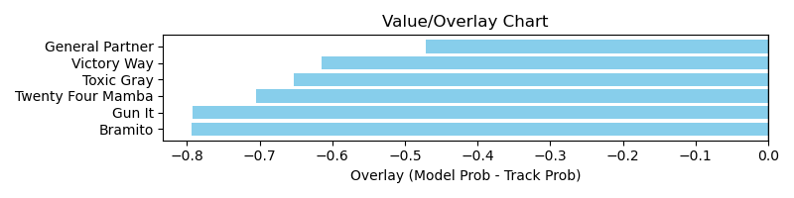

NOTE: GCSF - Global Combined Speed Figure

# Race: AQU | 2025-04-05 | Race #3 | Post: 13:17 | Track: AQUEDUCT

Track: AQUEDUCT

|  |  |  |  |  |  |
| --- | --- | --- | --- | --- | --- |
| Program # | Horse Name | Morn Odds | GCSF | Model Score | Win Prob (%) |
| 1 | Braca | 30-1 | 90.3 | 0.53 | 7.68 |
| 2 | Magic Beach | 6-1 | 92.5 | 0.65 | 11.64 |
| 3 | GOOD QUESTION | 12-1 | 100.0 | 0.59 | 9.66 |
| 4 | Rocked Out | 12-1 | 96.7 | 0.48 | 6.22 |
| 5 | Nine N Four | 4-1 | 110.3 | 0.71 | 14.02 |
| 6 | Sol the Frank | 30-1 | 106.6 | 0.41 | 4.65 |
| 7 | Drive Thru | 9-2 | 107.6 | 0.67 | 12.27 |
| 8 | Man From Malta | 8-1 | 107.1 | 0.58 | 9.26 |
| 9 | I Can See That | 5-1 | 100.0 | 0.66 | 12.09 |
| 10 | Total Silence | 3-1 | 102.5 | 0.67 | 12.52 |

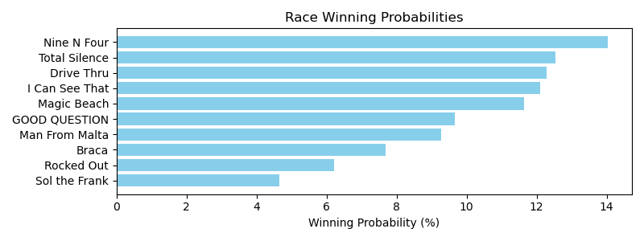

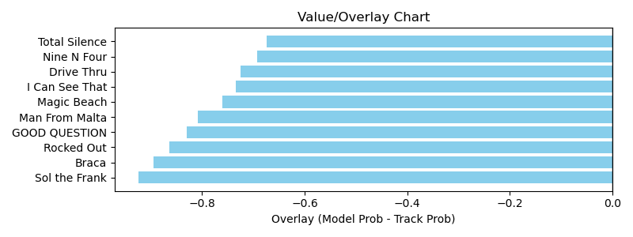

NOTE: GCSF - Global Combined Speed Figure

# Race: AQU | 2025-04-05 | Race #4 | Post: 13:50 | Track: AQUEDUCT

Track: AQUEDUCT

|  |  |  |  |  |  |
| --- | --- | --- | --- | --- | --- |
| Program # | Horse Name | Morn Odds | GCSF | Model Score | Win Prob (%) |
| 1 | Cumberland Blues | 10-1 | 89.4 | 0.81 | 7.53 |
| 2 | Allaboutthemoney | 15-1 | 97.7 | 0.78 | 6.94 |
| 3 | Valenzan Day | 2-1 | 104.9 | 1.12 | 14.69 |
| 4 | Best Bet | 9-2 | 101.6 | 0.85 | 8.40 |
| 5 | Prince of Joy | 30-1 | 99.5 | 0.64 | 4.72 |
| 6 | Screaming Uncle | 15-1 | 108.6 | 0.66 | 5.03 |
| 7 | Catch the Smoke | 15-1 | 95.4 | 0.71 | 5.74 |
| 8 | Retail Man | 20-1 | 104.6 | 0.63 | 4.50 |
| 9 | Empty Tomb | 3-1 | 94.3 | 1.36 | 21.97 |
| 10 | Allure of Money | 6-1 | 98.5 | 1.32 | 20.47 |

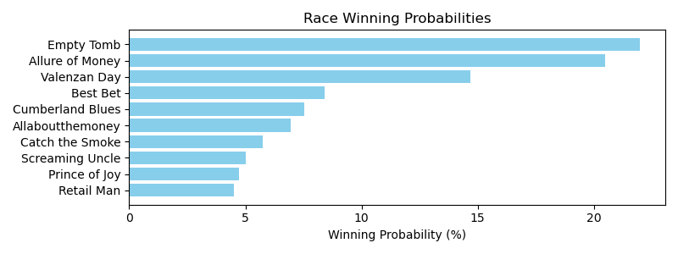

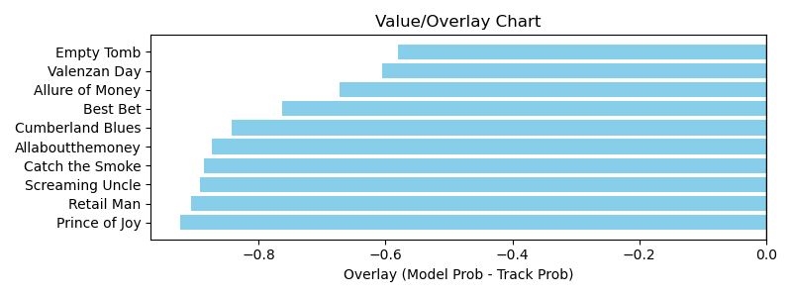

NOTE: GCSF - Global Combined Speed Figure

# Race: AQU | 2025-04-05 | Race #5 | Post: 14:22 | Track: AQUEDUCT

Track: AQUEDUCT

|  |  |  |  |  |  |
| --- | --- | --- | --- | --- | --- |
| Program # | Horse Name | Morn Odds | GCSF | Model Score | Win Prob (%) |
| 1 | Dr. Barry | 8-1 | 100.0 | 0.58 | 7.69 |
| 2 | Dominican Pirate | 20-1 | 93.4 | 0.53 | 6.43 |
| 3 | Twohonestmischief | 3-1 | 92.0 | 0.76 | 13.42 |
| 4 | Ferris Muler | 10-1 | 115.3 | 0.72 | 12.29 |
| 5 | Montauk Memoirs | 20-1 | 100.0 | 0.48 | 5.35 |
| 6 | Coco Sun | 15-1 | 100.0 | 0.63 | 9.33 |
| 7 | Solo Mio | 12-1 | 100.0 | 0.58 | 7.84 |
| 8 | Tap It Easy | 7-2 | 106.6 | 0.71 | 11.94 |
| 9 | Dear Chairman | 4-1 | 92.0 | 0.76 | 13.67 |
| 10 | Palace Boss | 5-1 | 108.2 | 0.72 | 12.05 |

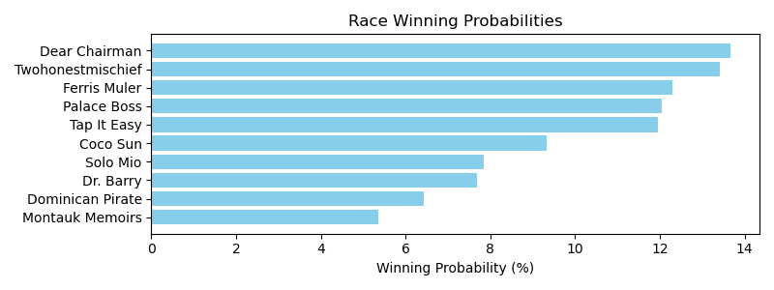

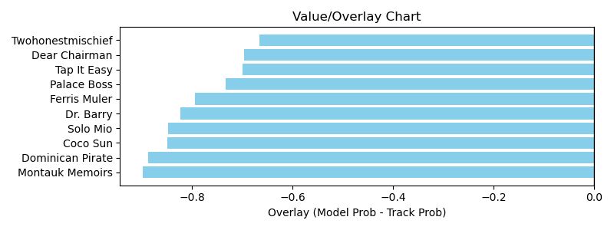

NOTE: GCSF - Global Combined Speed Figure

# Race: AQU | 2025-04-05 | Race #6 | Post: 14:55 | Track: AQUEDUCT

Track: AQUEDUCT

|  |  |  |  |  |  |
| --- | --- | --- | --- | --- | --- |
| Program # | Horse Name | Morn Odds | GCSF | Model Score | Win Prob (%) |
| 1 | Big Rich | 12-1 | 91.9 | 1.20 | 16.73 |
| 1A | Ice Time | 12-1 | 98.2 | 0.71 | 5.77 |
| 2 | Because the Night | 30-1 | 114.7 | 0.72 | 5.79 |
| 3 | Active Duty | 12-1 | 96.8 | 0.80 | 7.29 |
| 4 | Prove Worthy | 2-1 | 92.1 | 1.01 | 11.64 |
| 5 | Masterwork | 30-1 | 105.2 | 0.62 | 4.28 |
| 6 | Winter's Ghost | 8-1 | 96.4 | 0.88 | 8.76 |
| 7 | Zeebear | 8-1 | 118.5 | 0.76 | 6.62 |
| 8 | Six Kings | 8-1 | 94.4 | 0.73 | 6.01 |
| 9 | Indianquest | 50-1 | 111.8 | 0.57 | 3.63 |
| 10 | Quiet Wisdom | 5-2 | 110.6 | 1.01 | 11.68 |
| 11 | Beachwalker | 15-1 | 95.0 | 0.73 | 6.03 |
| 12 | Wild Banker | 30-1 | 94.9 | 0.71 | 5.77 |

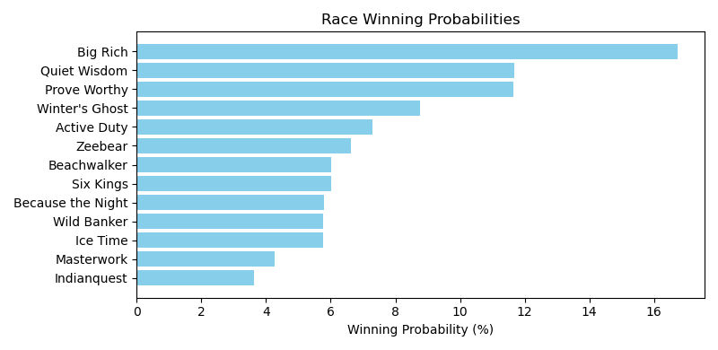

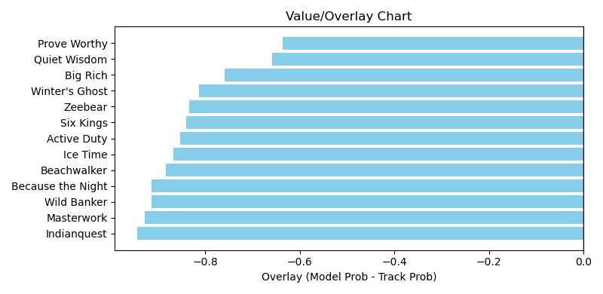

NOTE: GCSF - Global Combined Speed Figure

# Race: AQU | 2025-04-05 | Race #7 | Post: 15:29 | Track: AQUEDUCT

Track: AQUEDUCT

|  |  |  |  |  |  |
| --- | --- | --- | --- | --- | --- |
| Program # | Horse Name | Morn Odds | GCSF | Model Score | Win Prob (%) |
| 1 | Irish Maxima | 1-1 | 112.6 | 1.52 | 26.49 |
| 2 | Sea Dancer | 9-2 | 90.2 | 1.39 | 21.96 |
| 3 | Ocean Gateway | 20-1 | 89.2 | 0.77 | 6.58 |
| 4 | St. Benedicts Prep | 6-1 | 99.0 | 1.06 | 12.58 |
| 5 | Socially Selective | 7-2 | 112.0 | 1.04 | 12.09 |
| 6 | Royal Spa | 6-1 | 106.1 | 0.99 | 11.00 |
| 7 | All Class | 20-1 | 115.3 | 0.91 | 9.32 |

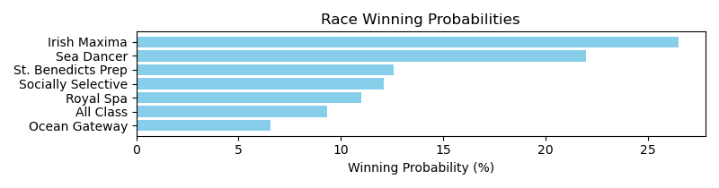

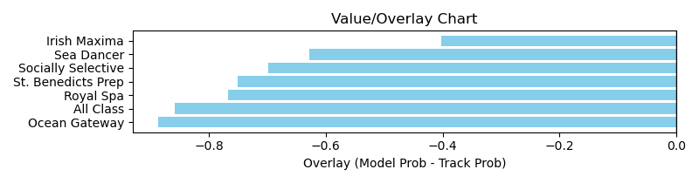

NOTE: GCSF - Global Combined Speed Figure

# Race: AQU | 2025-04-05 | Race #8 | Post: 16:02 | Track: AQUEDUCT

Track: AQUEDUCT

|  |  |  |  |  |  |
| --- | --- | --- | --- | --- | --- |
| Program # | Horse Name | Morn Odds | GCSF | Model Score | Win Prob (%) |
| 1 | Brewing | 20-1 | 106.6 | 0.58 | 4.69 |
| 2 | Brick Ambush | 6-1 | 105.7 | 0.82 | 9.65 |
| 3 | Trust Fund | 8-1 | 99.2 | 0.79 | 8.88 |
| 4 | Leo's Reward | 10-1 | 98.2 | 1.14 | 18.58 |
| 5 | Stewie | 15-1 | 106.6 | 0.73 | 7.42 |
| 6 | Crimson Light | 5-2 | 100.0 | 0.88 | 10.96 |
| 7 | Final Denile | 20-1 | 93.4 | 0.61 | 5.18 |
| 8 | Saint Gaudens | 7-2 | 95.9 | 0.84 | 10.08 |
| 9 | Sir Palace Prince | 30-1 | 95.5 | 0.68 | 6.53 |
| 10 | Noonzio | 4-1 | 108.6 | 0.92 | 12.08 |
| 11 | Enticing Prospect | 30-1 | 100.0 | 0.65 | 5.96 |

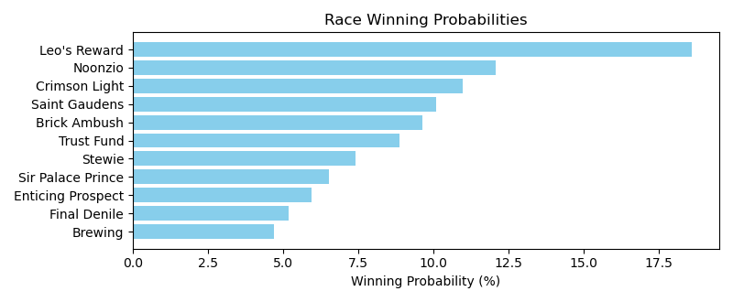

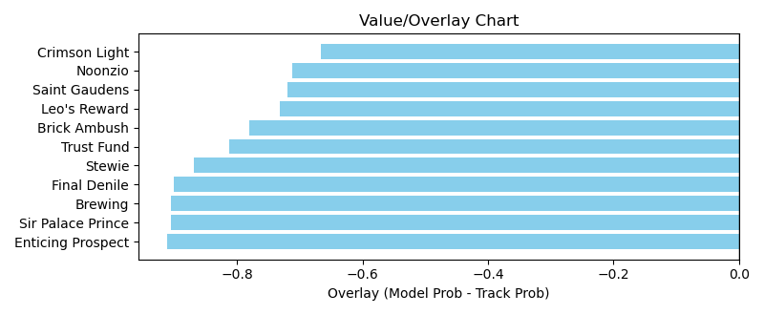

NOTE: GCSF - Global Combined Speed Figure

# Race: AQU | 2025-04-05 | Race #9 | Post: 16:34 | Track: AQUEDUCT

Track: AQUEDUCT

|  |  |  |  |  |  |
| --- | --- | --- | --- | --- | --- |
| Program # | Horse Name | Morn Odds | GCSF | Model Score | Win Prob (%) |
| 1 | Late Nite Call | 30-1 | 106.6 | 0.56 | 4.67 |
| 2 | Ballerina d'Oro | 1-1 | 110.5 | 0.98 | 14.62 |
| 3 | Vanilla Sundae | 6-1 | 106.6 | 0.62 | 5.78 |
| 4 | Early On | 6-1 | 103.1 | 1.36 | 28.38 |
| 5 | Deloraine | 8-1 | 109.5 | 0.80 | 9.61 |
| 6 | Diriyah | 20-1 | 100.0 | 0.72 | 7.83 |
| 7 | Pure Beauty | 9-2 | 106.6 | 1.10 | 18.39 |
| 8 | Liam in the Dust | 8-1 | 99.8 | 0.84 | 10.70 |

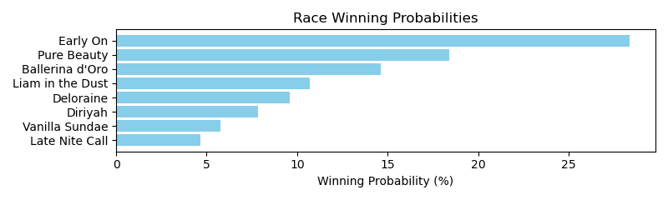

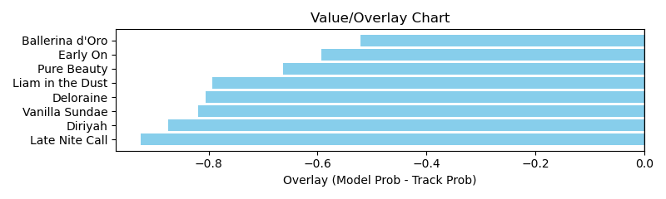

NOTE: GCSF - Global Combined Speed Figure

# Race: AQU | 2025-04-05 | Race #10 | Post: 17:06 | Track: AQUEDUCT

Track: AQUEDUCT

|  |  |  |  |  |  |
| --- | --- | --- | --- | --- | --- |
| Program # | Horse Name | Morn Odds | GCSF | Model Score | Win Prob (%) |
| 1 | Crazy Mason | 5-1 | 103.8 | 1.60 | 20.58 |
| 2 | Quint's Brew | 2-1 | 93.3 | 1.58 | 20.10 |
| 3 | Surveillance | 8-1 | 104.2 | 1.00 | 7.89 |
| 4 | Full Moon Madness | 7-2 | 96.3 | 1.08 | 9.26 |
| 5 | Donegal Momentum | 8-1 | 91.6 | 1.38 | 15.17 |
| 6 | Dilger (IRE) | 15-1 | 104.3 | 0.95 | 7.13 |
| 7 | Maximus Meridius | 4-1 | 111.5 | 1.27 | 12.72 |
| 8 | Sheriff Bianco | 15-1 | 96.5 | 0.96 | 7.16 |

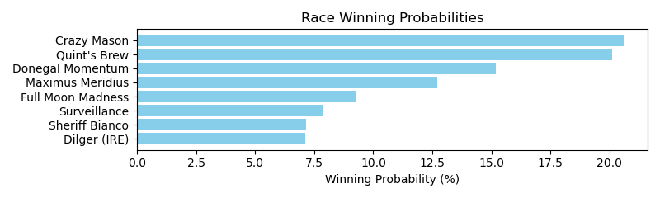

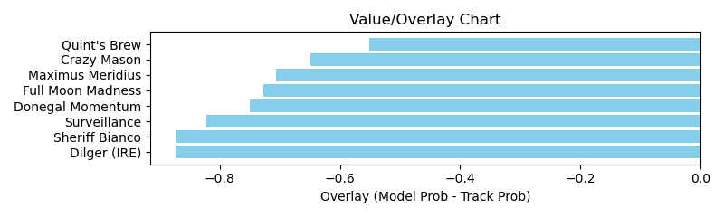

NOTE: GCSF - Global Combined Speed Figure

# Race: AQU | 2025-04-05 | Race #11 | Post: 17:38 | Track: AQUEDUCT

Track: AQUEDUCT

|  |  |  |  |  |  |
| --- | --- | --- | --- | --- | --- |
| Program # | Horse Name | Morn Odds | GCSF | Model Score | Win Prob (%) |
| 1 | Film Star | 12-1 | 107.8 | 1.37 | 14.84 |
| 2 | Classic Catch | 15-1 | 104.1 | 0.98 | 7.51 |
| 3 | Batten Down | 2-1 | 89.9 | 1.17 | 10.68 |
| 4 | Crupi | 4-1 | 102.6 | 1.02 | 8.07 |
| 5 | Curbstone | 12-1 | 100.8 | 1.61 | 20.71 |
| 6 | Phileas Fogg | 6-1 | 96.8 | 1.45 | 16.67 |
| 7 | Mama's Gold | 10-1 | 111.3 | 0.91 | 6.39 |
| 8 | Masmak | 5-2 | 97.2 | 1.38 | 15.13 |

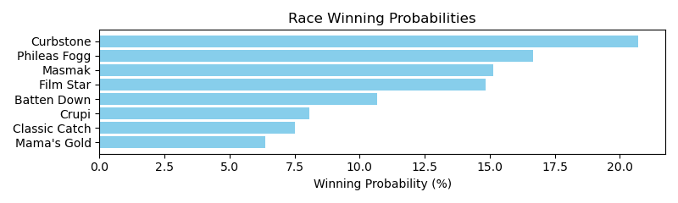

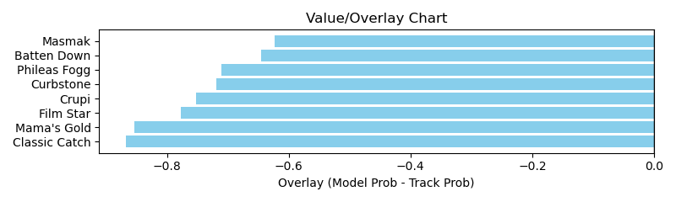

NOTE: GCSF - Global Combined Speed Figure

# Race: AQU | 2025-04-05 | Race #12 | Post: 18:10 | Track: AQUEDUCT

Track: AQUEDUCT

|  |  |  |  |  |  |
| --- | --- | --- | --- | --- | --- |
| Program # | Horse Name | Morn Odds | GCSF | Model Score | Win Prob (%) |
| 1 | Rodriguez | 5-2 | 109.8 | 0.98 | 7.47 |
| 2 | Captain Cook | 7-2 | 93.4 | 1.25 | 12.34 |
| 3 | Tiger Twenty Four | 30-1 | 93.4 | 0.92 | 6.57 |
| 4 | My Mitole | 20-1 | 101.5 | 0.97 | 7.26 |
| 5 | Sand Devil | 8-1 | 109.3 | 1.18 | 10.89 |
| 6 | Hill Road | 9-2 | 100.0 | 0.97 | 7.27 |
| 7 | Grande | 5-1 | 100.0 | 1.31 | 13.37 |
| 8 | Passion Rules | 12-1 | 100.0 | 0.93 | 6.72 |
| 9 | Bear Claw Necklace | 50-1 | 106.6 | 1.00 | 7.84 |
| 10 | McAfee | 20-1 | 106.6 | 0.90 | 6.19 |
| 11 | Statesman | 15-1 | 103.6 | 1.04 | 8.36 |
| 12 | Omaha Omaha | 30-1 | 88.7 | 0.86 | 5.70 |

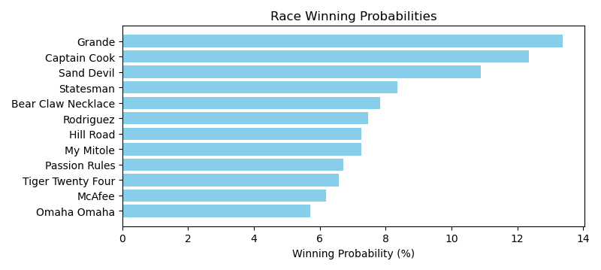

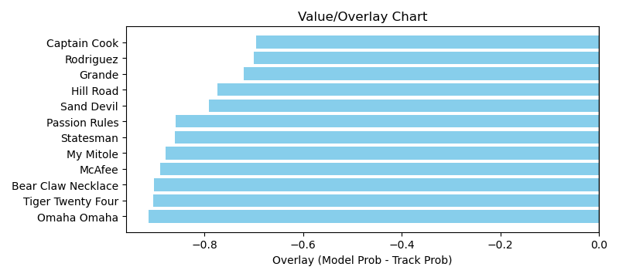

NOTE: GCSF - Global Combined Speed Figure

# Race: AQU | 2025-04-05 | Race #13 | Post: 18:44 | Track: AQUEDUCT

Track: AQUEDUCT

|  |  |  |  |  |  |
| --- | --- | --- | --- | --- | --- |
| Program # | Horse Name | Morn Odds | GCSF | Model Score | Win Prob (%) |
| 1 | A Maize Zing Dotie | 30-1 | 101.7 | 0.74 | 7.10 |
| 2 | True Empress | 30-1 | 107.0 | 0.81 | 8.54 |
| 3 | Dolomite | 1-1 | 94.4 | 1.08 | 15.35 |
| 4 | Nolita | 10-1 | 115.6 | 0.85 | 9.27 |
| 5 | Ariana Rye | 8-1 | 113.7 | 0.81 | 8.52 |
| 6 | Sweetest Princess | 10-1 | 94.8 | 0.83 | 9.00 |
| 7 | Snappin Buttons | 20-1 | 106.9 | 0.70 | 6.27 |
| 8 | Clover Street | 15-1 | 89.8 | 0.73 | 6.79 |
| 9 | Fast and Frisky | 8-1 | 93.7 | 0.84 | 9.15 |
| 10 | Sohana | 5-1 | 108.7 | 0.78 | 7.88 |
| 11 | Monetary Monarch | 30-1 | 90.5 | 0.96 | 12.13 |

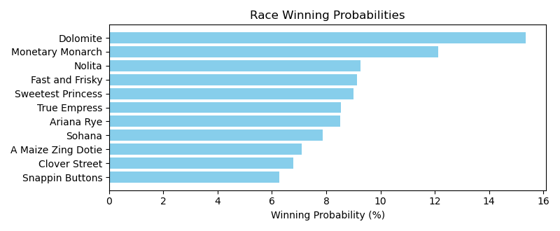

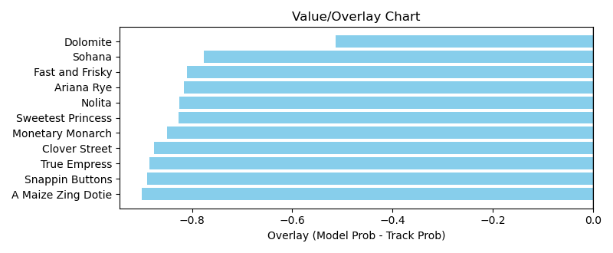

NOTE: GCSF - Global Combined Speed Figure

# Race: TGP | 2025-04-05 | Race #1 | Post: 12:50 | Track: GULFSTREAM PARK

Track: GULFSTREAM PARK

|  |  |  |  |  |  |
| --- | --- | --- | --- | --- | --- |
| Program # | Horse Name | Morn Odds | GCSF | Model Score | Win Prob (%) |
| 1 | Messagefromtheking | 15-1 | 98.6 | 0.67 | 11.54 |
| 2 | Renege | 20-1 | 93.9 | 0.57 | 8.44 |
| 3 | Last Run | 5-1 | 92.1 | 0.72 | 13.52 |
| 4 | Secret Bagent Man | 3-1 | 106.6 | 0.83 | 18.03 |
| 5 | Map This | 30-1 | 100.0 | 0.48 | 5.94 |
| 6 | Oscarworthy | 7-5 | 100.6 | 0.79 | 16.21 |
| 7 | Ocala Rocket | 9-2 | 97.3 | 0.77 | 15.38 |
| 8 | Smooth an Easy | 8-1 | 93.2 | 0.65 | 10.93 |

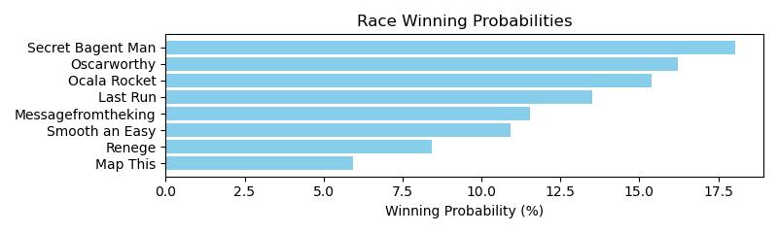

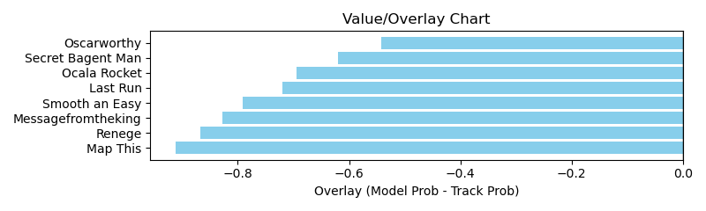

NOTE: GCSF - Global Combined Speed Figure

# Race: TGP | 2025-04-05 | Race #2 | Post: 13:24 | Track: GULFSTREAM PARK

Track: GULFSTREAM PARK

|  |  |  |  |  |  |
| --- | --- | --- | --- | --- | --- |
| Program # | Horse Name | Morn Odds | GCSF | Model Score | Win Prob (%) |
| 1 | Smooth Claret | 9-2 | 93.4 | 0.68 | 9.45 |
| 2 | Chitchatchitchat | 4-1 | 100.0 | 0.70 | 9.98 |
| 3 | Lindsay Smiles | 10-1 | 102.1 | 0.65 | 8.72 |
| 4 | IN FACT SHEZA ZASK | 20-1 | 100.0 | 0.59 | 7.10 |
| 5 | Anacapri | 20-1 | 93.4 | 0.49 | 4.84 |
| 6 | Accelerated News | 8-1 | 100.0 | 0.65 | 8.60 |
| 7 | SOUPER DESSERT | 6-1 | 100.0 | 0.67 | 9.34 |
| 8 | STARSHIP ASPEN | 15-1 | 100.0 | 0.61 | 7.59 |
| 9 | On Moonlight Bay | 7-2 | 115.2 | 0.86 | 15.36 |
| 10 | Clash City Rocker | 5-1 | 100.0 | 0.96 | 19.01 |

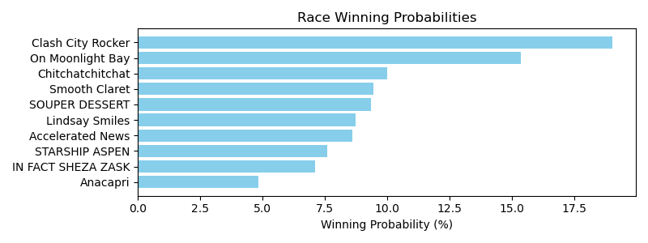

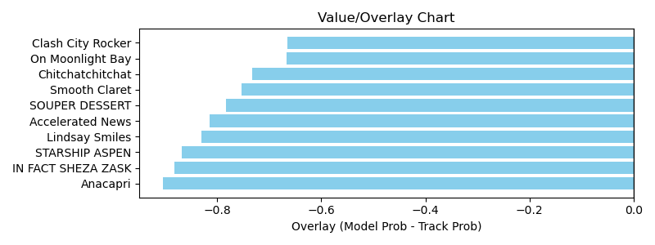

NOTE: GCSF - Global Combined Speed Figure

# Race: TGP | 2025-04-05 | Race #3 | Post: 13:55 | Track: GULFSTREAM PARK

Track: GULFSTREAM PARK

|  |  |  |  |  |  |
| --- | --- | --- | --- | --- | --- |
| Program # | Horse Name | Morn Odds | GCSF | Model Score | Win Prob (%) |
| 1 | Happy Ride | 8-1 | 90.6 | 0.72 | 6.23 |
| 2 | J Z's Last Schance | 20-1 | 93.4 | 0.60 | 4.31 |
| 3 | Lita | 8-1 | 92.8 | 0.79 | 7.63 |
| 4 | Denver's Alley | 7-2 | 94.5 | 1.21 | 18.24 |
| 5 | Royally Blue | 3-1 | 101.9 | 1.42 | 25.06 |
| 6 | Not Guilty | 4-1 | 112.4 | 1.47 | 27.08 |
| 7 | Warda | 2-1 | 97.3 | 0.97 | 11.45 |

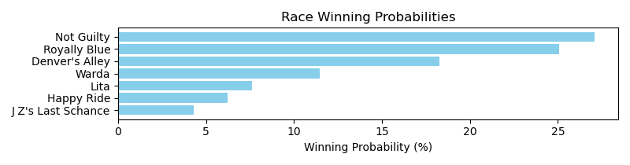

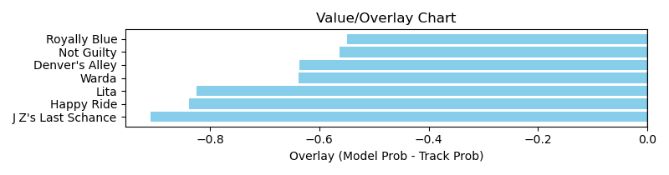

NOTE: GCSF - Global Combined Speed Figure

# Race: TGP | 2025-04-05 | Race #4 | Post: 14:27 | Track: GULFSTREAM PARK

Track: GULFSTREAM PARK

|  |  |  |  |  |  |
| --- | --- | --- | --- | --- | --- |
| Program # | Horse Name | Morn Odds | GCSF | Model Score | Win Prob (%) |
| 1 | C C Girl | 5-1 | 93.9 | 0.58 | 10.43 |
| 2 | Zennas Word | 20-1 | 106.6 | 0.44 | 5.95 |
| 3 | Grand Sticker | 9-5 | 100.0 | 0.86 | 23.86 |
| 4 | Blazin' Praline | 30-1 | 110.2 | 0.44 | 5.99 |
| 5 | Maxine Magic | 13-8 | 106.6 | 0.88 | 24.92 |
| 6 | Splash Dive | 9-2 | 106.6 | 0.67 | 14.42 |
| 7 | Lovelady Bolt | 10-1 | 110.4 | 0.51 | 8.08 |
| 8 | Gwenniethebutcher | 30-1 | 94.4 | 0.45 | 6.35 |

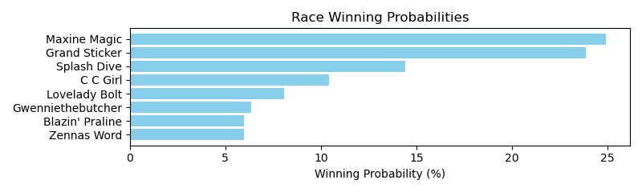

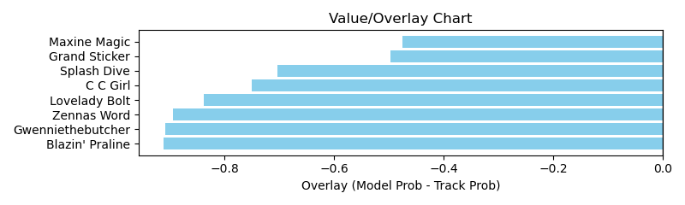

NOTE: GCSF - Global Combined Speed Figure

# Race: TGP | 2025-04-05 | Race #5 | Post: 15:12 | Track: GULFSTREAM PARK

Track: GULFSTREAM PARK

|  |  |  |  |  |  |
| --- | --- | --- | --- | --- | --- |
| Program # | Horse Name | Morn Odds | GCSF | Model Score | Win Prob (%) |
| 1 | Todo Fino (CHI) | 1-1 | 102.8 | 1.63 | 38.54 |
| 2 | Louisianimal | 15-1 | 106.3 | 0.76 | 8.08 |
| 3 | Amor Lejano (ARG) | 3-1 | 114.0 | 1.44 | 29.89 |
| 4 | Golden Skull | 9-2 | 91.3 | 0.85 | 10.04 |
| 5 | Walt Whitman (IRE) | 20-1 | 97.5 | 0.64 | 5.73 |
| 6 | Mayheminthepalace | 7-2 | 91.5 | 0.74 | 7.72 |

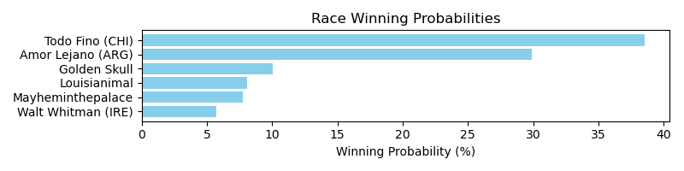

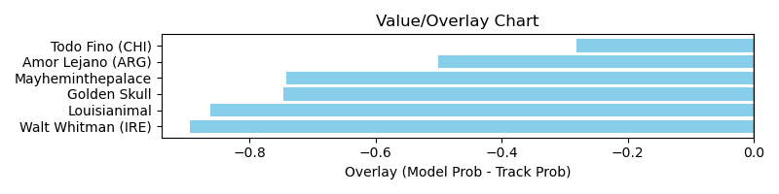

NOTE: GCSF - Global Combined Speed Figure

# Race: TGP | 2025-04-05 | Race #6 | Post: 15:42 | Track: GULFSTREAM PARK

Track: GULFSTREAM PARK

|  |  |  |  |  |  |
| --- | --- | --- | --- | --- | --- |
| Program # | Horse Name | Morn Odds | GCSF | Model Score | Win Prob (%) |
| 1 | Reef Runner | 5-1 | 98.1 | 1.14 | 10.33 |
| 2 | Okiro | 10-1 | 91.9 | 0.92 | 6.69 |
| 3 | Horsepower | 5-1 | 106.1 | 1.33 | 14.12 |
| 4 | Biz Biz Buzz | 10-1 | 101.8 | 0.99 | 7.76 |
| 5 | Fulanito | 30-1 | 95.3 | 0.91 | 6.61 |
| 6 | Yes I Am Free | 15-1 | 103.9 | 0.96 | 7.29 |
| 7 | Bring Theband Home | 9-2 | 92.4 | 1.50 | 18.15 |
| 8 | Panther Island | 12-1 | 106.5 | 1.04 | 8.56 |
| 9 | Eamonn | 4-1 | 95.7 | 1.11 | 9.80 |
| 10 | Xy Speed | 7-2 | 103.4 | 1.16 | 10.69 |

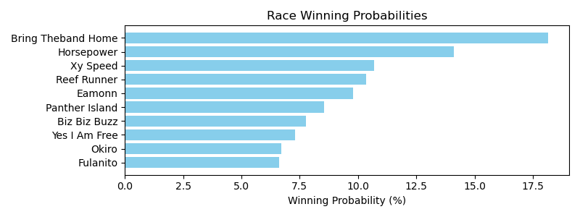

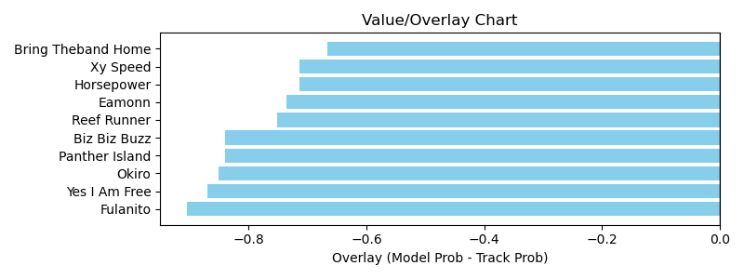

NOTE: GCSF - Global Combined Speed Figure

# Race: TGP | 2025-04-05 | Race #7 | Post: 16:15 | Track: GULFSTREAM PARK

Track: GULFSTREAM PARK

|  |  |  |  |  |  |
| --- | --- | --- | --- | --- | --- |
| Program # | Horse Name | Morn Odds | GCSF | Model Score | Win Prob (%) |
| 1 | Replevin | 4-1 | 95.7 | 0.83 | 16.84 |
| 2 | Night of Magic | 6-1 | 106.6 | 0.89 | 19.38 |
| 3 | GRAND SCAN | 6-1 | 100.0 | 0.65 | 10.18 |
| 4 | Soar Richard | 9-2 | 93.8 | 0.66 | 10.54 |
| 5 | El Guty | 7-2 | 100.0 | 0.71 | 12.14 |
| 6 | Distinguished Gent | 20-1 | 93.4 | 0.57 | 7.75 |
| 7 | Billionaires Row | 2-1 | 100.0 | 0.98 | 23.18 |

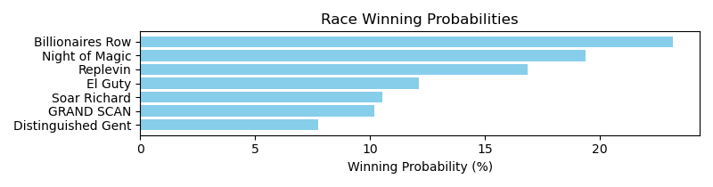

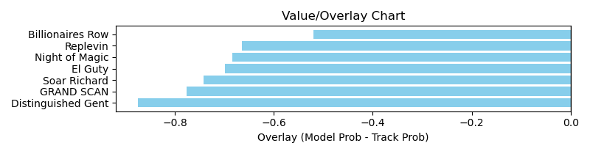

NOTE: GCSF - Global Combined Speed Figure

# Race: TGP | 2025-04-05 | Race #8 | Post: 16:45 | Track: GULFSTREAM PARK

Track: GULFSTREAM PARK

|  |  |  |  |  |  |
| --- | --- | --- | --- | --- | --- |
| Program # | Horse Name | Morn Odds | GCSF | Model Score | Win Prob (%) |
| 1 | Oxar | 30-1 | 89.4 | 0.63 | 5.55 |
| 2 | Prancing Spirit | 15-1 | 106.6 | 0.58 | 4.69 |
| 3 | No Time | 9-2 | 93.1 | 0.78 | 8.58 |
| 4 | Sol d'Oro | 5-2 | 100.0 | 1.46 | 31.44 |
| 5 | Capturing | 7-2 | 100.0 | 0.99 | 14.20 |
| 6 | Starship Impulsive | 6-1 | 110.5 | 1.14 | 19.00 |
| 7 | Ready to Battle | 5-1 | 94.4 | 0.73 | 7.59 |
| 8 | MISS BEETHOVEN (FR) | 4-1 | 100.0 | 0.79 | 8.95 |

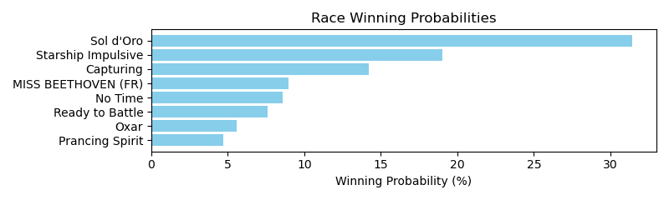

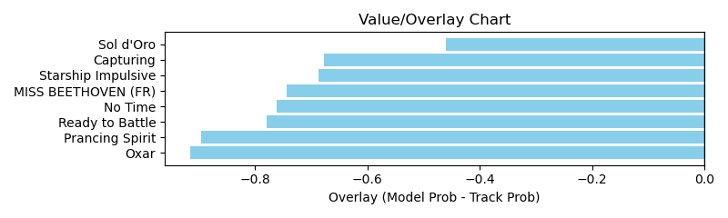

NOTE: GCSF - Global Combined Speed Figure

# Race: TGP | 2025-04-05 | Race #9 | Post: 17:17 | Track: GULFSTREAM PARK

Track: GULFSTREAM PARK

|  |  |  |  |  |  |
| --- | --- | --- | --- | --- | --- |
| Program # | Horse Name | Morn Odds | GCSF | Model Score | Win Prob (%) |
| 1 | Sonet's Name | 20-1 | 127.5 | 0.66 | 5.48 |
| 2 | Khosea | 30-1 | 93.6 | 0.62 | 4.88 |
| 3 | Spider Belle | 5-2 | 94.5 | 1.37 | 24.37 |
| 4 | Musical Romance (GB) | 6-1 | 111.5 | 0.78 | 7.75 |
| 5 | Dontmesswithtess | 7-2 | 97.5 | 0.87 | 9.58 |
| 6 | Don't Get Pickled | 6-1 | 96.3 | 0.76 | 7.39 |
| 7 | Queen Deymar | 30-1 | 100.5 | 0.65 | 5.27 |
| 8 | Wicklow Gal | 12-1 | 96.0 | 0.68 | 5.85 |
| 9 | Misprint | 8-1 | 94.4 | 0.81 | 8.25 |
| 10 | Be Here Now | 4-1 | 96.7 | 1.28 | 21.17 |

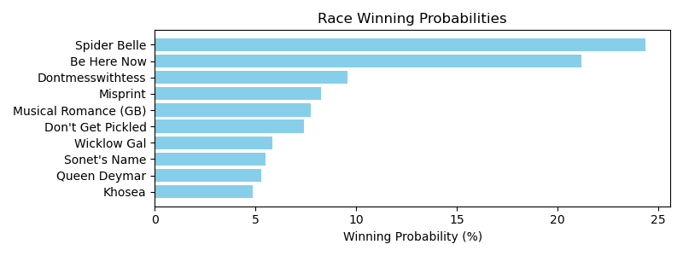

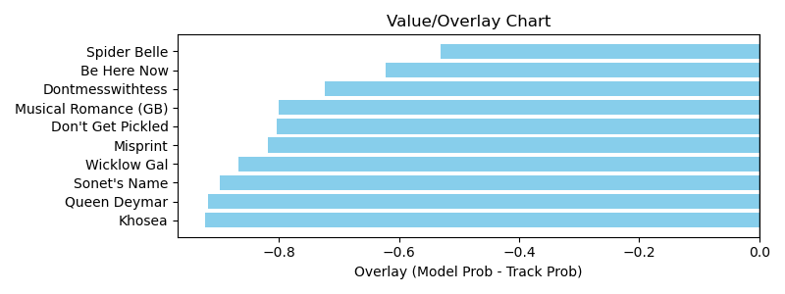

NOTE: GCSF - Global Combined Speed Figure

# Race: TGP | 2025-04-05 | Race #10 | Post: 17:50 | Track: GULFSTREAM PARK

Track: GULFSTREAM PARK

|  |  |  |  |  |  |
| --- | --- | --- | --- | --- | --- |
| Program # | Horse Name | Morn Odds | GCSF | Model Score | Win Prob (%) |
| 1 | Nice Try Riley | 20-1 | 100.0 | 0.54 | 5.03 |
| 2 | Dracula | 8-1 | 100.0 | 0.60 | 6.34 |
| 3 | SINGLEMINDED | 3-1 | 100.0 | 0.77 | 10.37 |
| 4 | Just Relax | 8-1 | 93.7 | 0.75 | 9.79 |
| 5 | Folktale | 8-1 | 100.0 | 0.70 | 8.71 |
| 6 | Venezuelan Hope | 15-1 | 106.6 | 0.66 | 7.51 |
| 7 | Landman Friday | 12-1 | 100.0 | 0.55 | 5.24 |
| 8 | Wearebackyoungman | 9-2 | 100.0 | 0.98 | 17.04 |
| 9 | Curved | 12-1 | 106.6 | 0.71 | 8.82 |
| 10 | Hooray for Me | 30-1 | 100.0 | 0.47 | 3.81 |
| 11 | Our Souper Hero | 7-2 | 100.0 | 0.99 | 17.34 |

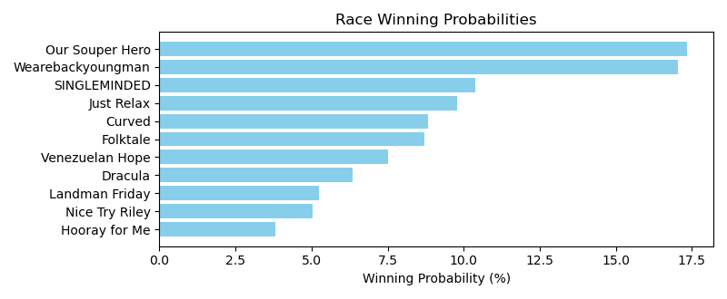

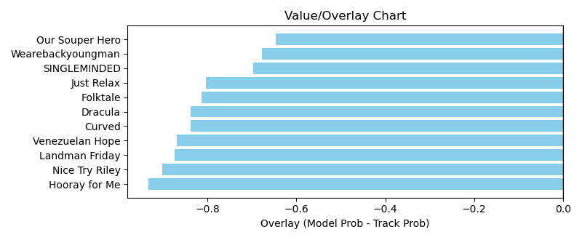

NOTE: GCSF - Global Combined Speed Figure

# Race: TGP | 2025-04-05 | Race #11 | Post: 18:20 | Track: GULFSTREAM PARK

Track: GULFSTREAM PARK

|  |  |  |  |  |  |
| --- | --- | --- | --- | --- | --- |
| Program # | Horse Name | Morn Odds | GCSF | Model Score | Win Prob (%) |
| 1 | EL DIENTE (URU) | 4-1 | 100.0 | 1.21 | 10.28 |
| 2 | SETTE BRAVO (URU) | 2-1 | 100.0 | 1.26 | 11.10 |
| 3 | ALBARINO (URU) | 20-1 | 100.0 | 1.07 | 7.90 |
| 4 | SABIO ZE (URU) | 9-2 | 100.0 | 1.22 | 10.45 |
| 5 | DOLARISIMO (ARG) | 6-1 | 100.0 | 1.37 | 13.14 |
| 6 | AZULGRANA (URU) | 4-1 | 100.0 | 1.21 | 10.13 |
| 7 | LEOPARDYNO (URU) | 9-2 | 100.0 | 1.27 | 11.34 |
| 8 | HOLIDAY NEW (URU) | 6-1 | 100.0 | 1.30 | 11.92 |
| 9 | UNIVERSO (URU) | 9-2 | 100.0 | 1.40 | 13.73 |

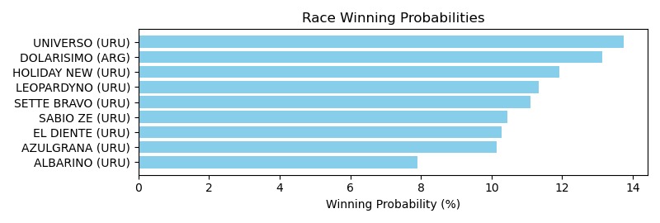

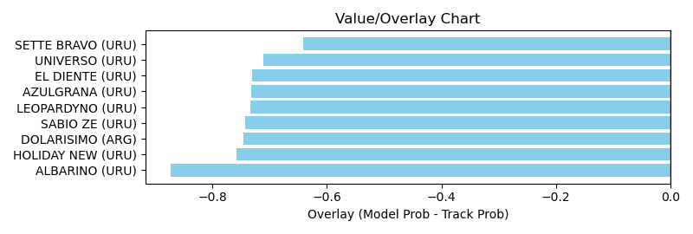

NOTE: GCSF - Global Combined Speed Figure

# Race: TGP | 2025-04-05 | Race #12 | Post: 18:50 | Track: GULFSTREAM PARK

Track: GULFSTREAM PARK

|  |  |  |  |  |  |
| --- | --- | --- | --- | --- | --- |
| Program # | Horse Name | Morn Odds | GCSF | Model Score | Win Prob (%) |
| 1 | CRAZYANALYZE (URU) | 8-1 | 100.0 | 1.20 | 8.30 |
| 2 | ESPARTACO (URU) | 6-1 | 100.0 | 1.29 | 9.55 |
| 3 | RAYO MCQUEEN (URU) | 3-1 | 100.0 | 1.45 | 12.23 |
| 4 | EL LEOPARDO (URU) | 4-1 | 100.0 | 1.22 | 8.51 |
| 5 | ILUSTRE DON (URU) | 6-1 | 100.0 | 1.30 | 9.75 |
| 6 | LEOPARD STAR (URU) | 6-1 | 100.0 | 1.18 | 7.96 |
| 7 | CHEF JOHN (URU) | 5-1 | 100.0 | 1.30 | 9.80 |
| 8 | PALE ALE (URU) | 20-1 | 100.0 | 1.16 | 7.69 |
| 9 | EL CASINO (URU) | 5-1 | 100.0 | 1.26 | 9.11 |
| 10 | CONQUISTADOR SOY (ARG) | 6-1 | 100.0 | 1.30 | 9.74 |
| 11 | TOMBALLET (URU) | 8-1 | 100.0 | 1.13 | 7.36 |

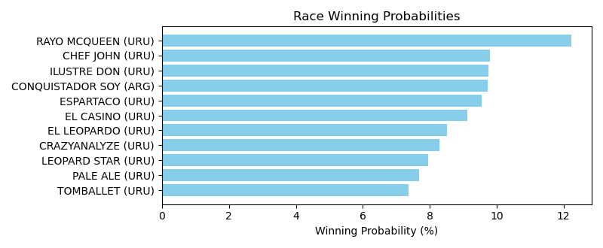

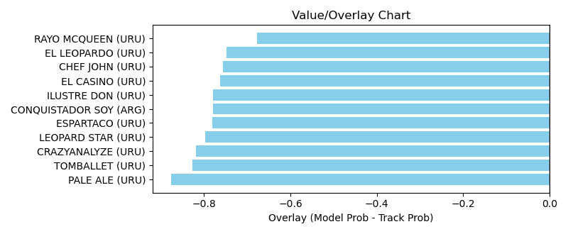

NOTE: GCSF - Global Combined Speed Figure

# Race: KEE | 2025-04-05 | Race #1 | Post: 13:00 | Track: KEENELAND

Track: KEENELAND

|  |  |  |  |  |  |
| --- | --- | --- | --- | --- | --- |
| Program # | Horse Name | Morn Odds | GCSF | Model Score | Win Prob (%) |
| 1 | Ship Ship Hooray | 20-1 | 94.6 | 0.64 | 7.78 |
| 2 | Camp Hale | 6-5 | 105.4 | 0.97 | 18.46 |
| 3 | Playa Del Mar | 4-1 | 100.0 | 0.72 | 9.84 |
| 4 | Call Shadd | 15-1 | 100.0 | 0.80 | 12.51 |
| 5 | Sock It to Me | 30-1 | 100.0 | 0.60 | 6.97 |
| 6 | Sergeant Capps | 20-1 | 100.8 | 0.67 | 8.69 |
| 7 | STEEZE | 12-1 | 100.0 | 0.66 | 8.45 |
| 8 | Invictus | 6-1 | 100.0 | 0.57 | 6.20 |
| 9 | MO WORK | 12-1 | 100.0 | 0.65 | 8.09 |
| 10 | Shepherd | 6-1 | 105.5 | 0.82 | 13.01 |

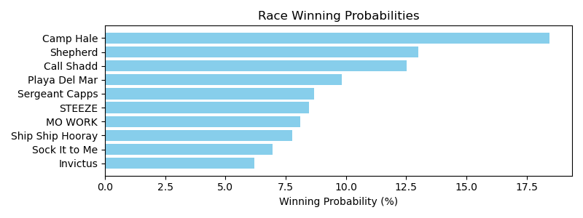

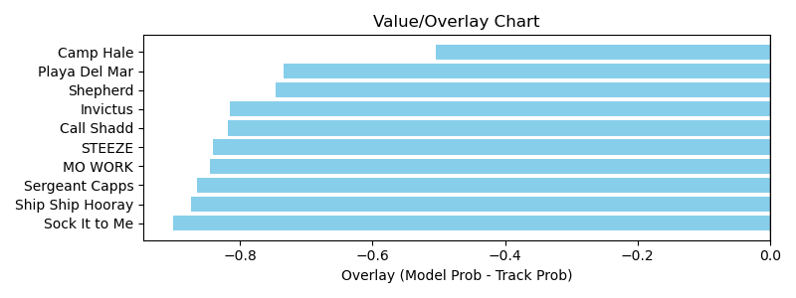

NOTE: GCSF - Global Combined Speed Figure

# Race: KEE | 2025-04-05 | Race #2 | Post: 13:32 | Track: KEENELAND

Track: KEENELAND

|  |  |  |  |  |  |
| --- | --- | --- | --- | --- | --- |
| Program # | Horse Name | Morn Odds | GCSF | Model Score | Win Prob (%) |
| 1 | Tomasello | 7-2 | 94.0 | 0.96 | 13.17 |
| 2 | Meritorious | 10-1 | 106.6 | 0.59 | 4.82 |
| 3 | Kicking Clear | 15-1 | 92.0 | 0.58 | 4.74 |
| 4 | Special Session | 12-1 | 91.1 | 0.89 | 11.42 |
| 5 | Courageous Clay | 10-1 | 90.3 | 0.82 | 9.48 |
| 6 | No Mo Moolah | 12-1 | 106.6 | 0.57 | 4.60 |
| 7 | Van Ginkel | 8-1 | 106.6 | 0.64 | 5.74 |
| 8 | Trigger Point | 30-1 | 100.0 | 0.56 | 4.34 |
| 9 | Fateful Lightning | 3-1 | 106.6 | 0.92 | 12.24 |
| 10 | Kick It In | 50-1 | 100.0 | 0.51 | 3.66 |
| 11 | Bermuda Triangle | 15-1 | 100.0 | 0.83 | 9.75 |
| 12 | Excite | 9-2 | 100.0 | 1.06 | 16.04 |

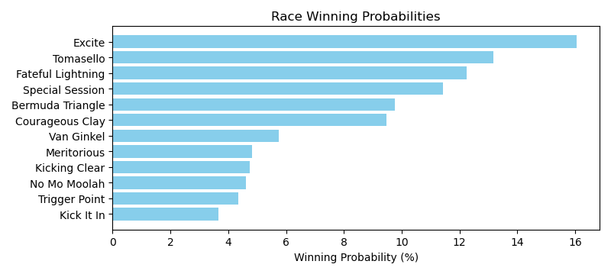

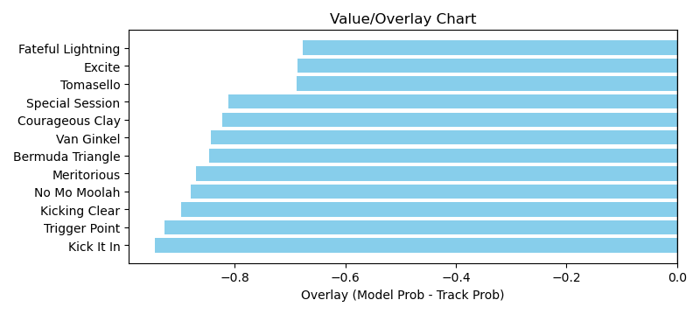

NOTE: GCSF - Global Combined Speed Figure

# Race: KEE | 2025-04-05 | Race #3 | Post: 14:04 | Track: KEENELAND

Track: KEENELAND

|  |  |  |  |  |  |
| --- | --- | --- | --- | --- | --- |
| Program # | Horse Name | Morn Odds | GCSF | Model Score | Win Prob (%) |
| 1 | Thrilla | 15-1 | 108.0 | 0.65 | 5.39 |
| 2 | Retribution | 4-1 | 100.0 | 0.94 | 11.40 |
| 3 | Brodeur | 6-1 | 95.1 | 1.56 | 32.31 |
| 4 | Fully Volatile | 30-1 | 100.0 | 0.68 | 5.88 |
| 5 | Got'm Cot'm | 20-1 | 97.7 | 0.77 | 7.51 |
| 6 | El Dandi | 30-1 | 109.8 | 0.65 | 5.41 |
| 7 | Tip Top Thomas | 2-1 | 100.0 | 1.08 | 15.23 |
| 8 | Dr Ruben M | 20-1 | 95.9 | 0.66 | 5.51 |
| 9 | Gunmetal | 13-8 | 92.0 | 0.94 | 11.37 |

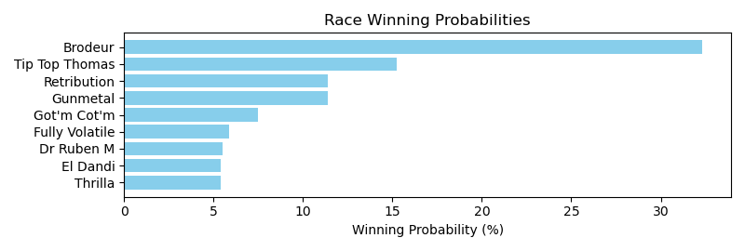

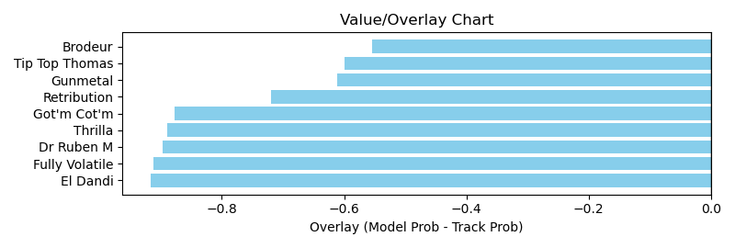

NOTE: GCSF - Global Combined Speed Figure

# Race: KEE | 2025-04-05 | Race #4 | Post: 14:36 | Track: KEENELAND

Track: KEENELAND

|  |  |  |  |  |  |
| --- | --- | --- | --- | --- | --- |
| Program # | Horse Name | Morn Odds | GCSF | Model Score | Win Prob (%) |
| 1 | Irish Aces | 3-1 | 99.6 | 1.13 | 7.25 |
| 2 | West Hollywood | 9-2 | 105.4 | 1.16 | 7.62 |
| 3 | Out of Deductions | 12-1 | 99.1 | 1.39 | 11.03 |
| 4 | Noted | 15-1 | 104.1 | 0.82 | 3.76 |
| 5 | Timeout | 8-1 | 106.4 | 1.49 | 12.83 |
| 6 | Tall Boy | 20-1 | 89.8 | 0.88 | 4.37 |
| 7 | Piper's Factor | 20-1 | 111.3 | 1.27 | 9.25 |
| 8 | Eldest Son | 15-1 | 99.9 | 1.40 | 11.19 |
| 9 | Lincoln Highway | 30-1 | 90.4 | 0.78 | 3.38 |
| 10 | Wonderful Justice (GB) | 30-1 | 98.9 | 0.83 | 3.88 |
| 11 | Smokey Mandate | 20-1 | 100.2 | 0.89 | 4.41 |
| 12 | Northern Invader | 2-1 | 106.8 | 1.12 | 7.11 |
| 13 | Hurry Hurry | 8-1 | 95.9 | 0.95 | 5.09 |
| 14 | Yamato | 15-1 | 97.5 | 0.89 | 4.41 |
| 15 | Degree of Risk | 12-1 | 100.4 | 0.89 | 4.42 |

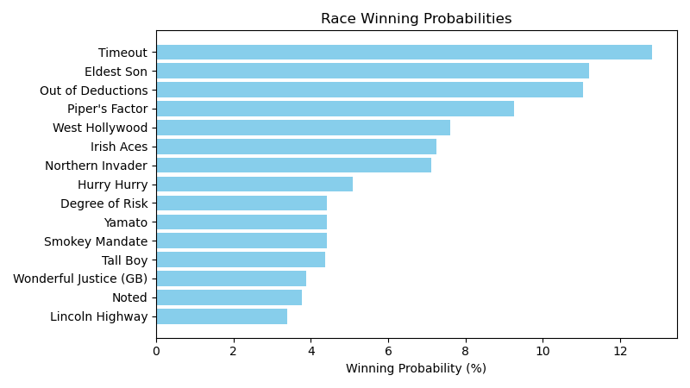

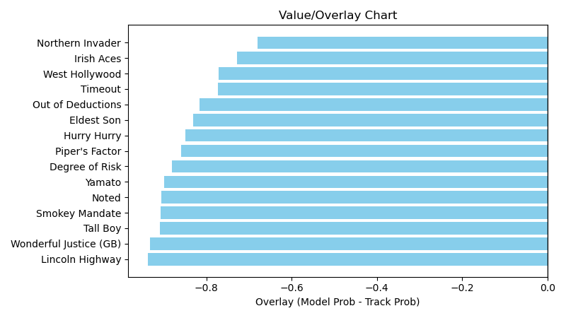

NOTE: GCSF - Global Combined Speed Figure

# Race: KEE | 2025-04-05 | Race #5 | Post: 15:08 | Track: KEENELAND

Track: KEENELAND

|  |  |  |  |  |  |
| --- | --- | --- | --- | --- | --- |
| Program # | Horse Name | Morn Odds | GCSF | Model Score | Win Prob (%) |
| 1 | Midnight Vengeance | 30-1 | 105.4 | 0.63 | 7.03 |
| 2 | Shangrala Road | 7-2 | 100.0 | 0.69 | 8.47 |
| 3 | Activity | 20-1 | 100.0 | 0.57 | 5.74 |
| 4 | Pitkin | 5-2 | 100.0 | 1.05 | 19.98 |
| 5 | Chillax | 20-1 | 100.0 | 0.56 | 5.42 |
| 6 | Fete | 20-1 | 100.0 | 0.56 | 5.41 |
| 7 | Last Man Standing | 9-2 | 100.0 | 0.76 | 10.36 |
| 8 | Abbi Fede | 30-1 | 100.0 | 0.49 | 4.19 |
| 9 | Keen Talent | 8-1 | 100.0 | 0.67 | 7.98 |
| 10 | Development Fee | 15-1 | 100.0 | 0.70 | 8.64 |
| 11 | Fountain Lake | 20-1 | 92.0 | 0.65 | 7.53 |
| 12 | Interceptor | 5-1 | 100.0 | 0.72 | 9.22 |

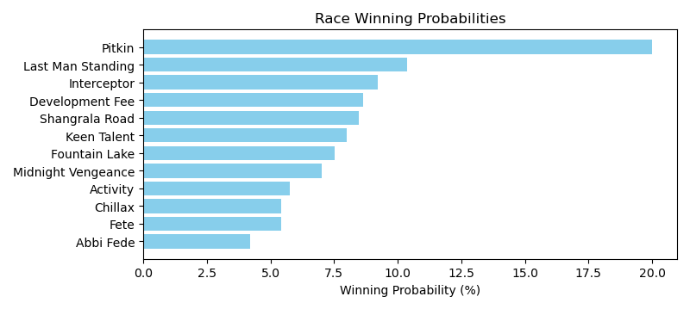

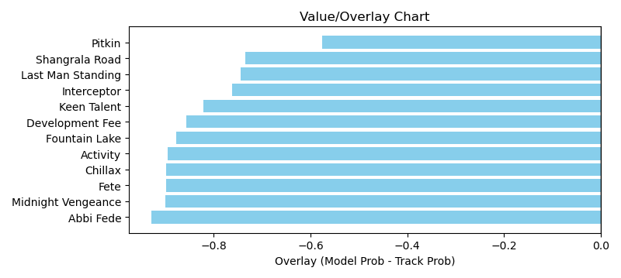

NOTE: GCSF - Global Combined Speed Figure

# Race: KEE | 2025-04-05 | Race #6 | Post: 15:40 | Track: KEENELAND

Track: KEENELAND

|  |  |  |  |  |  |
| --- | --- | --- | --- | --- | --- |
| Program # | Horse Name | Morn Odds | GCSF | Model Score | Win Prob (%) |
| 1 | Nitrogen | 2-1 | 105.2 | 1.25 | 12.73 |
| 2 | Vixen | 3-1 | 107.5 | 1.70 | 23.85 |
| 3 | Fionn | 8-1 | 93.4 | 1.05 | 8.98 |
| 4 | Fast Market | 30-1 | 97.4 | 0.78 | 4.92 |
| 5 | Good Temper | 20-1 | 93.4 | 0.77 | 4.70 |
| 6 | Totally Justified | 6-1 | 108.0 | 1.30 | 13.81 |
| 7 | Liam in the Dust | 15-1 | 98.8 | 0.73 | 4.29 |
| 8 | Lush Lips (GB) | 5-1 | 105.3 | 1.32 | 14.17 |
| 9 | dh-Foxtastic | 12-1 | 96.0 | 0.92 | 6.85 |
| 10 | Table Flirt | 20-1 | 103.3 | 0.84 | 5.68 |

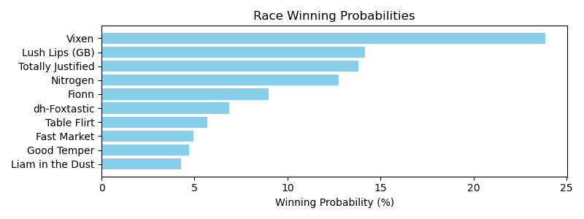

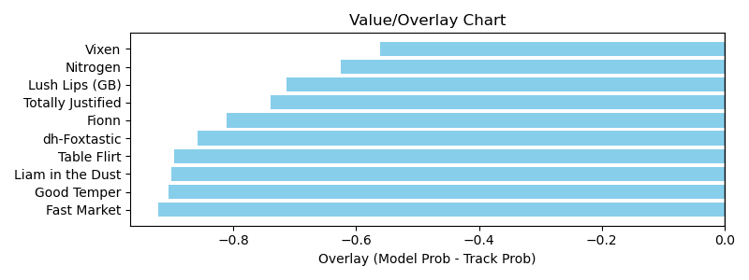

NOTE: GCSF - Global Combined Speed Figure

# Race: KEE | 2025-04-05 | Race #7 | Post: 16:14 | Track: KEENELAND

Track: KEENELAND

|  |  |  |  |  |  |
| --- | --- | --- | --- | --- | --- |
| Program # | Horse Name | Morn Odds | GCSF | Model Score | Win Prob (%) |
| 1 | Best Actor | 15-1 | 93.9 | 1.21 | 9.98 |
| 2 | Montalcino | 3-1 | 100.0 | 1.20 | 9.89 |
| 3 | Epic Ride | 6-1 | 109.9 | 1.46 | 14.84 |
| 4 | Caramel Chip | 30-1 | 113.5 | 0.87 | 5.16 |
| 5 | Nutella Fella | 12-1 | 106.0 | 0.91 | 5.59 |
| 6 | Hoist the Gold | 9-2 | 93.5 | 0.94 | 5.94 |
| 7 | Prince of Power | 20-1 | 89.4 | 1.07 | 7.87 |
| 8 | Here Mi Song | 8-1 | 107.3 | 1.45 | 14.48 |
| 9 | Surly Furious | 30-1 | 101.1 | 0.82 | 4.54 |
| 10 | Extra Anejo | 8-1 | 94.2 | 1.04 | 7.40 |
| 11 | Whatchatalkinabout | 4-1 | 107.9 | 1.03 | 7.26 |
| 12 | Ashcroft | 30-1 | 95.5 | 1.02 | 7.08 |

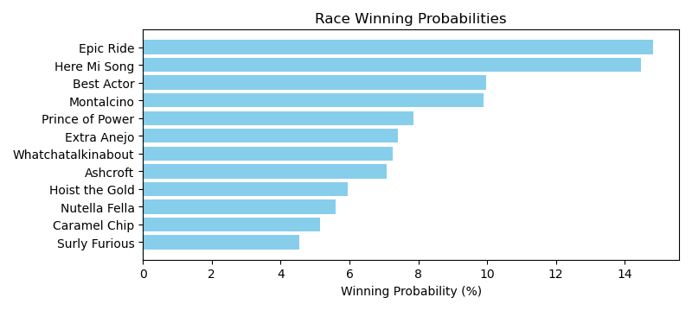

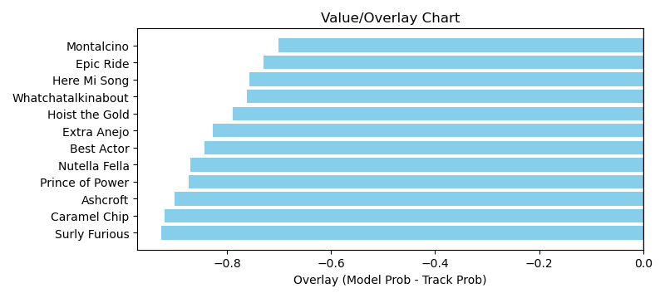

NOTE: GCSF - Global Combined Speed Figure

# Race: KEE | 2025-04-05 | Race #8 | Post: 16:48 | Track: KEENELAND

Track: KEENELAND

|  |  |  |  |  |  |
| --- | --- | --- | --- | --- | --- |
| Program # | Horse Name | Morn Odds | GCSF | Model Score | Win Prob (%) |
| 1 | Positano Sunset | 20-1 | 94.2 | 0.72 | 5.42 |
| 2 | Emery | 3-1 | 102.1 | 1.39 | 20.70 |
| 3 | Harbor Springs | 30-1 | 103.1 | 0.74 | 5.80 |
| 4 | My Mane Squeeze | 8-1 | 92.1 | 0.94 | 9.43 |
| 5 | Dazzling Move | 20-1 | 93.5 | 0.82 | 7.03 |
| 6 | Scylla | 13-8 | 108.7 | 1.19 | 15.24 |
| 7 | Justique | 9-2 | 95.9 | 0.97 | 9.99 |
| 8 | Mystic Lake | 7-2 | 112.0 | 1.56 | 26.39 |

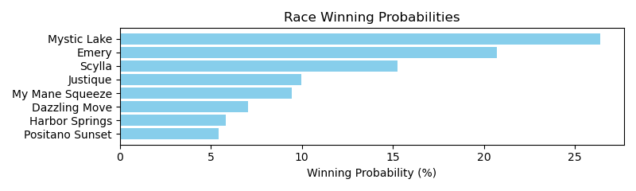

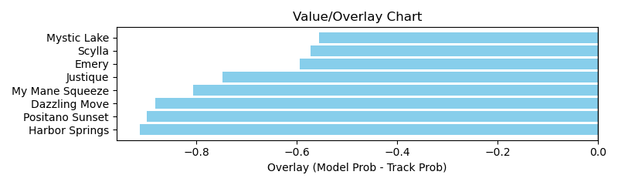

NOTE: GCSF - Global Combined Speed Figure

# Race: KEE | 2025-04-05 | Race #9 | Post: 17:20 | Track: KEENELAND

Track: KEENELAND

|  |  |  |  |  |  |
| --- | --- | --- | --- | --- | --- |
| Program # | Horse Name | Morn Odds | GCSF | Model Score | Win Prob (%) |
| 1 | Run Carson | 6-1 | 98.6 | 1.84 | 21.66 |
| 2 | Our Shot | 7-2 | 99.6 | 1.62 | 16.70 |
| 3 | Arzak | 4-1 | 116.1 | 1.07 | 7.10 |
| 4 | ROGUE LIGHTNING (IRE) | 5-1 | 100.0 | 0.94 | 5.45 |
| 5 | Valentine Candy | 6-1 | 87.6 | 1.10 | 7.51 |
| 6 | No Nay Hudson (IRE) | 12-1 | 108.5 | 0.97 | 5.86 |
| 7 | Eamonn | 20-1 | 102.5 | 0.88 | 4.83 |
| 8 | Petcoff | 20-1 | 96.9 | 0.86 | 4.63 |
| 9 | Mischievous Rogue | 30-1 | 91.1 | 0.92 | 5.28 |
| 10 | Coppola | 6-1 | 114.6 | 1.37 | 11.90 |
| 11 | Think Big | 15-1 | 94.6 | 1.20 | 9.07 |

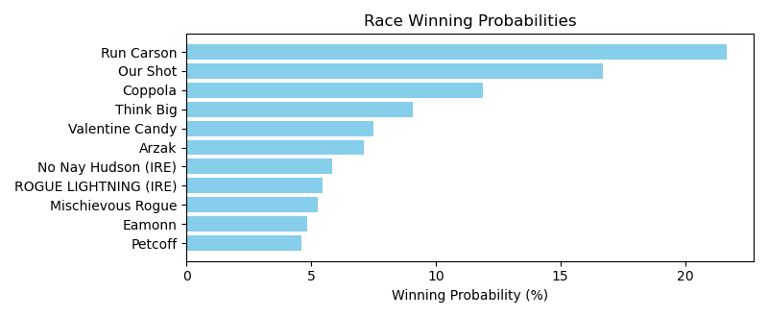

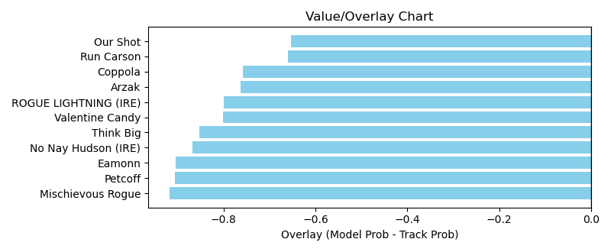

NOTE: GCSF - Global Combined Speed Figure

# Race: KEE | 2025-04-05 | Race #10 | Post: 17:52 | Track: KEENELAND

Track: KEENELAND

|  |  |  |  |  |  |
| --- | --- | --- | --- | --- | --- |
| Program # | Horse Name | Morn Odds | GCSF | Model Score | Win Prob (%) |
| 1 | River Thames | 5-2 | 105.4 | 1.54 | 24.51 |
| 2 | Render Judgment | 20-1 | 96.1 | 0.75 | 5.67 |
| 3 | Burnham Square | 9-2 | 106.7 | 1.34 | 18.44 |
| 4 | Owen Almighty | 3-1 | 96.8 | 1.05 | 11.23 |
| 5 | dh-East Avenue | 3-1 | 105.4 | 1.42 | 20.73 |
| 6 | Chancer McPatrick | 7-2 | 94.3 | 0.87 | 7.65 |
| 7 | Admiral Dennis | 20-1 | 105.4 | 1.08 | 11.77 |

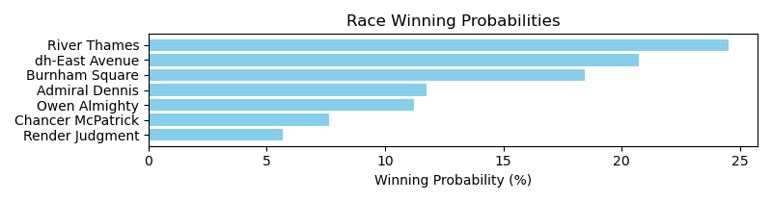

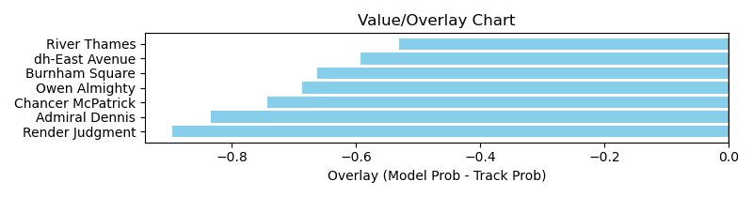

NOTE: GCSF - Global Combined Speed Figure

# Race: KEE | 2025-04-05 | Race #11 | Post: 18:26 | Track: KEENELAND

Track: KEENELAND

|  |  |  |  |  |  |
| --- | --- | --- | --- | --- | --- |
| Program # | Horse Name | Morn Odds | GCSF | Model Score | Win Prob (%) |
| 1 | Seaport Lane | 2-1 | 106.6 | 0.99 | 7.82 |
| 2 | Risk It | 6-1 | 112.7 | 0.90 | 6.37 |
| 3 | Pentathlon | 10-1 | 90.8 | 1.43 | 16.61 |
| 4 | Lou's Legacy | 15-1 | 91.7 | 0.81 | 5.19 |
| 5 | Run Jalen Run | 12-1 | 111.4 | 0.91 | 6.60 |
| 6 | Reynolds Channel | 4-1 | 95.7 | 1.13 | 10.24 |
| 7 | Wyoming Bill | 20-1 | 93.1 | 1.03 | 8.50 |
| 8 | Map to the Stars | 5-1 | 105.4 | 0.93 | 6.90 |
| 9 | Big Hammer | 50-1 | 106.7 | 0.70 | 3.82 |
| 10 | Accident | 30-1 | 104.5 | 0.77 | 4.63 |
| 11 | It's My Life | 15-1 | 99.0 | 0.65 | 3.30 |
| 12 | Theismann | 20-1 | 106.9 | 1.13 | 10.19 |
| 13 | Great Richie M | 20-1 | 110.6 | 0.87 | 6.07 |
| 14 | Standard of Proof | 20-1 | 91.3 | 0.69 | 3.75 |

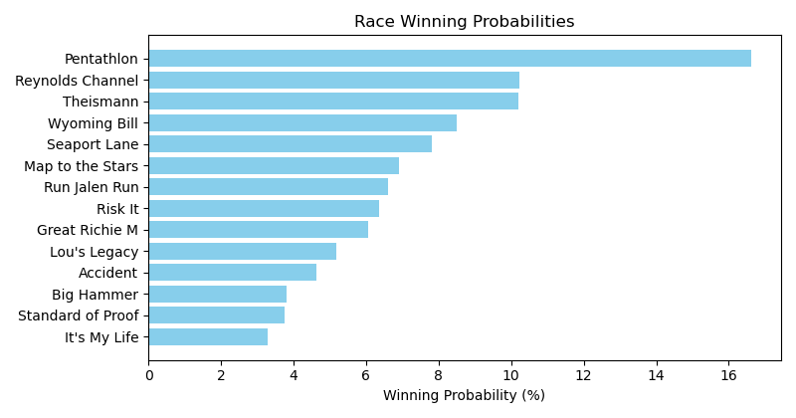

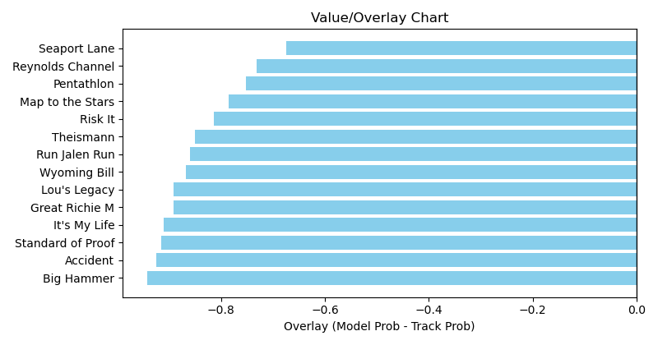

NOTE: GCSF - Global Combined Speed Figure

# Race: KEE | 2025-04-06 | Race #1 | Post: 13:00 | Track: KEENELAND

Track: KEENELAND

|  |  |  |  |  |  |
| --- | --- | --- | --- | --- | --- |
| Program # | Horse Name | Morn Odds | GCSF | Model Score | Win Prob (%) |
| 1 | GOLDEN KEEN | 30-1 | 100.0 | 1.00 | 6.01 |
| 2 | CHAMBOURCIN | 15-1 | 100.0 | 1.07 | 6.92 |
| 3 | GIVEMETHEBEAT | 10-1 | 100.0 | 1.07 | 6.97 |
| 4 | HONOR AND OBAY | 20-1 | 100.0 | 1.01 | 6.16 |
| 5 | LENNILU | 9-2 | 100.0 | 1.19 | 8.58 |
| 6 | LA MONARCA | 30-1 | 100.0 | 0.99 | 5.91 |
| 7 | JUNO PALACE | 30-1 | 100.0 | 1.02 | 6.21 |
| 8 | BAYTOWN CASSINA | 20-1 | 100.0 | 1.01 | 6.19 |
| 9 | KADABRA | 3-1 | 100.0 | 1.30 | 10.38 |
| 10 | DRAGON NAVY | 15-1 | 100.0 | 1.03 | 6.34 |
| 11 | THE LITTLE SULTANA | 20-1 | 100.0 | 1.03 | 6.42 |
| 12 | DAPHNE BLUE | 13-8 | 100.0 | 1.26 | 9.68 |
| 13 | ESTRELLA SILVER | 30-1 | 100.0 | 1.00 | 5.97 |
| 14 | CLOWNING AROUND | 6-1 | 100.0 | 1.17 | 8.27 |

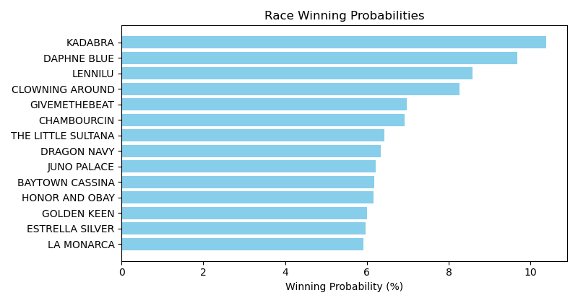

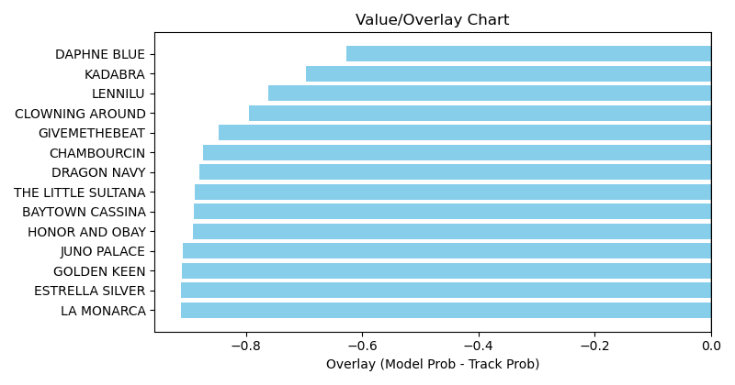

NOTE: GCSF - Global Combined Speed Figure

# Race: KEE | 2025-04-06 | Race #2 | Post: 13:32 | Track: KEENELAND

Track: KEENELAND

|  |  |  |  |  |  |
| --- | --- | --- | --- | --- | --- |
| Program # | Horse Name | Morn Odds | GCSF | Model Score | Win Prob (%) |
| 1 | Chachaching | 20-1 | 96.2 | 0.68 | 6.76 |
| 2 | Mr. Chuck | 6-1 | 100.0 | 0.59 | 4.97 |
| 3 | Promissione | 15-1 | 107.8 | 0.59 | 5.12 |
| 4 | Shortstop | 7-2 | 116.7 | 0.85 | 10.75 |
| 5 | And Thats My Story | 15-1 | 106.6 | 0.61 | 5.41 |
| 6 | Baobab | 5-2 | 100.0 | 0.82 | 9.97 |
| 7 | Mi Compadre | 30-1 | 100.0 | 0.59 | 5.12 |
| 8 | Turnbuckle | 20-1 | 96.7 | 0.64 | 5.86 |
| 9 | Midnight Survivor | 6-1 | 100.0 | 0.57 | 4.62 |
| 10 | Catalina Cat | 12-1 | 100.0 | 0.51 | 3.81 |
| 11 | Paved in Gold | 8-1 | 106.6 | 0.70 | 7.09 |
| 12 | Byword | 20-1 | 100.0 | 0.51 | 3.81 |
| 13 | Cue Country Roads | 20-1 | 100.0 | 0.66 | 6.26 |
| 14 | Task Force | 12-1 | 100.0 | 0.59 | 5.01 |
| 15 | Freedom Maker | 4-1 | 91.4 | 0.80 | 9.35 |
| 16 | Money Memolo | 20-1 | 89.8 | 0.65 | 6.08 |

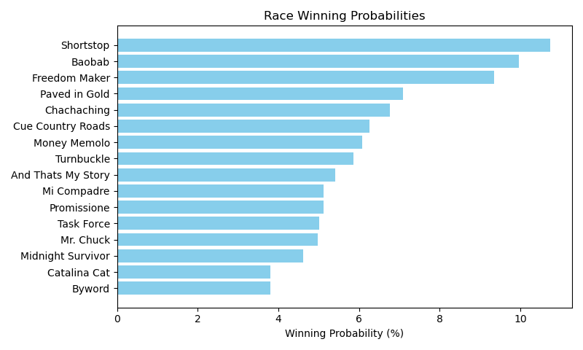

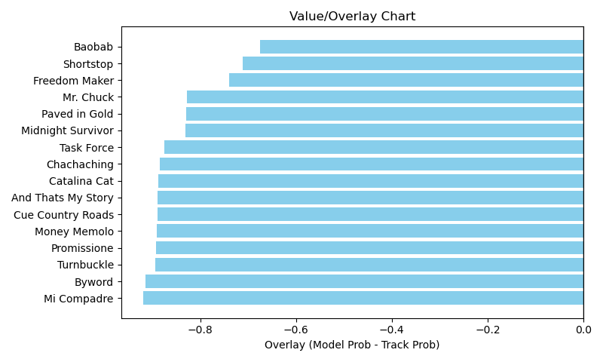

NOTE: GCSF - Global Combined Speed Figure

# Race: KEE | 2025-04-06 | Race #3 | Post: 14:04 | Track: KEENELAND

Track: KEENELAND

|  |  |  |  |  |  |
| --- | --- | --- | --- | --- | --- |
| Program # | Horse Name | Morn Odds | GCSF | Model Score | Win Prob (%) |
| 1 | Three Coins | 30-1 | 98.4 | 0.68 | 3.79 |
| 2 | Goats On a Tree | 9-2 | 97.0 | 1.34 | 15.27 |
| 3 | Cheyenne Moon | 30-1 | 89.8 | 0.61 | 3.09 |
| 4 | Expatriate | 7-2 | 93.4 | 1.24 | 12.96 |
| 5 | Hay Stack | 8-1 | 98.3 | 0.93 | 7.22 |
| 6 | Gal Capone | 20-1 | 110.0 | 0.76 | 4.74 |
| 7 | Romantica | 6-1 | 106.6 | 1.37 | 15.93 |
| 8 | Twirling Good Time | 15-1 | 112.9 | 0.57 | 2.63 |
| 9 | New Rome | 4-1 | 94.6 | 0.93 | 7.18 |
| 10 | Quietly | 10-1 | 106.6 | 0.85 | 6.03 |
| 11 | Heart Spin | 20-1 | 96.0 | 0.77 | 4.85 |
| 12 | Storm Miami (IRE) | 8-1 | 113.3 | 0.94 | 7.36 |
| 13 | Sierra Sky | 20-1 | 92.4 | 1.03 | 8.94 |

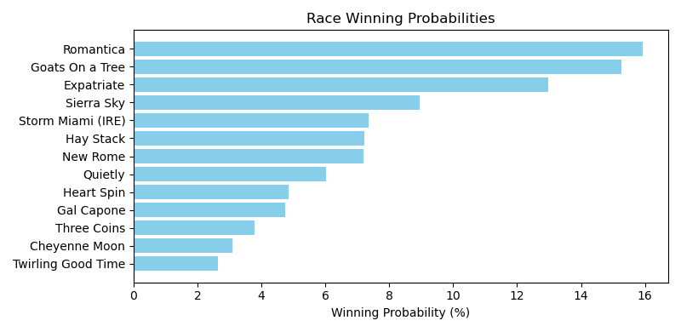

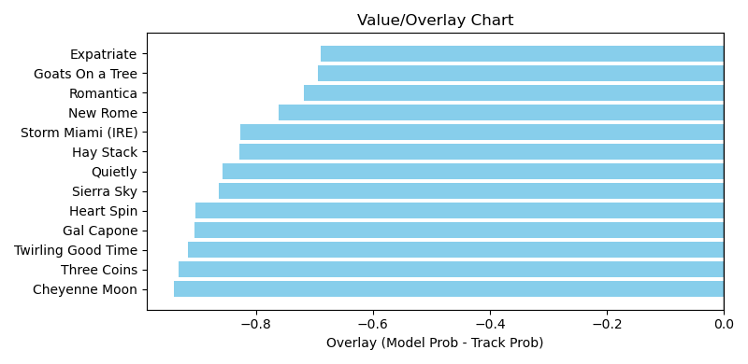

NOTE: GCSF - Global Combined Speed Figure

# Race: KEE | 2025-04-06 | Race #4 | Post: 14:36 | Track: KEENELAND

Track: KEENELAND

|  |  |  |  |  |  |
| --- | --- | --- | --- | --- | --- |
| Program # | Horse Name | Morn Odds | GCSF | Model Score | Win Prob (%) |
| 1 | Up to No Good | 20-1 | 94.2 | 0.60 | 4.95 |
| 2 | Canisius | 30-1 | 93.4 | 1.02 | 14.41 |
| 3 | Sprint Out Pass | 12-1 | 91.6 | 0.68 | 6.25 |
| 4 | Magnum Force | 3-1 | 100.0 | 0.97 | 12.92 |
| 5 | Piquant | 6-1 | 114.2 | 0.94 | 12.24 |
| 6 | Covert Law | 10-1 | 108.6 | 0.71 | 6.92 |
| 7 | South Bend Tom | 20-1 | 100.0 | 0.71 | 6.82 |
| 8 | Art Fair | 4-1 | 110.3 | 0.82 | 9.20 |
| 9 | Farley Hall | 15-1 | 102.5 | 0.68 | 6.25 |
| 10 | Mo Hair Sam | 8-1 | 108.0 | 0.83 | 9.56 |
| 11 | Jack's Promise | 9-2 | 91.8 | 0.87 | 10.49 |

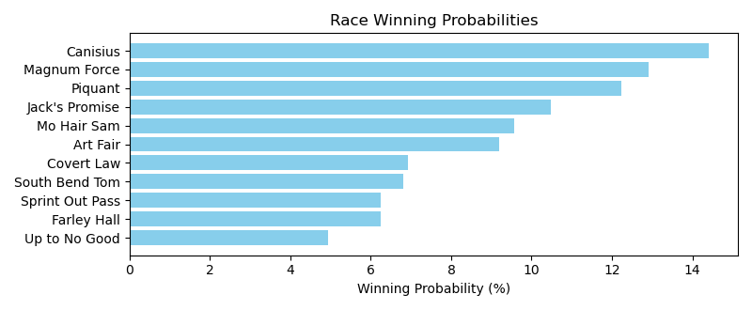

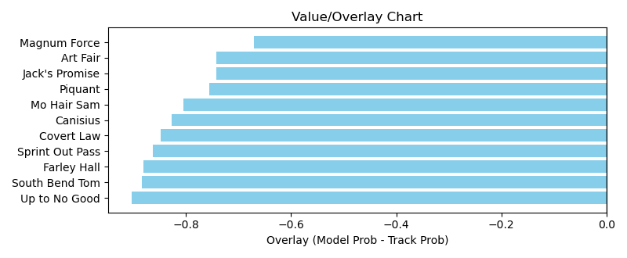

NOTE: GCSF - Global Combined Speed Figure

# Race: KEE | 2025-04-06 | Race #5 | Post: 15:08 | Track: KEENELAND

Track: KEENELAND

|  |  |  |  |  |  |
| --- | --- | --- | --- | --- | --- |
| Program # | Horse Name | Morn Odds | GCSF | Model Score | Win Prob (%) |
| 1 | MIWA (GB) | 8-1 | 100.0 | 0.86 | 5.03 |
| 2 | Just Better | 12-1 | 107.8 | 0.82 | 4.49 |
| 3 | Segesta | 2-1 | 106.6 | 0.98 | 6.50 |
| 4 | Federalism | 20-1 | 106.6 | 0.72 | 3.47 |
| 5 | Serene Seraph (IRE) | 15-1 | 100.0 | 0.92 | 5.66 |
| 6 | Waves of Mischief | 6-1 | 106.4 | 1.29 | 11.49 |
| 7 | Lady Firefoot | 12-1 | 86.5 | 0.77 | 3.95 |
| 8 | Buttercream Babe | 4-1 | 106.7 | 1.02 | 7.09 |
| 9 | Belle of Rights | 12-1 | 102.7 | 0.92 | 5.78 |
| 10 | Chilled | 30-1 | 100.6 | 1.30 | 11.63 |
| 11 | Random Harvest | 15-1 | 100.0 | 1.19 | 9.75 |
| 12 | PARTIR (FR) | 15-1 | 100.0 | 0.80 | 4.35 |
| 13 | Broughty Ferry | 30-1 | 108.0 | 0.71 | 3.39 |
| 14 | Sweet Chablis | 30-1 | 102.5 | 0.80 | 4.32 |
| 15 | Shiloh's Mistress | 20-1 | 101.8 | 1.38 | 13.09 |

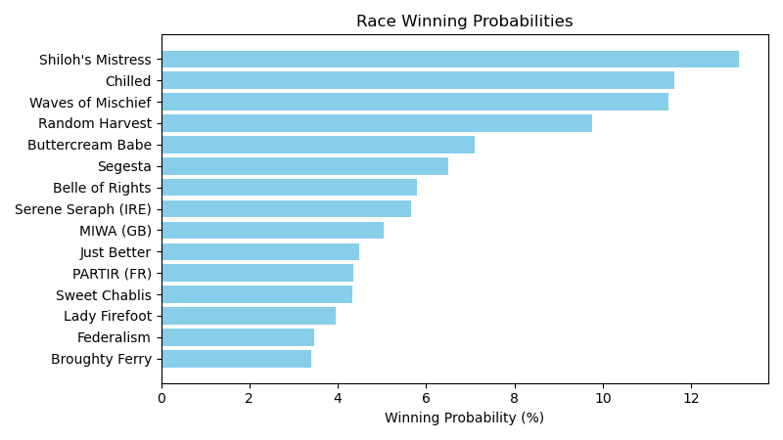

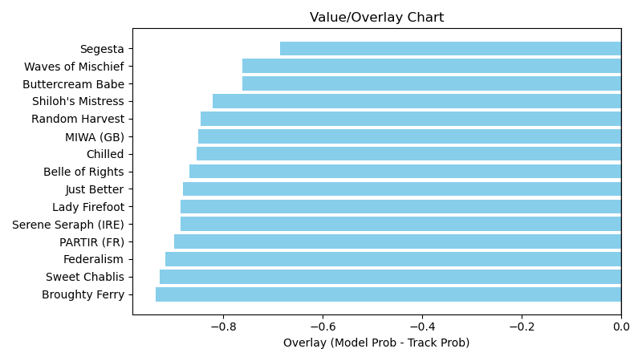

NOTE: GCSF - Global Combined Speed Figure

# Race: KEE | 2025-04-06 | Race #6 | Post: 15:40 | Track: KEENELAND

Track: KEENELAND

|  |  |  |  |  |  |
| --- | --- | --- | --- | --- | --- |
| Program # | Horse Name | Morn Odds | GCSF | Model Score | Win Prob (%) |
| 1 | Paris Lily | 10-1 | 100.0 | 0.81 | 9.39 |
| 2 | Especially | 8-1 | 100.0 | 0.79 | 9.00 |
| 3 | Getting After It | 15-1 | 104.0 | 0.75 | 8.15 |
| 4 | Liam in the Dust | 9-2 | 83.8 | 0.85 | 10.41 |
| 5 | Ruth | 15-1 | 93.4 | 0.64 | 5.81 |
| 6 | Mad About Marie | 20-1 | 93.4 | 0.65 | 5.95 |
| 7 | Indeed | 8-1 | 92.9 | 1.07 | 16.67 |
| 8 | Ultima Grace | 6-1 | 106.6 | 0.63 | 5.55 |
| 9 | Justinqueso | 7-2 | 93.4 | 0.87 | 11.03 |
| 10 | Chasten | 3-1 | 100.0 | 1.11 | 18.03 |

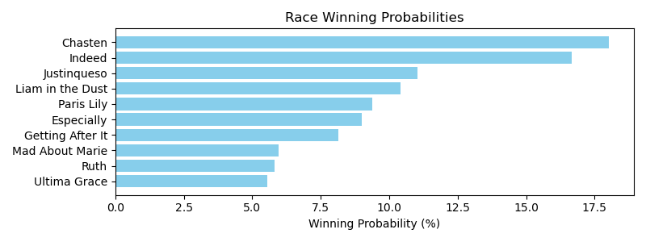

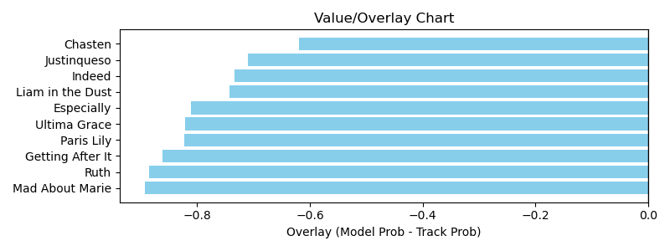

NOTE: GCSF - Global Combined Speed Figure

# Race: KEE | 2025-04-06 | Race #7 | Post: 16:12 | Track: KEENELAND

Track: KEENELAND

|  |  |  |  |  |  |
| --- | --- | --- | --- | --- | --- |
| Program # | Horse Name | Morn Odds | GCSF | Model Score | Win Prob (%) |
| 1 | Heavenly Sunset | 4-1 | 100.0 | 0.76 | 9.96 |
| 2 | Salted | 3-1 | 106.2 | 0.81 | 11.15 |
| 3 | Lolo Le Plume | 15-1 | 96.1 | 0.76 | 9.93 |
| 4 | Tejanita | 20-1 | 100.0 | 0.48 | 3.91 |
| 5 | Plaza Cue | 6-1 | 93.4 | 0.96 | 16.03 |
| 6 | Miss Authentic | 15-1 | 100.0 | 0.59 | 5.97 |
| 7 | Fallon | 30-1 | 93.4 | 0.55 | 5.13 |
| 8 | High Note | 8-1 | 100.0 | 0.60 | 6.04 |
| 9 | In the Stars | 15-1 | 100.0 | 0.56 | 5.21 |
| 10 | LADY SCUDERIA | 6-1 | 100.0 | 0.70 | 8.32 |
| 11 | Ghanaayem | 8-1 | 100.0 | 0.66 | 7.45 |
| 12 | HEARTBEAT | 20-1 | 100.0 | 0.57 | 5.53 |
| 13 | Protective Custody | 15-1 | 100.0 | 0.56 | 5.37 |

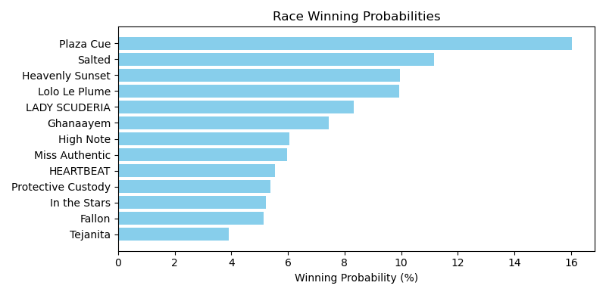

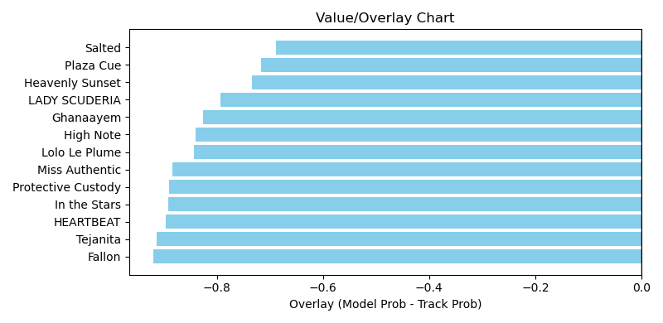

NOTE: GCSF - Global Combined Speed Figure

# Race: KEE | 2025-04-06 | Race #8 | Post: 16:44 | Track: KEENELAND

Track: KEENELAND

|  |  |  |  |  |  |
| --- | --- | --- | --- | --- | --- |
| Program # | Horse Name | Morn Odds | GCSF | Model Score | Win Prob (%) |
| 1 | Long Neck Paula | 10-1 | 93.4 | 0.76 | 5.72 |
| 2 | Out On Bail | 7-2 | 105.8 | 0.91 | 8.44 |
| 3 | Normandy Coast | 20-1 | 93.4 | 0.84 | 7.17 |
| 4 | Makeit to Cheyenne | 4-1 | 106.6 | 1.23 | 15.51 |
| 5 | Dreamaway | 5-1 | 93.4 | 1.17 | 14.02 |
| 6 | Turbulent Force | 6-1 | 106.6 | 1.16 | 13.68 |
| 7 | Brie's in Town | 30-1 | 93.4 | 0.68 | 4.65 |
| 8 | Absolutely Hot | 20-1 | 106.6 | 0.83 | 6.99 |
| 9 | Killjoy | 20-1 | 88.2 | 0.89 | 8.03 |
| 10 | Warheart | 3-1 | 94.5 | 0.82 | 6.68 |
| 11 | Flat to Da Mat | 30-1 | 94.8 | 0.95 | 9.11 |

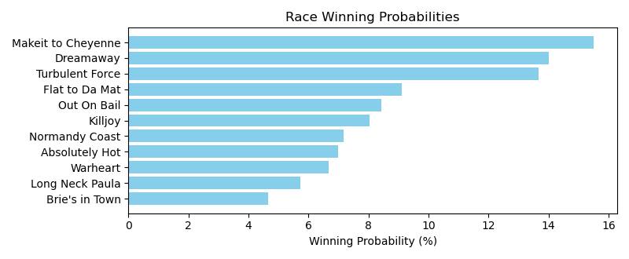

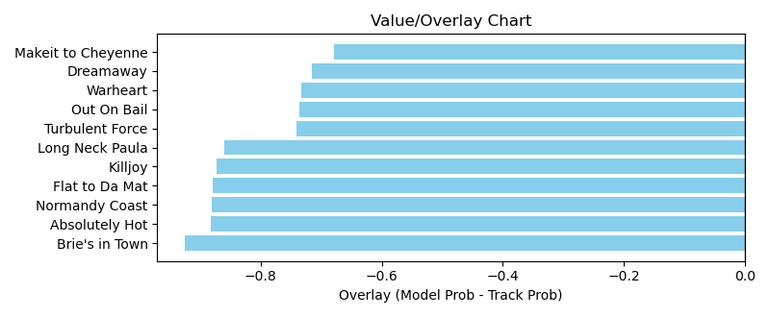

NOTE: GCSF - Global Combined Speed Figure

# Race: KEE | 2025-04-06 | Race #9 | Post: 17:16 | Track: KEENELAND

Track: KEENELAND

|  |  |  |  |  |  |
| --- | --- | --- | --- | --- | --- |
| Program # | Horse Name | Morn Odds | GCSF | Model Score | Win Prob (%) |
| 1 | Eclatant | 13-8 | 93.4 | 1.02 | 12.66 |
| 2 | Volleyballprincess | 20-1 | 93.4 | 0.86 | 9.01 |
| 3 | G W's Girl | 2-1 | 110.6 | 1.51 | 28.46 |
| 4 | Continuity | 12-1 | 100.0 | 0.91 | 10.15 |
| 5 | Stunner | 3-1 | 93.9 | 1.04 | 13.24 |
| 6 | Verity | 9-2 | 106.6 | 1.46 | 26.49 |

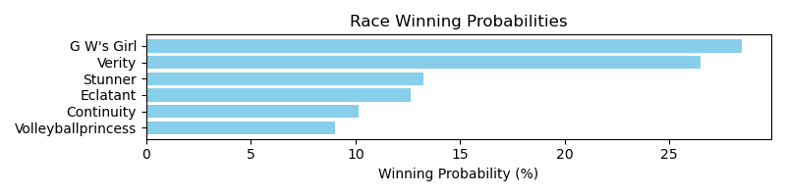

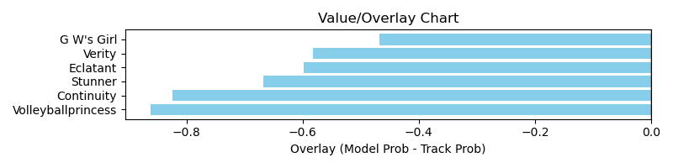

NOTE: GCSF - Global Combined Speed Figure

# Race: KEE | 2025-04-06 | Race #10 | Post: 17:48 | Track: KEENELAND

Track: KEENELAND

|  |  |  |  |  |  |
| --- | --- | --- | --- | --- | --- |
| Program # | Horse Name | Morn Odds | GCSF | Model Score | Win Prob (%) |
| 1 | Warrior Johny | 12-1 | 103.8 | 1.53 | 12.28 |
| 2 | Balnikhov (IRE) | 5-1 | 87.5 | 1.05 | 5.61 |
| 3 | Deterministic | 9-2 | 108.8 | 1.62 | 13.72 |
| 4 | Another Mystery | 20-1 | 99.9 | 0.82 | 3.43 |
| 5 | Accredit | 30-1 | 93.0 | 0.84 | 3.61 |
| 6 | Strong Quality | 7-2 | 110.9 | 1.14 | 6.69 |
| 7 | Taking Candy | 4-1 | 110.3 | 1.21 | 7.52 |
| 8 | Starting Over | 15-1 | 93.7 | 1.44 | 10.83 |
| 9 | Injunction | 12-1 | 117.1 | 1.02 | 5.39 |
| 10 | Money Supply | 20-1 | 111.8 | 0.93 | 4.43 |
| 11 | Swiftsure | 15-1 | 109.8 | 1.35 | 9.47 |
| 12 | Lagynos | 8-1 | 92.4 | 0.99 | 5.07 |
| 13 | Signator | 12-1 | 99.8 | 0.90 | 4.09 |
| 14 | Miranda Rights | 15-1 | 112.5 | 1.23 | 7.86 |

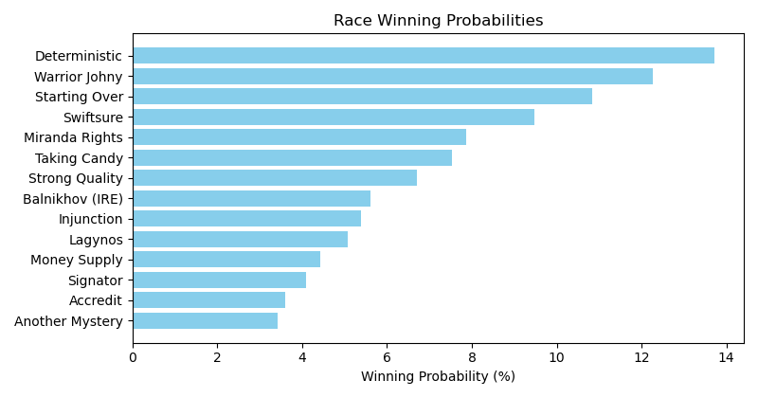

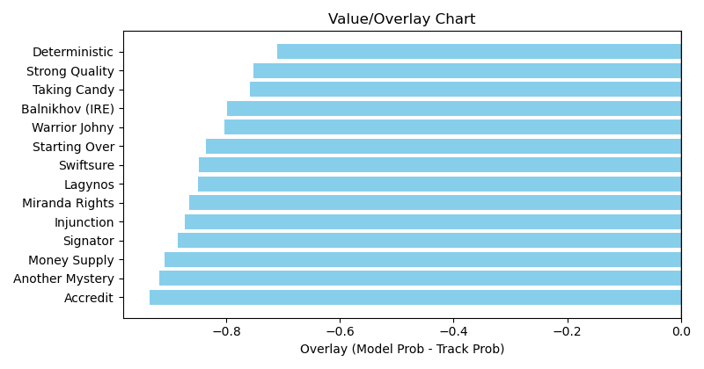

NOTE: GCSF - Global Combined Speed Figure

# Race: KEE | 2025-04-07 | Race #1 | Post: 13:00 | Track: KEENELAND

Track: KEENELAND

|  |  |  |  |  |  |
| --- | --- | --- | --- | --- | --- |
| Program # | Horse Name | Morn Odds | GCSF | Model Score | Win Prob (%) |
| 1 | LILY'S ARMY | 15-1 | 100.0 | 1.16 | 7.37 |
| 2 | EL HALCON | 30-1 | 100.0 | 1.12 | 6.88 |
| 3 | MONSTER | 4-1 | 100.0 | 1.24 | 8.43 |
| 4 | TIEMPOS BUENOS | 30-1 | 100.0 | 1.14 | 7.10 |
| 5 | CHATTERFIELD | 20-1 | 100.0 | 1.23 | 8.33 |
| 6 | HAPPYHAPPYBOY | 12-1 | 100.0 | 1.18 | 7.65 |
| 7 | RED LAD | 15-1 | 100.0 | 1.11 | 6.70 |
| 8 | PINKY FINGER | 7-5 | 100.0 | 1.33 | 9.70 |
| 9 | BARSTOOL | 6-1 | 100.0 | 1.23 | 8.20 |
| 10 | RED SPEEDO | 8-1 | 100.0 | 1.21 | 7.93 |
| 11 | COACH RUDY | 20-1 | 100.0 | 1.10 | 6.53 |
| 12 | FLAMING STAR | 30-1 | 100.0 | 1.08 | 6.33 |
| 13 | DOUBLE TALKER | 7-2 | 100.0 | 1.27 | 8.86 |

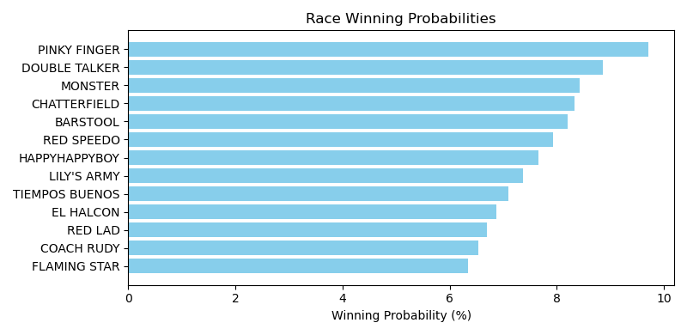

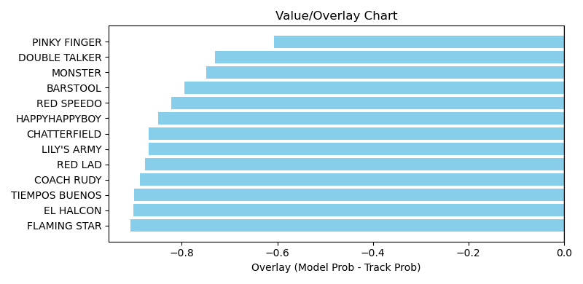

NOTE: GCSF - Global Combined Speed Figure

# Race: KEE | 2025-04-07 | Race #2 | Post: 13:32 | Track: KEENELAND

Track: KEENELAND

|  |  |  |  |  |  |
| --- | --- | --- | --- | --- | --- |
| Program # | Horse Name | Morn Odds | GCSF | Model Score | Win Prob (%) |
| 1 | Mission of Joy | 7-2 | 110.7 | 1.04 | 9.04 |
| 2 | Amber Cascade | 12-1 | 95.6 | 0.90 | 6.79 |
| 3 | Pin Up Betty | 4-1 | 92.4 | 1.08 | 9.79 |
| 4 | Ready for Shirl | 8-1 | 102.0 | 1.37 | 16.01 |
| 5 | Scarlet Poppy (IRE) | 6-1 | 100.4 | 1.61 | 22.36 |
| 6 | Spaliday | 5-2 | 99.2 | 1.16 | 11.42 |
| 7 | Justifiable Belle | 8-1 | 105.9 | 1.25 | 13.18 |
| 8 | Peignoir | 10-1 | 100.8 | 0.88 | 6.48 |
| 9 | Catmint | 30-1 | 99.7 | 0.77 | 4.93 |

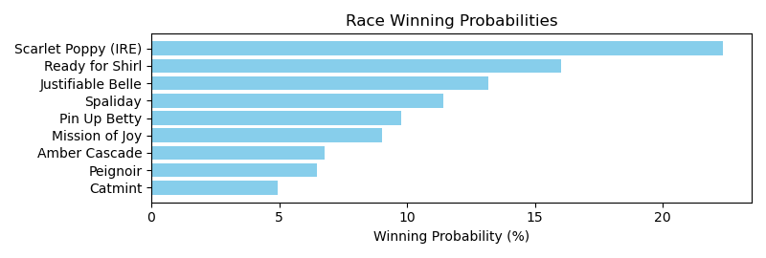

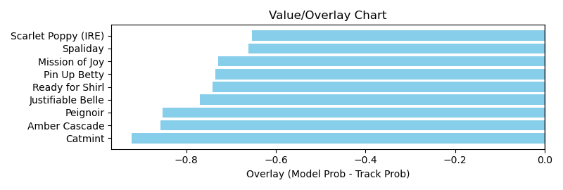

NOTE: GCSF - Global Combined Speed Figure

# Race: KEE | 2025-04-07 | Race #3 | Post: 14:04 | Track: KEENELAND

Track: KEENELAND

|  |  |  |  |  |  |
| --- | --- | --- | --- | --- | --- |
| Program # | Horse Name | Morn Odds | GCSF | Model Score | Win Prob (%) |
| 1 | Evanescence | 15-1 | 100.0 | 0.90 | 10.71 |
| 2 | Velvet Vortex | 5-2 | 93.3 | 0.99 | 12.96 |
| 3 | Shoot It True | 9-5 | 105.4 | 0.98 | 12.74 |
| 4 | Naive Melody | 15-1 | 100.0 | 1.09 | 15.88 |
| 5 | Beauty Reigns | 12-1 | 94.6 | 0.65 | 5.49 |
| 6 | Foie Gras | 8-1 | 100.0 | 1.07 | 15.27 |
| 7 | American Women | 10-1 | 105.4 | 1.00 | 13.20 |
| 8 | Lynn's Milky Way | 7-2 | 94.6 | 1.02 | 13.74 |

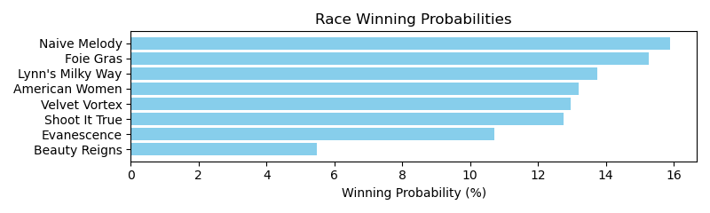

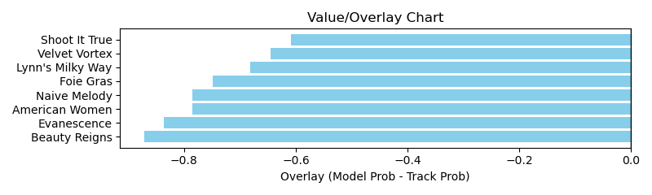

NOTE: GCSF - Global Combined Speed Figure

# Race: KEE | 2025-04-07 | Race #4 | Post: 14:36 | Track: KEENELAND

Track: KEENELAND

|  |  |  |  |  |  |
| --- | --- | --- | --- | --- | --- |
| Program # | Horse Name | Morn Odds | GCSF | Model Score | Win Prob (%) |
| 1 | Straight Forward | 8-1 | 106.6 | 0.80 | 7.04 |
| 2 | Vice | 15-1 | 106.6 | 0.73 | 5.84 |
| 3 | ITZA KITTY | 20-1 | 106.6 | 0.66 | 4.75 |
| 4 | Acceptance Speech | 20-1 | 106.6 | 0.56 | 3.32 |
| 5 | My Gal | 9-2 | 106.6 | 0.84 | 7.79 |
| 6 | Chere Amia | 20-1 | 105.4 | 0.85 | 7.98 |
| 7 | Green Jobs | 6-1 | 106.6 | 0.86 | 8.07 |
| 8 | Lolo Le Plume | 15-1 | 109.6 | 0.71 | 5.48 |
| 9 | Grayleigh | 10-1 | 94.6 | 0.72 | 5.69 |
| 10 | Rather Distinct | 5-1 | 106.6 | 0.81 | 7.16 |
| 11 | Hereforagoodtime | 4-1 | 104.4 | 0.87 | 8.25 |
| 12 | Gum | 8-1 | 106.6 | 0.86 | 8.19 |
| 13 | Hideaway | 7-2 | 106.6 | 0.86 | 8.04 |
| 14 | Eyes On Italy | 30-1 | 106.6 | 0.61 | 3.95 |
| 15 | Isle Be Ready | 15-1 | 106.6 | 0.56 | 3.36 |
| 16 | Athaliah | 6-1 | 106.6 | 0.68 | 5.09 |

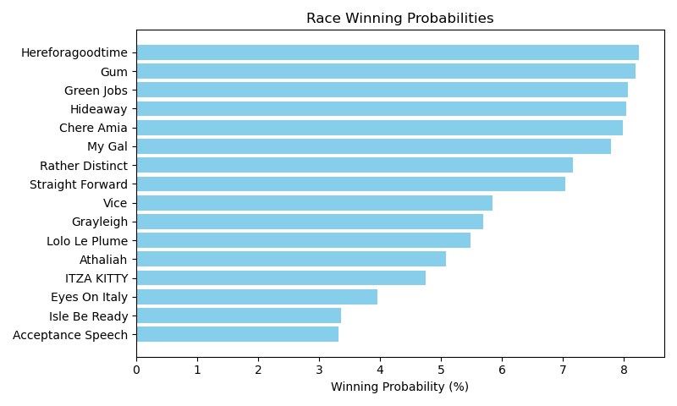

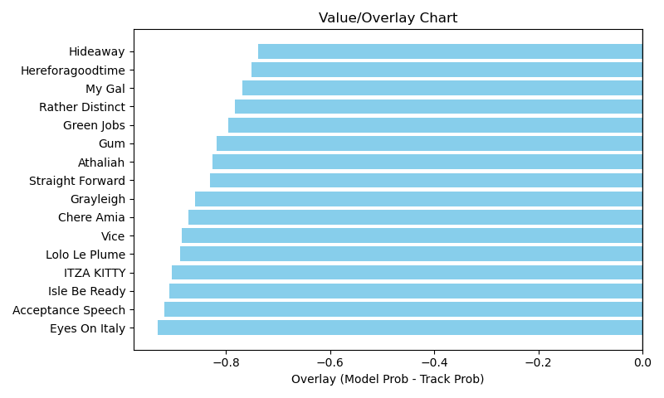

NOTE: GCSF - Global Combined Speed Figure

# Race: KEE | 2025-04-07 | Race #5 | Post: 15:08 | Track: KEENELAND

Track: KEENELAND

|  |  |  |  |  |  |
| --- | --- | --- | --- | --- | --- |
| Program # | Horse Name | Morn Odds | GCSF | Model Score | Win Prob (%) |
| 1 | Debt Free | 4-1 | 100.0 | 1.18 | 7.57 |
| 2 | MAEVE | 12-1 | 100.0 | 1.24 | 8.32 |
| 3 | Ivory and Ebony | 10-1 | 100.0 | 1.10 | 6.49 |
| 4 | La Neige | 15-1 | 100.0 | 0.98 | 5.15 |
| 5 | B D's Angel | 30-1 | 100.0 | 0.90 | 4.37 |
| 6 | MIDNIGHT MYTH | 8-1 | 100.0 | 1.24 | 8.31 |
| 7 | Twisted Viper | 30-1 | 100.0 | 0.92 | 4.56 |
| 8 | FORBIDDEN FRIEND | 20-1 | 100.0 | 1.15 | 7.14 |
| 9 | Kapoor | 7-2 | 100.0 | 1.35 | 9.91 |
| 10 | STARSHIP ATHENA | 12-1 | 100.0 | 1.27 | 8.69 |
| 11 | Unwavering Trust | 5-2 | 100.0 | 1.69 | 15.65 |
| 12 | MOTOWN HONEY | 20-1 | 100.0 | 1.19 | 7.60 |
| 13 | RACHEL'S KID | 30-1 | 100.0 | 1.08 | 6.23 |

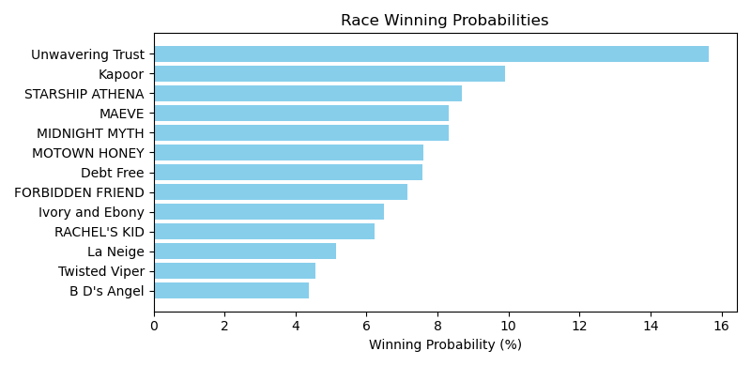

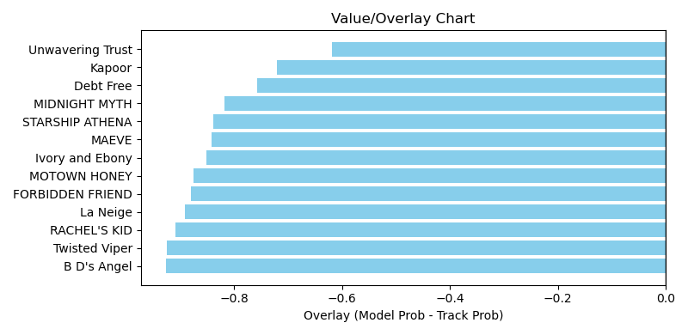

NOTE: GCSF - Global Combined Speed Figure

# Race: KEE | 2025-04-07 | Race #6 | Post: 15:40 | Track: KEENELAND

Track: KEENELAND

|  |  |  |  |  |  |
| --- | --- | --- | --- | --- | --- |
| Program # | Horse Name | Morn Odds | GCSF | Model Score | Win Prob (%) |
| 1 | Ocean Pointe | 30-1 | 95.7 | 0.76 | 4.72 |
| 2 | Georgie W | 8-1 | 102.7 | 1.00 | 8.26 |
| 3 | American Hope | 12-1 | 106.0 | 0.85 | 5.95 |
| 4 | Wico (IRE) | 8-1 | 114.3 | 1.03 | 8.77 |
| 5 | Raptor's (BRZ) | 15-1 | 100.0 | 0.90 | 6.58 |
| 6 | Oscar Season | 6-1 | 105.4 | 1.10 | 10.03 |
| 7 | El Rezeen | 6-1 | 93.3 | 1.36 | 15.49 |
| 8 | This Is Uscar | 20-1 | 111.4 | 0.93 | 7.06 |
| 9 | Evade (FR) | 4-1 | 94.6 | 1.04 | 8.91 |
| 10 | Tough Little Nut | 12-1 | 99.0 | 0.90 | 6.55 |
| 11 | INTELLECT (FR) | 7-2 | 100.0 | 0.90 | 6.57 |
| 12 | Winters Lion | 30-1 | 91.4 | 0.84 | 5.71 |
| 13 | Archie the Giza | 15-1 | 94.6 | 0.81 | 5.39 |

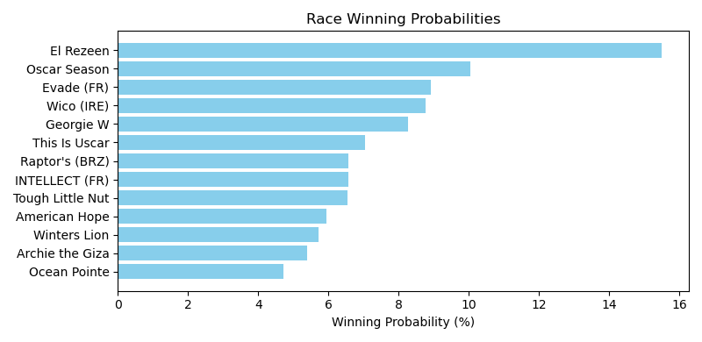

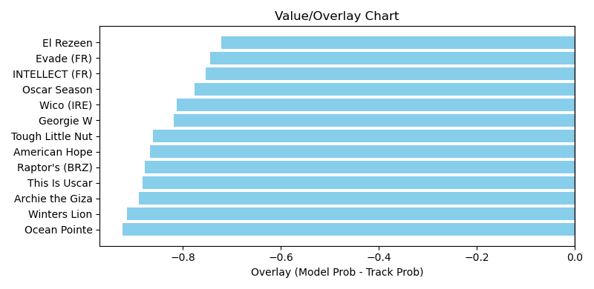

NOTE: GCSF - Global Combined Speed Figure

# Race: KEE | 2025-04-07 | Race #7 | Post: 16:12 | Track: KEENELAND

Track: KEENELAND

|  |  |  |  |  |  |
| --- | --- | --- | --- | --- | --- |
| Program # | Horse Name | Morn Odds | GCSF | Model Score | Win Prob (%) |
| 1 | Gunmetal | 3-1 | 108.0 | 0.85 | 7.07 |
| 2 | Colloquial | 6-5 | 100.0 | 1.16 | 13.56 |
| 3 | Smoken Wicked | 10-1 | 89.9 | 1.21 | 14.74 |
| 4 | Touchy | 8-1 | 105.4 | 0.97 | 9.36 |
| 5 | Gate to Wire | 9-2 | 93.6 | 1.43 | 20.54 |
| 6 | Itsmybirthday | 30-1 | 100.0 | 0.70 | 4.75 |
| 7 | One True Shance | 20-1 | 100.0 | 0.92 | 8.48 |
| 8 | Rolando | 8-1 | 104.6 | 1.46 | 21.49 |

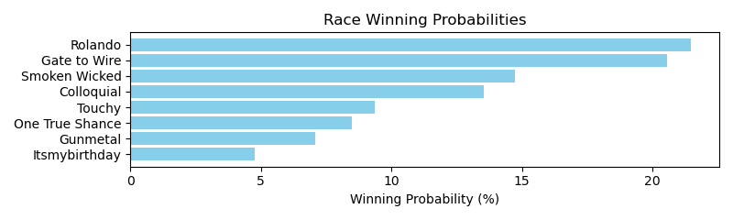

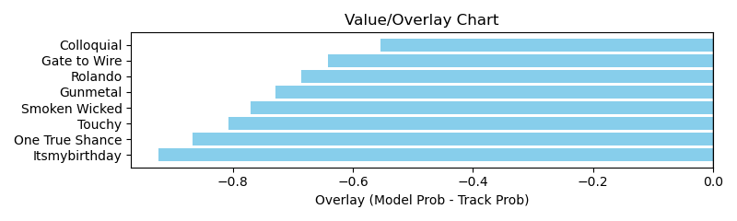

NOTE: GCSF - Global Combined Speed Figure

# Race: KEE | 2025-04-07 | Race #8 | Post: 16:44 | Track: KEENELAND

Track: KEENELAND

|  |  |  |  |  |  |
| --- | --- | --- | --- | --- | --- |
| Program # | Horse Name | Morn Odds | GCSF | Model Score | Win Prob (%) |
| 1 | Chasing Liberty | 15-1 | 98.2 | 1.27 | 8.70 |
| 2 | Reagan's Wit | 4-1 | 94.6 | 0.99 | 5.26 |
| 3 | Golden Afternoon | 15-1 | 100.0 | 1.19 | 7.61 |
| 4 | Maui Strong | 8-1 | 94.6 | 0.97 | 4.97 |
| 5 | Sabertooth | 30-1 | 107.8 | 0.88 | 4.09 |
| 6 | Versus | 10-1 | 97.3 | 0.97 | 5.00 |
| 7 | Test Score | 8-1 | 94.6 | 0.96 | 4.86 |
| 8 | Scipio | 6-1 | 107.3 | 1.43 | 11.09 |
| 9 | Tom's Magic | 12-1 | 100.0 | 0.93 | 4.55 |
| 10 | Clock Tower | 10-1 | 96.7 | 1.14 | 7.02 |
| 11 | Mi Bago | 3-1 | 94.6 | 1.44 | 11.19 |
| 12 | Hammerhead | 20-1 | 96.2 | 0.90 | 4.28 |
| 13 | Barricade | 8-1 | 94.6 | 0.93 | 4.63 |
| 14 | Septarian | 6-1 | 105.4 | 1.18 | 7.54 |
| 15 | Pretty Capable | 8-1 | 100.0 | 0.84 | 3.70 |
| 16 | Valentinian | 4-1 | 100.0 | 1.02 | 5.51 |

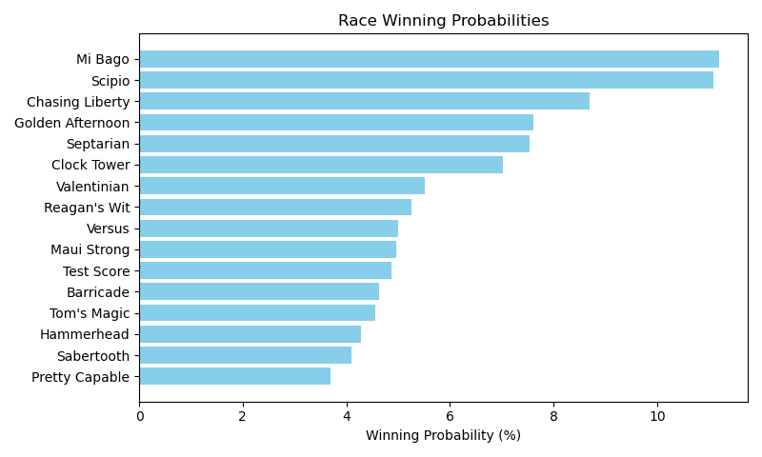

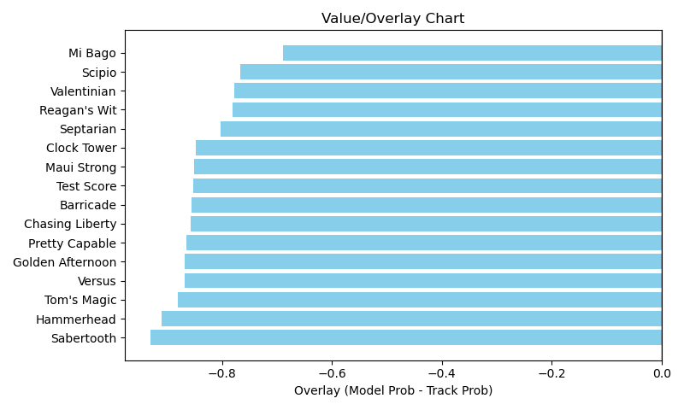

NOTE: GCSF - Global Combined Speed Figure

# Race: KEE | 2025-04-07 | Race #9 | Post: 17:16 | Track: KEENELAND

Track: KEENELAND

|  |  |  |  |  |  |
| --- | --- | --- | --- | --- | --- |
| Program # | Horse Name | Morn Odds | GCSF | Model Score | Win Prob (%) |
| 1 | Look Forward | 20-1 | 108.7 | 1.20 | 10.47 |
| 2 | La Cara | 9-2 | 109.8 | 1.38 | 13.81 |
| 3 | Supa Speed | 4-1 | 109.9 | 1.59 | 18.50 |
| 4 | Muhimma | 9-5 | 97.7 | 1.37 | 13.58 |
| 5 | Running Away | 3-1 | 105.4 | 1.47 | 15.80 |
| 6 | Take Charge Milady | 8-1 | 98.3 | 1.17 | 9.86 |
| 7 | Amarth | 20-1 | 94.5 | 1.32 | 12.63 |
| 8 | Admit | 15-1 | 110.1 | 0.87 | 5.35 |

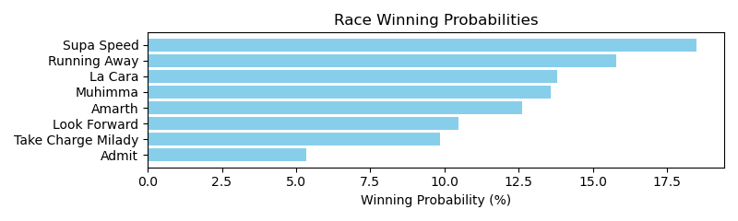

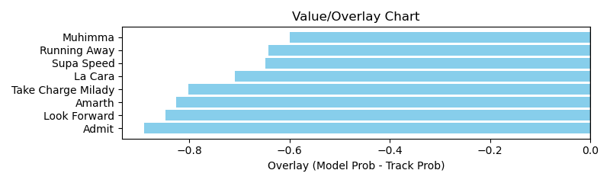

NOTE: GCSF - Global Combined Speed Figure

# Race: KEE | 2025-04-07 | Race #10 | Post: 17:48 | Track: KEENELAND

Track: KEENELAND

|  |  |  |  |  |  |
| --- | --- | --- | --- | --- | --- |
| Program # | Horse Name | Morn Odds | GCSF | Model Score | Win Prob (%) |
| 1 | Itwillbefun | 12-1 | 106.0 | 0.91 | 7.53 |
| 2 | Mom's Cheesecake | 30-1 | 96.9 | 0.61 | 3.34 |
| 3 | Moochie Girl | 15-1 | 100.3 | 0.91 | 7.66 |
| 4 | Rando | 20-1 | 103.6 | 0.65 | 3.79 |
| 5 | Mizmalice | 15-1 | 89.8 | 0.58 | 3.01 |
| 6 | Bread to Run | 9-2 | 92.1 | 1.31 | 16.06 |
| 7 | Carolina Smokeshow | 6-1 | 94.6 | 0.77 | 5.45 |
| 8 | Bindi | 5-1 | 100.0 | 0.87 | 6.86 |
| 9 | Royal Princess | 10-1 | 100.0 | 0.64 | 3.65 |
| 10 | Mezcalifornia | 15-1 | 110.2 | 0.93 | 7.88 |
| 11 | Golden Irish | 7-2 | 100.0 | 0.78 | 5.55 |
| 12 | Sister Carlie | 8-1 | 100.0 | 0.78 | 5.55 |
| 13 | Zaghruta | 5-1 | 100.0 | 0.69 | 4.32 |
| 14 | Autumn Rhythm | 6-1 | 105.4 | 0.68 | 4.17 |
| 15 | Madeline's Promise | 8-1 | 103.7 | 0.95 | 8.34 |
| 16 | Sherbini | 2-1 | 95.6 | 0.86 | 6.82 |

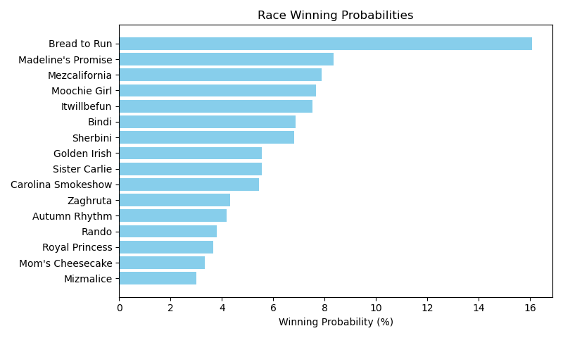

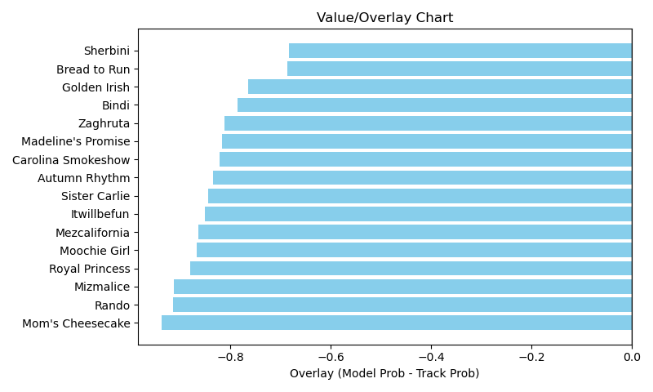

NOTE: GCSF - Global Combined Speed Figure

# Race: KEE | 2025-04-08 | Race #1 | Post: 13:00 | Track: KEENELAND

Track: KEENELAND

|  |  |  |  |  |  |
| --- | --- | --- | --- | --- | --- |
| Program # | Horse Name | Morn Odds | GCSF | Model Score | Win Prob (%) |
| 1 | Ship Ship Hooray | 20-1 | 94.6 | 0.68 | 7.56 |
| 2 | Camp Hale | 6-5 | 105.4 | 1.00 | 16.77 |
| 3 | Playa Del Mar | 4-1 | 100.0 | 0.80 | 10.66 |
| 4 | Call Shadd | 15-1 | 100.0 | 0.89 | 13.21 |
| 5 | Sock It to Me | 30-1 | 100.0 | 0.61 | 6.14 |
| 6 | Sergeant Capps | 20-1 | 100.8 | 0.69 | 7.86 |
| 7 | STEEZE | 12-1 | 100.0 | 0.78 | 10.21 |
| 8 | Invictus | 6-1 | 100.0 | 0.65 | 7.05 |
| 9 | MO WORK | 12-1 | 100.0 | 0.77 | 9.74 |
| 10 | Shepherd | 6-1 | 105.5 | 0.81 | 10.80 |

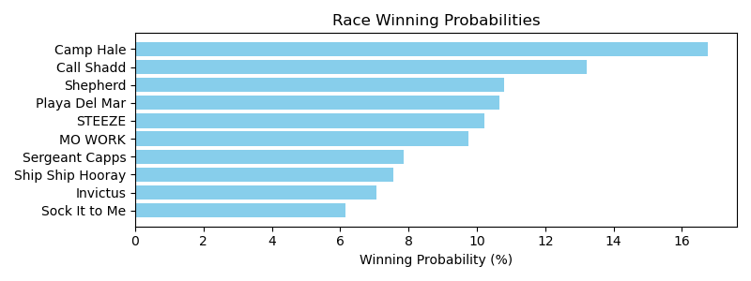

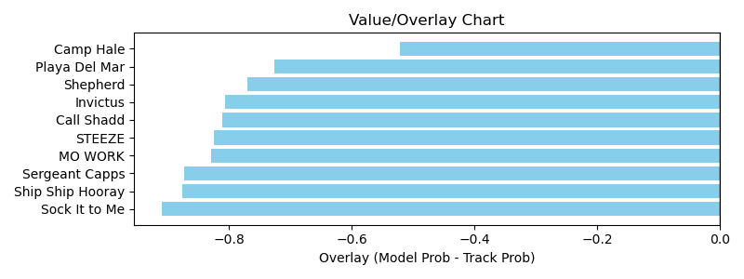

NOTE: GCSF - Global Combined Speed Figure

# Race: KEE | 2025-04-08 | Race #2 | Post: 13:32 | Track: KEENELAND

Track: KEENELAND

|  |  |  |  |  |  |
| --- | --- | --- | --- | --- | --- |
| Program # | Horse Name | Morn Odds | GCSF | Model Score | Win Prob (%) |
| 1 | Tomasello | 7-2 | 94.0 | 0.98 | 13.11 |
| 2 | Meritorious | 10-1 | 93.4 | 0.62 | 5.16 |
| 3 | Kicking Clear | 15-1 | 92.0 | 0.62 | 5.04 |
| 4 | Special Session | 12-1 | 91.1 | 0.95 | 12.24 |
| 5 | Courageous Clay | 10-1 | 90.3 | 0.82 | 8.94 |
| 6 | No Mo Moolah | 12-1 | 93.4 | 0.62 | 5.13 |
| 7 | Van Ginkel | 8-1 | 93.4 | 0.68 | 6.21 |
| 8 | Trigger Point | 30-1 | 100.0 | 0.55 | 3.92 |
| 9 | Fateful Lightning | 3-1 | 93.4 | 0.97 | 12.72 |
| 10 | Kick It In | 50-1 | 100.0 | 0.51 | 3.35 |
| 11 | Bermuda Triangle | 15-1 | 100.0 | 0.82 | 9.06 |
| 12 | Excite | 9-2 | 100.0 | 1.06 | 15.12 |

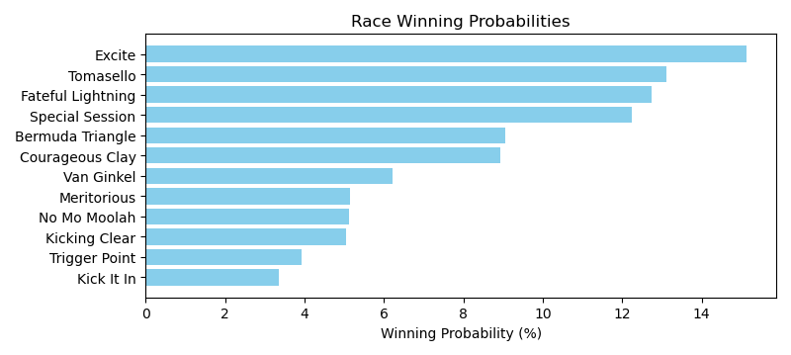

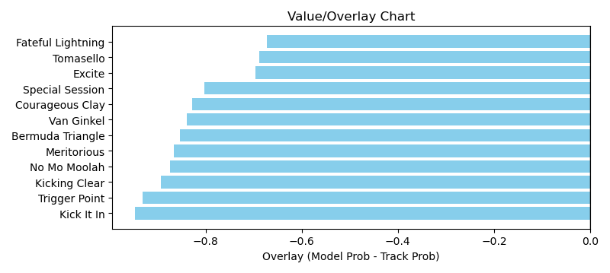

NOTE: GCSF - Global Combined Speed Figure

# Race: KEE | 2025-04-08 | Race #3 | Post: 14:04 | Track: KEENELAND

Track: KEENELAND

|  |  |  |  |  |  |
| --- | --- | --- | --- | --- | --- |
| Program # | Horse Name | Morn Odds | GCSF | Model Score | Win Prob (%) |
| 1 | Thrilla | 15-1 | 108.0 | 0.71 | 6.35 |
| 2 | Retribution | 4-1 | 100.0 | 0.97 | 12.03 |
| 3 | Brodeur | 6-1 | 95.1 | 1.52 | 30.25 |
| 4 | Fully Volatile | 30-1 | 100.0 | 0.72 | 6.54 |
| 5 | Got'm Cot'm | 20-1 | 97.7 | 0.79 | 7.84 |
| 6 | El Dandi | 30-1 | 109.8 | 0.65 | 5.35 |
| 7 | Tip Top Thomas | 2-1 | 100.0 | 1.08 | 14.93 |
| 8 | Dr Ruben M | 20-1 | 95.9 | 0.66 | 5.45 |
| 9 | Gunmetal | 13-8 | 92.0 | 0.94 | 11.25 |

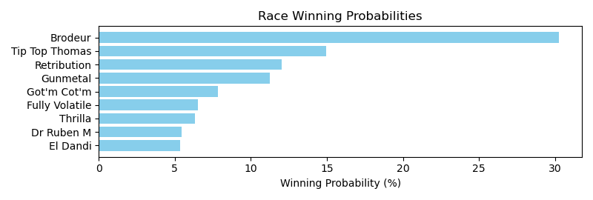

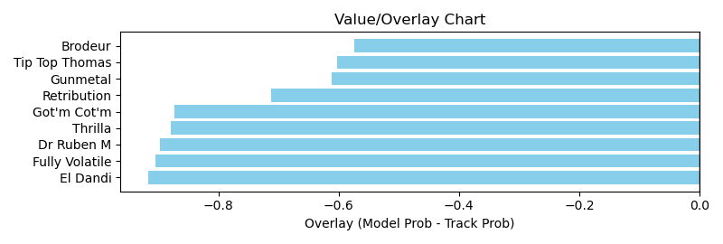

NOTE: GCSF - Global Combined Speed Figure

# Race: KEE | 2025-04-08 | Race #4 | Post: 14:36 | Track: KEENELAND

Track: KEENELAND

|  |  |  |  |  |  |
| --- | --- | --- | --- | --- | --- |
| Program # | Horse Name | Morn Odds | GCSF | Model Score | Win Prob (%) |
| 1 | Irish Aces | 3-1 | 99.6 | 1.13 | 7.26 |
| 2 | West Hollywood | 9-2 | 105.4 | 1.16 | 7.63 |
| 3 | Out of Deductions | 12-1 | 99.1 | 1.39 | 11.05 |
| 4 | Noted | 15-1 | 104.1 | 0.80 | 3.55 |
| 5 | Timeout | 8-1 | 106.4 | 1.49 | 12.86 |
| 6 | Tall Boy | 20-1 | 89.8 | 0.88 | 4.38 |
| 7 | Piper's Factor | 20-1 | 111.3 | 1.27 | 9.27 |
| 8 | Eldest Son | 15-1 | 99.9 | 1.40 | 11.22 |
| 9 | Lincoln Highway | 30-1 | 90.4 | 0.78 | 3.39 |
| 10 | Wonderful Justice (GB) | 30-1 | 98.9 | 0.83 | 3.89 |
| 11 | Smokey Mandate | 20-1 | 100.2 | 0.89 | 4.42 |
| 12 | Northern Invader | 2-1 | 106.8 | 1.12 | 7.12 |
| 13 | Hurry Hurry | 8-1 | 95.9 | 0.95 | 5.10 |
| 14 | Yamato | 15-1 | 97.5 | 0.89 | 4.42 |
| 15 | Degree of Risk | 12-1 | 100.4 | 0.89 | 4.43 |

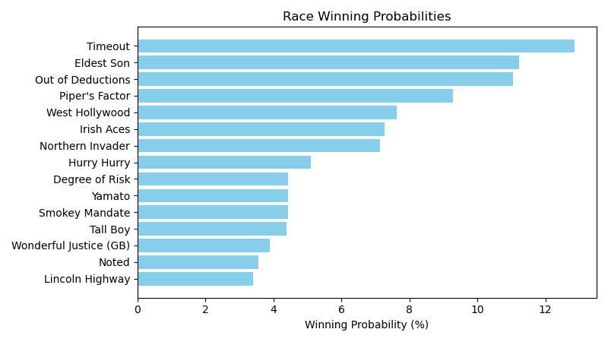

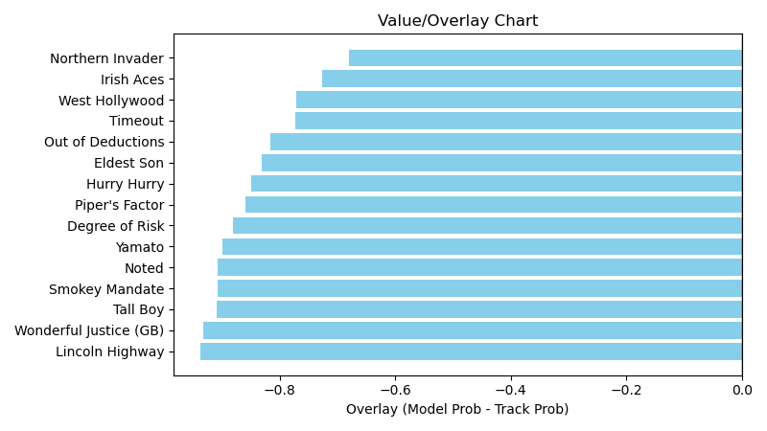

NOTE: GCSF - Global Combined Speed Figure

# Race: KEE | 2025-04-08 | Race #5 | Post: 15:08 | Track: KEENELAND

Track: KEENELAND

|  |  |  |  |  |  |
| --- | --- | --- | --- | --- | --- |
| Program # | Horse Name | Morn Odds | GCSF | Model Score | Win Prob (%) |
| 1 | Midnight Vengeance | 30-1 | 105.4 | 0.67 | 6.95 |
| 2 | Shangrala Road | 7-2 | 100.0 | 0.74 | 8.39 |
| 3 | Activity | 20-1 | 100.0 | 0.61 | 5.75 |
| 4 | Pitkin | 5-2 | 100.0 | 1.12 | 19.76 |
| 5 | Chillax | 20-1 | 100.0 | 0.59 | 5.44 |
| 6 | Fete | 20-1 | 100.0 | 0.59 | 5.44 |
| 7 | Last Man Standing | 9-2 | 100.0 | 0.84 | 11.14 |
| 8 | Abbi Fede | 30-1 | 100.0 | 0.54 | 4.55 |
| 9 | Keen Talent | 8-1 | 100.0 | 0.72 | 7.98 |
| 10 | Development Fee | 15-1 | 100.0 | 0.72 | 8.05 |
| 11 | Fountain Lake | 20-1 | 92.0 | 0.70 | 7.55 |
| 12 | Interceptor | 5-1 | 100.0 | 0.76 | 9.01 |

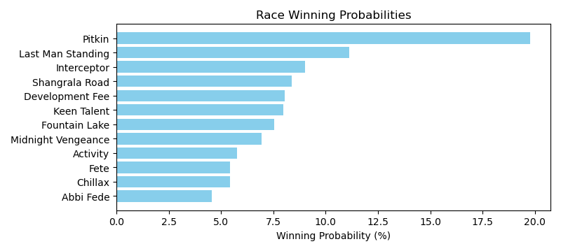

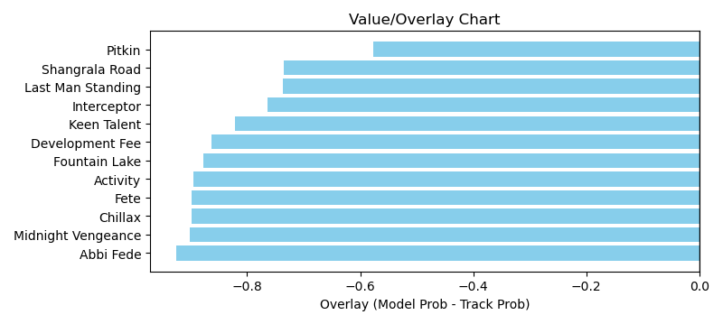

NOTE: GCSF - Global Combined Speed Figure

# Race: KEE | 2025-04-08 | Race #6 | Post: 15:40 | Track: KEENELAND

Track: KEENELAND

|  |  |  |  |  |  |
| --- | --- | --- | --- | --- | --- |
| Program # | Horse Name | Morn Odds | GCSF | Model Score | Win Prob (%) |
| 1 | Nitrogen | 2-1 | 105.2 | 1.25 | 12.76 |
| 2 | Vixen | 3-1 | 107.5 | 1.70 | 23.89 |
| 3 | Fionn | 8-1 | 106.6 | 1.05 | 8.99 |
| 4 | Fast Market | 30-1 | 97.4 | 0.78 | 4.93 |
| 5 | Good Temper | 20-1 | 106.6 | 0.77 | 4.71 |
| 6 | Totally Justified | 6-1 | 108.0 | 1.29 | 13.67 |
| 7 | Liam in the Dust | 15-1 | 98.8 | 0.73 | 4.30 |
| 8 | Lush Lips (GB) | 5-1 | 105.3 | 1.32 | 14.20 |
| 9 | dh-Foxtastic | 12-1 | 96.0 | 0.92 | 6.86 |
| 10 | Table Flirt | 20-1 | 103.3 | 0.84 | 5.69 |

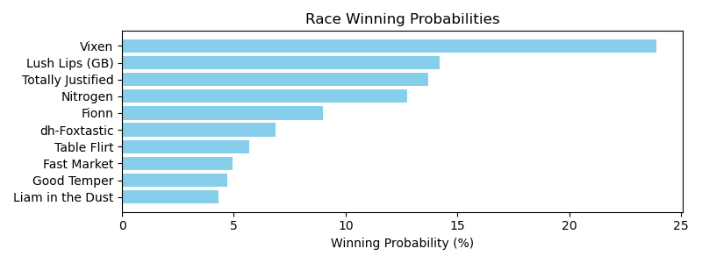

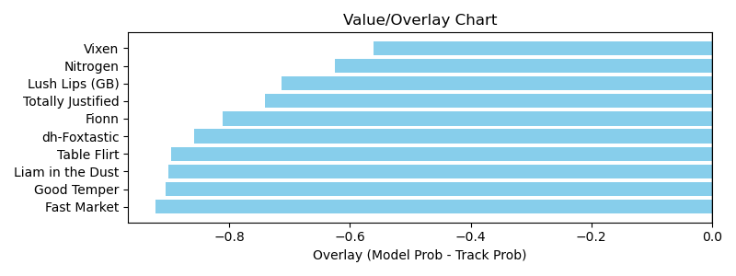

NOTE: GCSF - Global Combined Speed Figure

# Race: KEE | 2025-04-08 | Race #7 | Post: 16:14 | Track: KEENELAND

Track: KEENELAND

|  |  |  |  |  |  |
| --- | --- | --- | --- | --- | --- |
| Program # | Horse Name | Morn Odds | GCSF | Model Score | Win Prob (%) |
| 1 | Best Actor | 15-1 | 93.9 | 1.21 | 9.63 |
| 2 | Montalcino | 3-1 | 100.0 | 1.24 | 10.18 |
| 3 | Epic Ride | 6-1 | 109.9 | 1.48 | 14.55 |
| 4 | Caramel Chip | 30-1 | 113.5 | 0.91 | 5.47 |
| 5 | Nutella Fella | 12-1 | 106.0 | 1.00 | 6.50 |
| 6 | Hoist the Gold | 9-2 | 93.5 | 0.98 | 6.34 |
| 7 | Prince of Power | 20-1 | 89.4 | 1.07 | 7.60 |
| 8 | Here Mi Song | 8-1 | 107.3 | 1.45 | 13.98 |
| 9 | Surly Furious | 30-1 | 101.1 | 0.83 | 4.45 |
| 10 | Extra Anejo | 8-1 | 94.2 | 1.05 | 7.23 |
| 11 | Whatchatalkinabout | 4-1 | 107.9 | 1.05 | 7.24 |
| 12 | Ashcroft | 30-1 | 95.5 | 1.02 | 6.83 |

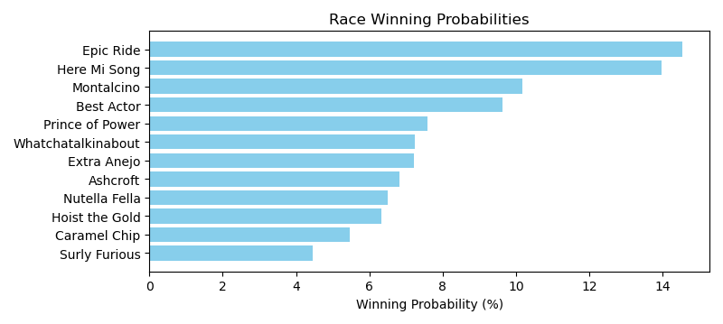

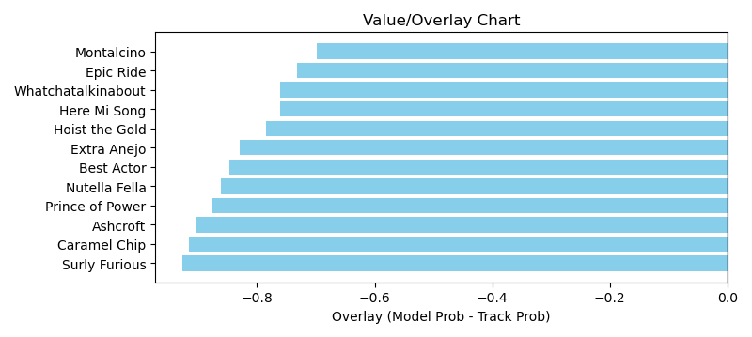

NOTE: GCSF - Global Combined Speed Figure

# Race: KEE | 2025-04-08 | Race #8 | Post: 16:48 | Track: KEENELAND

Track: KEENELAND

|  |  |  |  |  |  |
| --- | --- | --- | --- | --- | --- |
| Program # | Horse Name | Morn Odds | GCSF | Model Score | Win Prob (%) |
| 1 | Positano Sunset | 20-1 | 94.2 | 0.76 | 5.97 |
| 2 | Emery | 3-1 | 102.1 | 1.39 | 20.26 |
| 3 | Harbor Springs | 30-1 | 103.1 | 0.79 | 6.35 |
| 4 | My Mane Squeeze | 8-1 | 92.1 | 0.97 | 9.65 |
| 5 | Dazzling Move | 20-1 | 93.5 | 0.84 | 7.22 |
| 6 | Scylla | 13-8 | 108.7 | 1.19 | 14.78 |
| 7 | Justique | 9-2 | 95.9 | 0.98 | 9.95 |
| 8 | Mystic Lake | 7-2 | 112.0 | 1.56 | 25.82 |

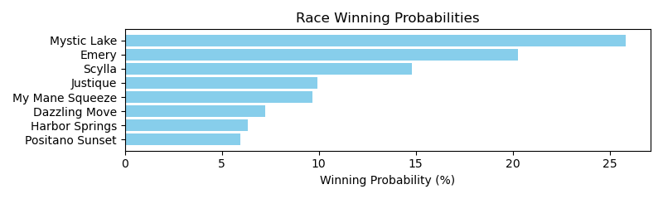

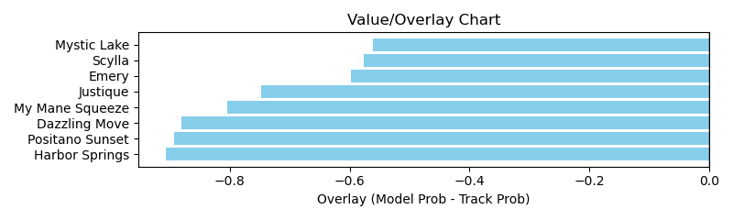

NOTE: GCSF - Global Combined Speed Figure

# Race: KEE | 2025-04-08 | Race #9 | Post: 17:20 | Track: KEENELAND

Track: KEENELAND

|  |  |  |  |  |  |
| --- | --- | --- | --- | --- | --- |
| Program # | Horse Name | Morn Odds | GCSF | Model Score | Win Prob (%) |
| 1 | Run Carson | 6-1 | 98.6 | 1.84 | 21.67 |
| 2 | Our Shot | 7-2 | 99.6 | 1.61 | 16.52 |
| 3 | Arzak | 4-1 | 116.1 | 1.07 | 7.10 |
| 4 | ROGUE LIGHTNING (IRE) | 5-1 | 100.0 | 0.94 | 5.45 |
| 5 | Valentine Candy | 6-1 | 87.6 | 1.10 | 7.51 |
| 6 | No Nay Hudson (IRE) | 12-1 | 108.5 | 0.97 | 5.86 |
| 7 | Eamonn | 20-1 | 102.5 | 0.90 | 5.00 |
| 8 | Petcoff | 20-1 | 96.9 | 0.86 | 4.63 |
| 9 | Mischievous Rogue | 30-1 | 91.1 | 0.92 | 5.28 |
| 10 | Coppola | 6-1 | 114.6 | 1.37 | 11.90 |
| 11 | Think Big | 15-1 | 94.6 | 1.20 | 9.07 |

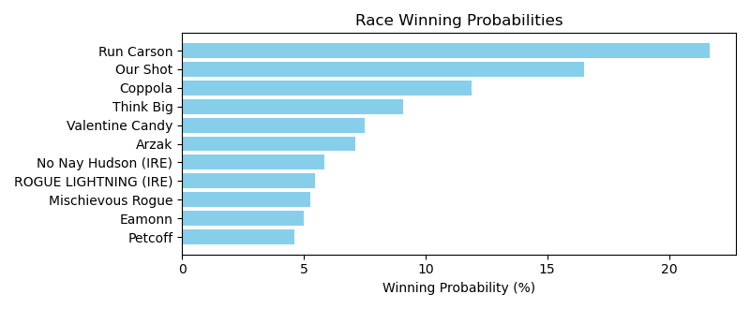

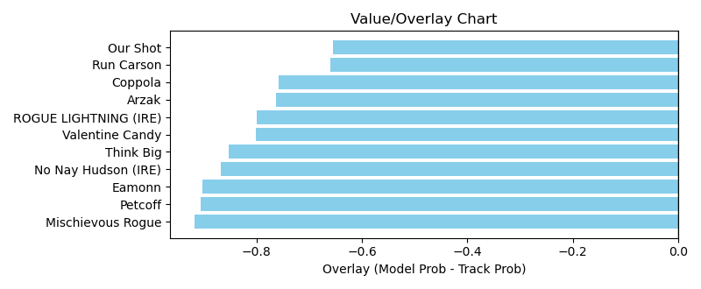

NOTE: GCSF - Global Combined Speed Figure

# Race: KEE | 2025-04-08 | Race #10 | Post: 17:52 | Track: KEENELAND

Track: KEENELAND

|  |  |  |  |  |  |
| --- | --- | --- | --- | --- | --- |
| Program # | Horse Name | Morn Odds | GCSF | Model Score | Win Prob (%) |
| 1 | River Thames | 5-2 | 105.4 | 1.52 | 24.75 |
| 2 | Render Judgment | 20-1 | 96.1 | 0.74 | 5.63 |
| 3 | Burnham Square | 9-2 | 106.7 | 1.33 | 18.62 |
| 4 | Owen Almighty | 3-1 | 96.8 | 1.04 | 11.38 |
| 5 | dh-East Avenue | 3-1 | 105.4 | 1.40 | 20.80 |
| 6 | Chancer McPatrick | 7-2 | 94.3 | 0.86 | 7.73 |
| 7 | Admiral Dennis | 20-1 | 105.4 | 1.03 | 11.09 |

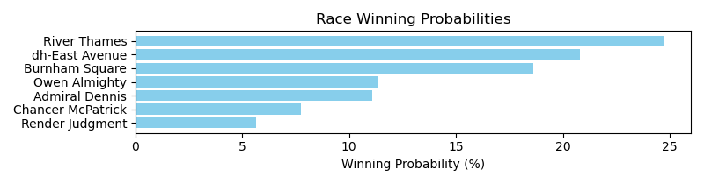

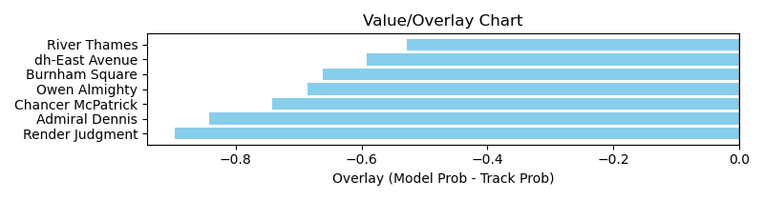

NOTE: GCSF - Global Combined Speed Figure

# Race: KEE | 2025-04-08 | Race #11 | Post: 18:26 | Track: KEENELAND

Track: KEENELAND

|  |  |  |  |  |  |
| --- | --- | --- | --- | --- | --- |
| Program # | Horse Name | Morn Odds | GCSF | Model Score | Win Prob (%) |
| 1 | Seaport Lane | 2-1 | 93.4 | 1.00 | 7.86 |
| 2 | Risk It | 6-1 | 112.7 | 0.92 | 6.58 |
| 3 | Pentathlon | 10-1 | 90.8 | 1.40 | 15.73 |
| 4 | Lou's Legacy | 15-1 | 91.7 | 0.81 | 5.11 |
| 5 | Run Jalen Run | 12-1 | 111.4 | 0.88 | 6.08 |
| 6 | Reynolds Channel | 4-1 | 95.7 | 1.10 | 9.46 |
| 7 | Wyoming Bill | 20-1 | 93.1 | 1.10 | 9.46 |
| 8 | Map to the Stars | 5-1 | 105.4 | 0.95 | 7.13 |
| 9 | Big Hammer | 50-1 | 106.7 | 0.71 | 3.94 |
| 10 | Accident | 30-1 | 104.5 | 0.76 | 4.47 |
| 11 | It's My Life | 15-1 | 99.0 | 0.71 | 3.90 |
| 12 | Theismann | 20-1 | 106.9 | 1.16 | 10.60 |
| 13 | Great Richie M | 20-1 | 110.6 | 0.85 | 5.58 |
| 14 | Standard of Proof | 20-1 | 91.3 | 0.73 | 4.09 |

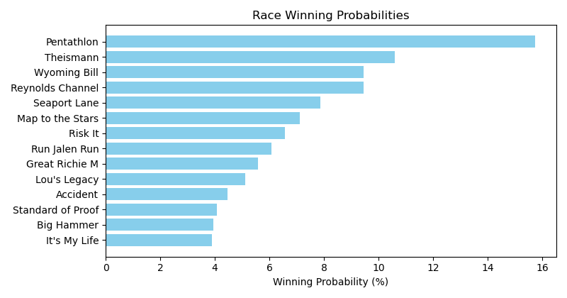

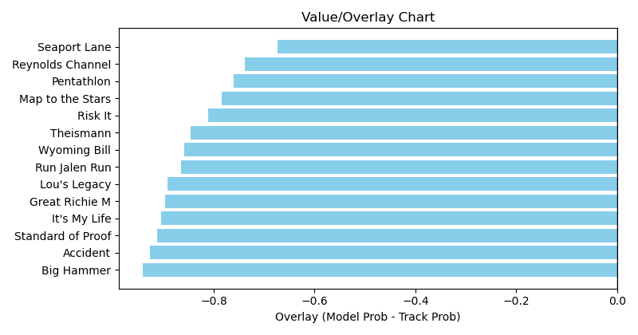

NOTE: GCSF - Global Combined Speed Figure

# Race: MVR | 2025-04-05 | Race #1 | Post: 12:15 | Track: MAHONING VALLEY RACE COURSE

Track: MAHONING VALLEY RACE COURSE

|  |  |  |  |  |  |
| --- | --- | --- | --- | --- | --- |
| Program # | Horse Name | Morn Odds | GCSF | Model Score | Win Prob (%) |
| 1 | National Story | 13-8 | 100.0 | 0.85 | 16.63 |
| 2 | My Hombre | 6-1 | 100.0 | 0.78 | 13.85 |
| 3 | Global Hysteria | 3-1 | 100.0 | 0.89 | 18.27 |
| 4 | Playfulasitgets | 5-1 | 100.0 | 1.20 | 33.68 |
| 5 | Mor Crafty | 5-2 | 100.0 | 0.87 | 17.56 |

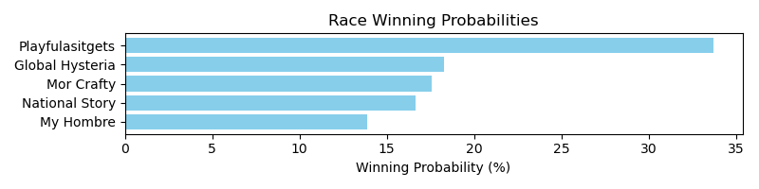

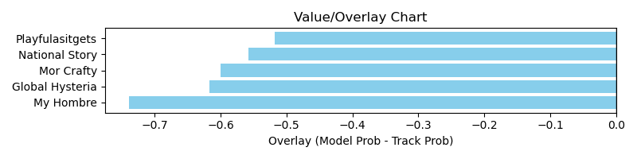

NOTE: GCSF - Global Combined Speed Figure

# Race: MVR | 2025-04-05 | Race #2 | Post: 12:43 | Track: MAHONING VALLEY RACE COURSE

Track: MAHONING VALLEY RACE COURSE

|  |  |  |  |  |  |
| --- | --- | --- | --- | --- | --- |
| Program # | Horse Name | Morn Odds | GCSF | Model Score | Win Prob (%) |
| 1 | Hip Hip Hooray | 5-1 | 115.6 | 0.89 | 14.80 |
| 2 | Thoughtthatcounts | 5-2 | 94.3 | 0.95 | 17.01 |
| 3 | Eddie M | 2-1 | 97.7 | 0.84 | 13.27 |
| 4 | P H Factor | 4-1 | 90.3 | 1.42 | 38.52 |
| 5 | Wildcat Express | 3-1 | 100.0 | 0.94 | 16.41 |

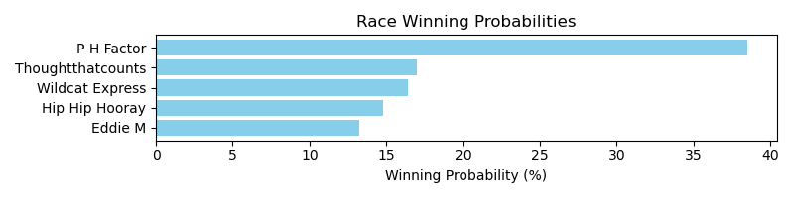

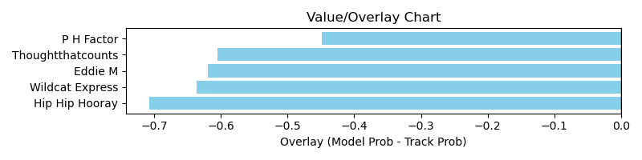

NOTE: GCSF - Global Combined Speed Figure

# Race: MVR | 2025-04-05 | Race #3 | Post: 13:11 | Track: MAHONING VALLEY RACE COURSE

Track: MAHONING VALLEY RACE COURSE

|  |  |  |  |  |  |
| --- | --- | --- | --- | --- | --- |
| Program # | Horse Name | Morn Odds | GCSF | Model Score | Win Prob (%) |
| 1 | The Devil's Dream | 12-1 | 111.9 | 0.72 | 13.74 |
| 2 | Lady Jasper | 3-1 | 106.6 | 0.78 | 16.05 |
| 3 | Mobil Lady | 5-2 | 89.5 | 0.72 | 13.62 |
| 4 | High Fire | 10-1 | 100.0 | 0.68 | 12.39 |
| 5 | Sushi Q | 10-1 | 100.0 | 0.59 | 9.00 |
| 6 | Crossed Up | 6-1 | 95.7 | 0.70 | 13.06 |
| 7 | The Miracle Kiut | 2-1 | 115.7 | 0.91 | 22.14 |

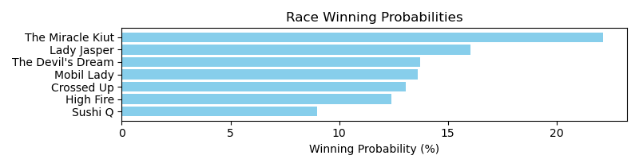

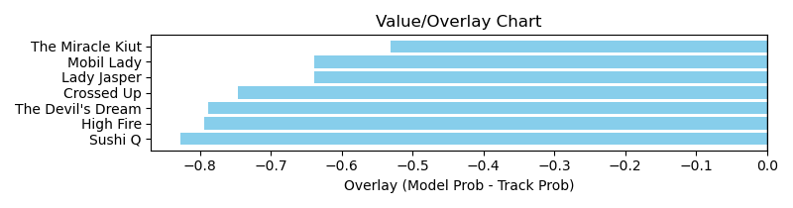

NOTE: GCSF - Global Combined Speed Figure

# Race: MVR | 2025-04-05 | Race #4 | Post: 13:39 | Track: MAHONING VALLEY RACE COURSE

Track: MAHONING VALLEY RACE COURSE

|  |  |  |  |  |  |
| --- | --- | --- | --- | --- | --- |
| Program # | Horse Name | Morn Odds | GCSF | Model Score | Win Prob (%) |
| 1 | Shortly | 3-1 | 91.5 | 0.80 | 21.15 |
| 2 | Mindship Q | 10-1 | 106.6 | 0.59 | 11.33 |
| 3 | Bang a Rang | 5-2 | 98.1 | 0.70 | 16.33 |
| 4 | Grand Bey | 8-1 | 108.2 | 0.68 | 15.51 |
| 5 | Buckeye Mike | 12-1 | 100.0 | 0.62 | 12.60 |
| 6 | Midnight Council | 6-5 | 88.8 | 0.83 | 23.10 |

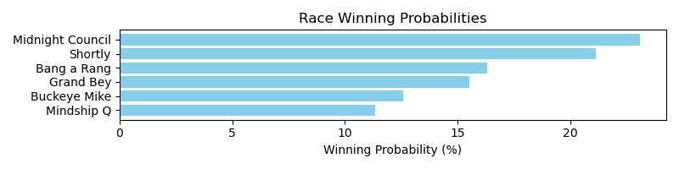

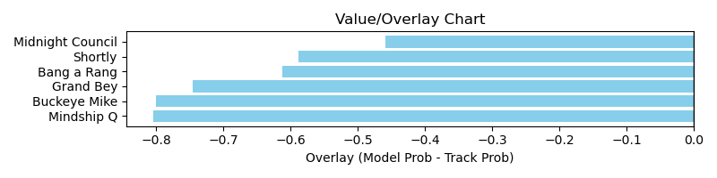

NOTE: GCSF - Global Combined Speed Figure

# Race: MVR | 2025-04-05 | Race #5 | Post: 14:07 | Track: MAHONING VALLEY RACE COURSE

Track: MAHONING VALLEY RACE COURSE

|  |  |  |  |  |  |
| --- | --- | --- | --- | --- | --- |
| Program # | Horse Name | Morn Odds | GCSF | Model Score | Win Prob (%) |
| 1 | Bamby Boom | 12-1 | 94.9 | 0.59 | 8.31 |
| 2 | Jedi's Way | 5-2 | 107.6 | 0.85 | 17.75 |
| 3 | Photo Hop | 3-1 | 97.9 | 0.71 | 12.30 |
| 4 | Third Degree | 7-2 | 96.0 | 0.92 | 20.52 |
| 5 | Convert | 6-1 | 100.0 | 0.72 | 12.67 |
| 6 | Big Elm | 4-1 | 92.6 | 0.86 | 18.06 |
| 7 | Lt's Jacknthebox | 10-1 | 100.0 | 0.66 | 10.41 |

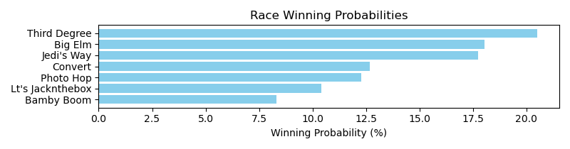

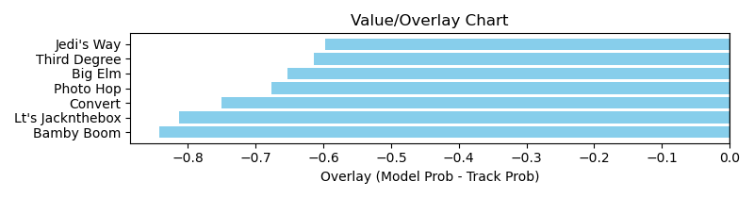

NOTE: GCSF - Global Combined Speed Figure

# Race: MVR | 2025-04-05 | Race #6 | Post: 14:35 | Track: MAHONING VALLEY RACE COURSE

Track: MAHONING VALLEY RACE COURSE

|  |  |  |  |  |  |
| --- | --- | --- | --- | --- | --- |
| Program # | Horse Name | Morn Odds | GCSF | Model Score | Win Prob (%) |
| 1 | Sadie the Goat | 9-5 | 89.5 | 0.89 | 22.16 |
| 2 | No Body Likes Me | 3-1 | 98.7 | 0.94 | 24.81 |
| 3 | Mobil Chic | 10-1 | 92.6 | 0.69 | 13.36 |
| 4 | dh-Miss Fussy Pants | 2-1 | 115.1 | 0.86 | 20.59 |
| 5 | Miranda's Rocky | 4-1 | 112.3 | 0.83 | 19.08 |

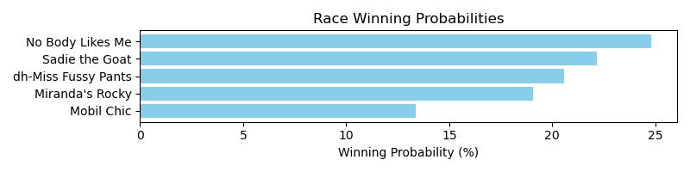

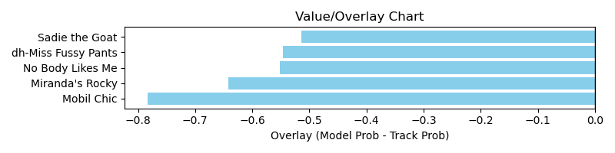

NOTE: GCSF - Global Combined Speed Figure

# Race: MVR | 2025-04-05 | Race #7 | Post: 15:03 | Track: MAHONING VALLEY RACE COURSE

Track: MAHONING VALLEY RACE COURSE

|  |  |  |  |  |  |
| --- | --- | --- | --- | --- | --- |
| Program # | Horse Name | Morn Odds | GCSF | Model Score | Win Prob (%) |
| 1 | Jokemeister | 7-2 | 89.4 | 0.93 | 16.58 |
| 2 | Inside Stunt | 3-1 | 96.0 | 0.97 | 18.17 |
| 3 | Atlantic Firestorm | 12-1 | 99.0 | 1.04 | 20.84 |
| 4 | Lord of Mischief | 5-2 | 92.4 | 0.89 | 15.31 |
| 5 | Saint Goar | 2-1 | 93.2 | 0.97 | 17.89 |
| 6 | Timesatappin | 10-1 | 100.0 | 0.77 | 11.22 |

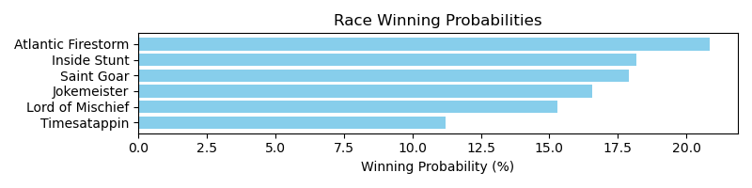

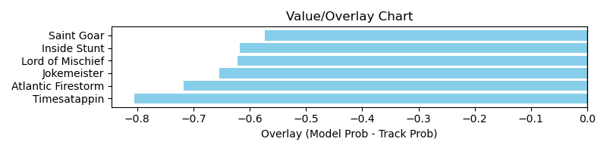

NOTE: GCSF - Global Combined Speed Figure

# Race: MVR | 2025-04-05 | Race #8 | Post: 15:31 | Track: MAHONING VALLEY RACE COURSE

Track: MAHONING VALLEY RACE COURSE

|  |  |  |  |  |  |
| --- | --- | --- | --- | --- | --- |
| Program # | Horse Name | Morn Odds | GCSF | Model Score | Win Prob (%) |
| 1 | Mighty Mo | 4-1 | 93.2 | 0.75 | 11.06 |
| 2 | Cool Couple | 7-2 | 100.0 | 0.78 | 12.05 |
| 3 | Bright Charger | 3-1 | 111.5 | 0.87 | 15.27 |
| 4 | Bigtonten | 6-1 | 100.0 | 0.76 | 11.59 |
| 5 | Action Man | 10-1 | 100.0 | 0.67 | 8.72 |
| 6 | Mister Rosso | 5-2 | 93.3 | 1.29 | 33.72 |
| 7 | Streets of War | 12-1 | 89.5 | 0.62 | 7.59 |

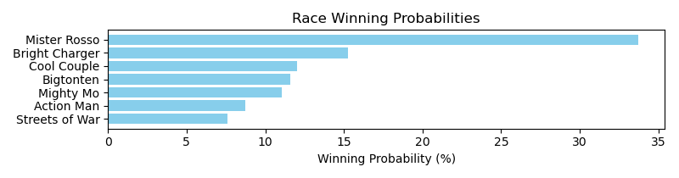

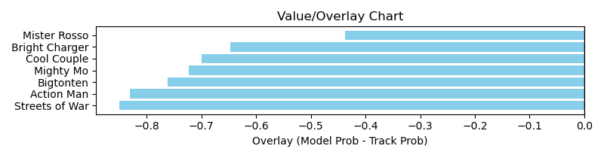

NOTE: GCSF - Global Combined Speed Figure

# Race: MVR | 2025-04-07 | Race #1 | Post: 12:15 | Track: MAHONING VALLEY RACE COURSE

Track: MAHONING VALLEY RACE COURSE

|  |  |  |  |  |  |
| --- | --- | --- | --- | --- | --- |
| Program # | Horse Name | Morn Odds | GCSF | Model Score | Win Prob (%) |
| 1 | Polyester Bride | 4-5 | 107.9 | 0.76 | 24.34 |
| 2 | I Feel the Need | 5-1 | 82.6 | 0.65 | 17.76 |
| 3 | Hebrides | 6-1 | 98.1 | 0.67 | 18.52 |
| 4 | Funtastica | 5-2 | 115.7 | 0.71 | 21.01 |
| 5 | Pearlintherough | 10-1 | 95.0 | 0.67 | 18.38 |

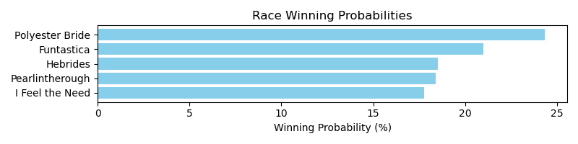

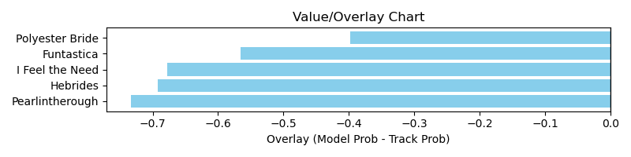

NOTE: GCSF - Global Combined Speed Figure

# Race: MVR | 2025-04-07 | Race #2 | Post: 12:43 | Track: MAHONING VALLEY RACE COURSE

Track: MAHONING VALLEY RACE COURSE

|  |  |  |  |  |  |
| --- | --- | --- | --- | --- | --- |
| Program # | Horse Name | Morn Odds | GCSF | Model Score | Win Prob (%) |
| 1 | STOPTALKINGSARAH | 8-1 | 100.0 | 1.14 | 14.52 |
| 2 | Peekaboo Mom | 4-1 | 100.0 | 1.21 | 16.41 |
| 3 | Kelley Jean | 3-1 | 100.0 | 1.24 | 17.39 |
| 4 | Quetzaly | 7-2 | 100.0 | 1.23 | 17.15 |
| 5 | Drill Blitz | 5-2 | 100.0 | 1.31 | 19.38 |
| 6 | Destiny's Tot | 5-1 | 100.0 | 1.16 | 15.15 |

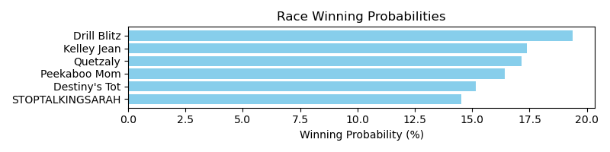

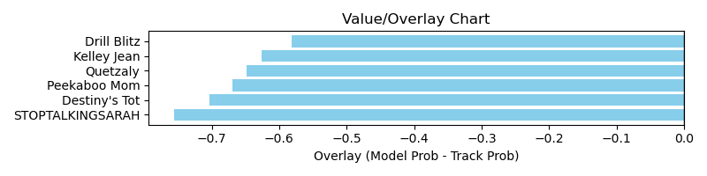

NOTE: GCSF - Global Combined Speed Figure

# Race: MVR | 2025-04-07 | Race #3 | Post: 13:11 | Track: MAHONING VALLEY RACE COURSE

Track: MAHONING VALLEY RACE COURSE

|  |  |  |  |  |  |
| --- | --- | --- | --- | --- | --- |
| Program # | Horse Name | Morn Odds | GCSF | Model Score | Win Prob (%) |
| 1 | Penny's Treasure | 8-1 | 100.0 | 0.62 | 12.52 |
| 2 | Saltmakeshersweet | 5-2 | 100.0 | 0.68 | 15.09 |
| 3 | Thelma Lucille | 6-1 | 110.2 | 0.59 | 11.32 |
| 4 | State of Grace | 10-1 | 97.7 | 0.80 | 20.80 |
| 5 | C More Pride | 12-1 | 100.0 | 0.56 | 10.30 |
| 6 | Shes a Storm | 2-1 | 100.0 | 0.69 | 15.48 |
| 7 | Office Chatter | 7-2 | 100.0 | 0.67 | 14.49 |

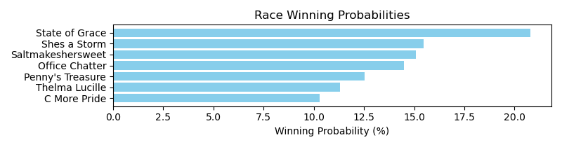

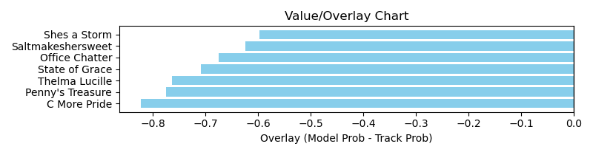

NOTE: GCSF - Global Combined Speed Figure

# Race: MVR | 2025-04-07 | Race #4 | Post: 13:39 | Track: MAHONING VALLEY RACE COURSE

Track: MAHONING VALLEY RACE COURSE

|  |  |  |  |  |  |
| --- | --- | --- | --- | --- | --- |
| Program # | Horse Name | Morn Odds | GCSF | Model Score | Win Prob (%) |
| 1 | Alter the Stars | 10-1 | 97.5 | 0.61 | 11.44 |
| 2 | Datttsafancyfox | 4-1 | 91.9 | 0.72 | 15.93 |
| 3 | Bareback Fun | 7-2 | 97.6 | 0.74 | 16.84 |
| 4 | Devra Warrior | 8-1 | 89.2 | 0.68 | 13.86 |
| 5 | Epicurean | 2-1 | 107.9 | 0.88 | 23.67 |
| 6 | Varton | 5-2 | 99.2 | 0.77 | 18.25 |

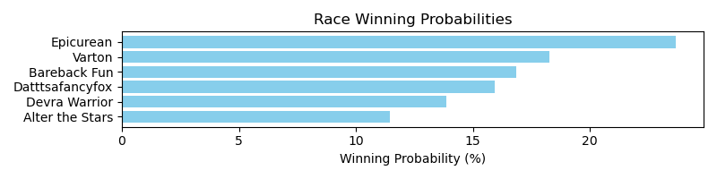

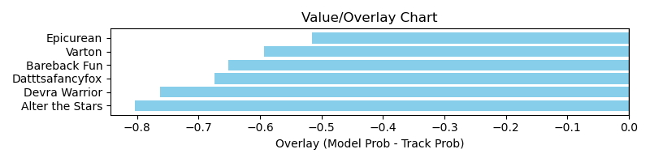

NOTE: GCSF - Global Combined Speed Figure

# Race: MVR | 2025-04-07 | Race #5 | Post: 14:07 | Track: MAHONING VALLEY RACE COURSE

Track: MAHONING VALLEY RACE COURSE

|  |  |  |  |  |  |
| --- | --- | --- | --- | --- | --- |
| Program # | Horse Name | Morn Odds | GCSF | Model Score | Win Prob (%) |
| 1 | Tom's Spirit | 3-1 | 84.4 | 0.85 | 14.06 |
| 2 | Food Foodie | 20-1 | 94.5 | 0.64 | 7.78 |
| 3 | Outa Jail On Bail | 12-1 | 100.0 | 0.53 | 5.32 |
| 4 | Stevie T | 20-1 | 100.0 | 0.61 | 7.10 |
| 5 | Puff'smagicdragon | 7-2 | 90.9 | 0.83 | 13.27 |
| 6 | Beyond Talented | 4-1 | 107.5 | 0.71 | 9.70 |
| 7 | Lomachenko | 5-2 | 99.5 | 1.18 | 27.11 |
| 8 | Tiverton | 10-1 | 90.1 | 0.69 | 8.96 |
| 9 | Royally Flushed | 15-1 | 106.0 | 0.59 | 6.70 |

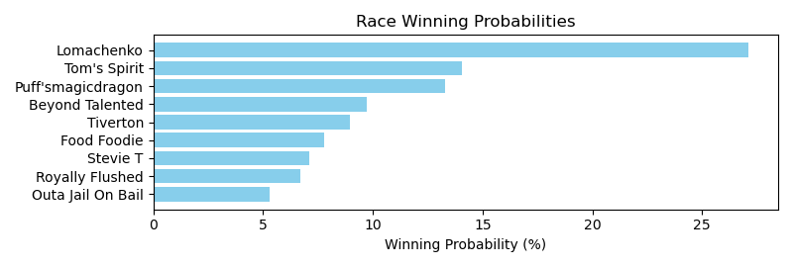

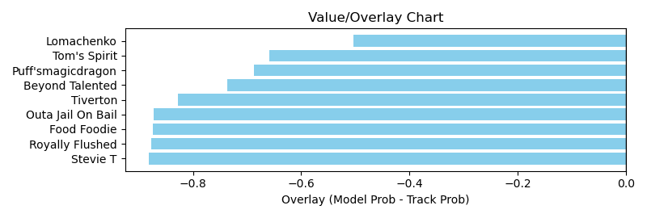

NOTE: GCSF - Global Combined Speed Figure

# Race: MVR | 2025-04-07 | Race #6 | Post: 14:35 | Track: MAHONING VALLEY RACE COURSE

Track: MAHONING VALLEY RACE COURSE

|  |  |  |  |  |  |
| --- | --- | --- | --- | --- | --- |
| Program # | Horse Name | Morn Odds | GCSF | Model Score | Win Prob (%) |
| 1 | She's Crafty | 10-1 | 111.1 | 1.11 | 20.13 |
| 2 | R Three Angels | 15-1 | 101.9 | 0.71 | 8.23 |
| 3 | Neechi | 12-1 | 109.5 | 0.87 | 12.18 |
| 4 | Silent Rule | 6-5 | 100.0 | 1.00 | 16.39 |
| 5 | Back to Ohio | 4-5 | 101.7 | 1.61 | 43.07 |

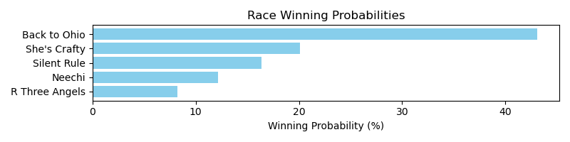

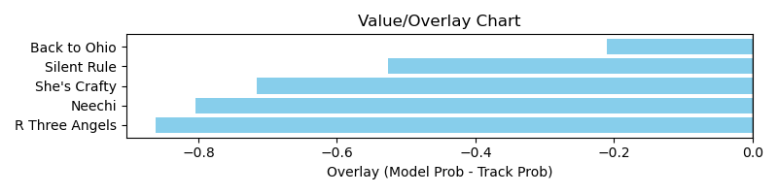

NOTE: GCSF - Global Combined Speed Figure

# Race: MVR | 2025-04-07 | Race #7 | Post: 15:03 | Track: MAHONING VALLEY RACE COURSE

Track: MAHONING VALLEY RACE COURSE

|  |  |  |  |  |  |
| --- | --- | --- | --- | --- | --- |
| Program # | Horse Name | Morn Odds | GCSF | Model Score | Win Prob (%) |
| 1 | Need to Know Basis | 4-1 | 106.6 | 0.85 | 14.70 |
| 2 | Mister Mobil | 10-1 | 95.7 | 0.65 | 8.39 |
| 3 | It's Official | 3-1 | 100.0 | 0.89 | 16.14 |
| 4 | Brilliant Journey | 5-2 | 98.1 | 1.01 | 20.92 |
| 5 | Raven Moon | 7-2 | 100.0 | 0.90 | 16.52 |
| 6 | Hidden Access | 6-1 | 111.0 | 0.77 | 11.85 |
| 7 | Gone in a Flash | 12-1 | 95.4 | 0.75 | 11.48 |

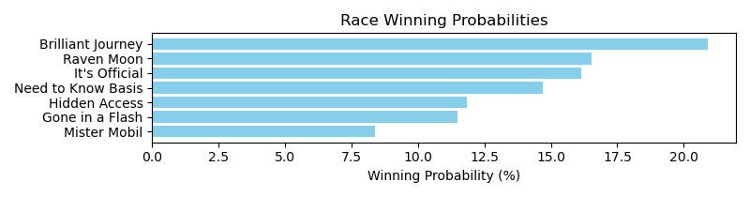

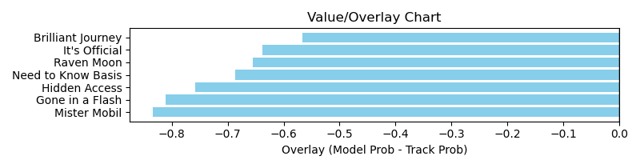

NOTE: GCSF - Global Combined Speed Figure

# Race: MVR | 2025-04-07 | Race #8 | Post: 15:31 | Track: MAHONING VALLEY RACE COURSE

Track: MAHONING VALLEY RACE COURSE

|  |  |  |  |  |  |
| --- | --- | --- | --- | --- | --- |
| Program # | Horse Name | Morn Odds | GCSF | Model Score | Win Prob (%) |
| 1 | K Kid | 15-1 | 112.7 | 0.69 | 8.05 |
| 2 | Washington's Union | 8-1 | 106.4 | 0.72 | 8.71 |
| 3 | Stormin Love | 4-1 | 90.9 | 0.78 | 10.30 |
| 4 | Florida Gator | 10-1 | 106.6 | 0.76 | 9.72 |
| 5 | Magical Monarch | 3-1 | 95.1 | 0.84 | 12.01 |
| 6 | Tier One | 6-1 | 114.4 | 0.79 | 10.54 |
| 7 | Cavendish | 12-1 | 109.8 | 0.70 | 8.30 |
| 8 | Thunderian | 7-2 | 95.8 | 0.93 | 14.67 |
| 9 | Crafted | 10-1 | 109.9 | 0.72 | 8.79 |
| 10 | Only Get'n Better | 15-1 | 100.0 | 0.73 | 8.90 |

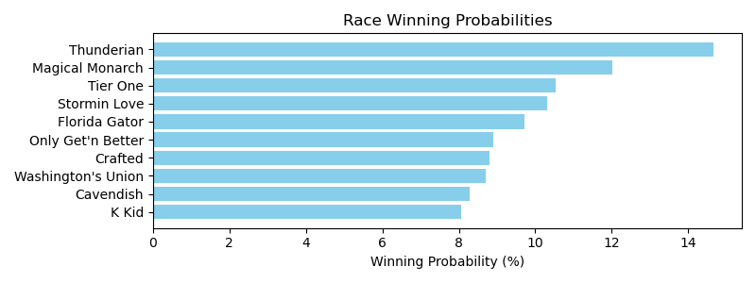

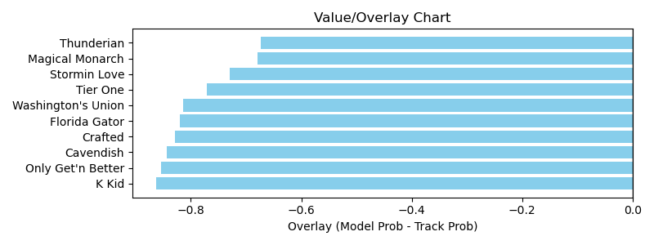

NOTE: GCSF - Global Combined Speed Figure

# Race: MVR | 2025-04-08 | Race #1 | Post: 12:15 | Track: MAHONING VALLEY RACE COURSE

Track: MAHONING VALLEY RACE COURSE

|  |  |  |  |  |  |
| --- | --- | --- | --- | --- | --- |
| Program # | Horse Name | Morn Odds | GCSF | Model Score | Win Prob (%) |
| 1 | The Drake | 6-1 | 96.3 | 0.64 | 16.01 |
| 2 | Seeing Red | 5-2 | 100.5 | 0.94 | 34.60 |
| 3 | Nosey Power | 20-1 | 88.3 | 0.57 | 12.65 |
| 4 | Unclejackomo | 10-1 | 92.7 | 0.60 | 13.77 |
| 5 | Feelthebeat | 1-2 | 91.2 | 0.77 | 22.97 |

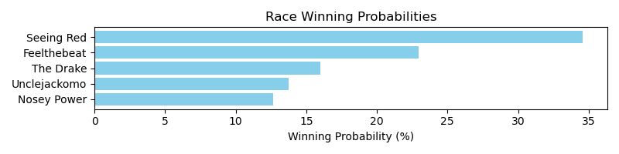

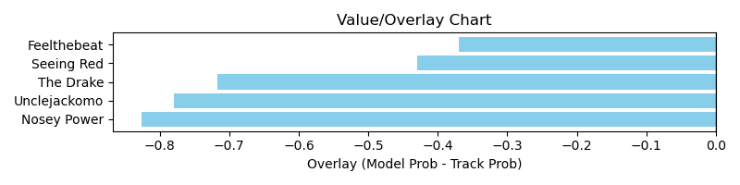

NOTE: GCSF - Global Combined Speed Figure

# Race: MVR | 2025-04-08 | Race #2 | Post: 12:43 | Track: MAHONING VALLEY RACE COURSE

Track: MAHONING VALLEY RACE COURSE

|  |  |  |  |  |  |
| --- | --- | --- | --- | --- | --- |
| Program # | Horse Name | Morn Odds | GCSF | Model Score | Win Prob (%) |
| 1 | Beautiful Mandate | 5-2 | 90.0 | 0.76 | 15.49 |
| 2 | Tovia | 8-1 | 120.2 | 0.59 | 9.30 |
| 3 | Sand Wedge | 6-1 | 107.2 | 0.59 | 9.24 |
| 4 | She's a Saint | 2-1 | 96.9 | 0.99 | 26.68 |
| 5 | Ocho's Secret | 4-1 | 91.3 | 0.65 | 11.20 |
| 6 | Pootoogook | 9-2 | 109.9 | 1.02 | 28.09 |

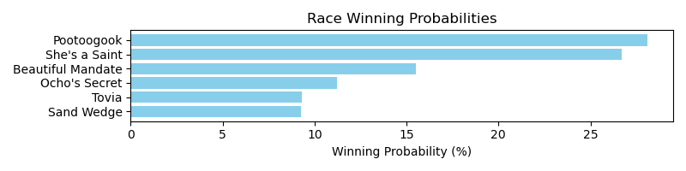

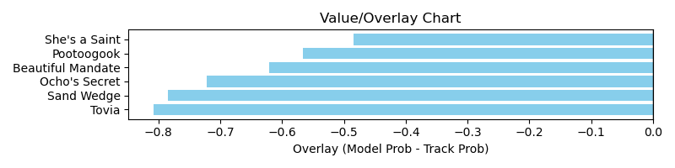

NOTE: GCSF - Global Combined Speed Figure

# Race: MVR | 2025-04-08 | Race #3 | Post: 13:11 | Track: MAHONING VALLEY RACE COURSE

Track: MAHONING VALLEY RACE COURSE

|  |  |  |  |  |  |
| --- | --- | --- | --- | --- | --- |
| Program # | Horse Name | Morn Odds | GCSF | Model Score | Win Prob (%) |
| 1 | Florida Gator | 7-2 | 93.4 | 0.84 | 14.44 |
| 2 | Ernie's Martini | 2-1 | 99.6 | 0.85 | 14.97 |
| 3 | Reinvest | 12-1 | 98.1 | 0.69 | 9.64 |
| 4 | Don't Cross Jack | 4-1 | 100.8 | 0.84 | 14.37 |
| 5 | Cugine | 10-1 | 100.0 | 0.70 | 9.91 |
| 6 | Star Entertainer | 12-1 | 93.6 | 0.75 | 11.43 |
| 7 | Morethanreadyeddie | 8-1 | 101.0 | 0.70 | 10.04 |
| 8 | Hitsville | 5-1 | 100.0 | 0.86 | 15.20 |

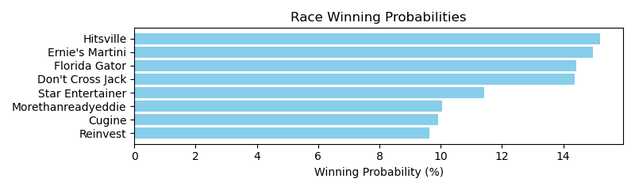

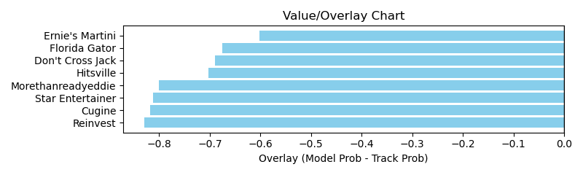

NOTE: GCSF - Global Combined Speed Figure

# Race: MVR | 2025-04-08 | Race #4 | Post: 13:39 | Track: MAHONING VALLEY RACE COURSE

Track: MAHONING VALLEY RACE COURSE

|  |  |  |  |  |  |
| --- | --- | --- | --- | --- | --- |
| Program # | Horse Name | Morn Odds | GCSF | Model Score | Win Prob (%) |
| 1 | This Time | 6-5 | 101.8 | 0.74 | 23.20 |
| 2 | Polster | 13-8 | 103.8 | 0.80 | 27.03 |
| 3 | Vinny and Leo | 4-1 | 97.4 | 0.74 | 22.88 |
| 4 | Classic Richie | 6-1 | 100.0 | 0.61 | 15.76 |
| 5 | Mo Snow | 15-1 | 94.3 | 0.52 | 11.12 |

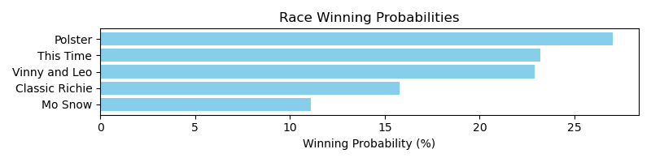

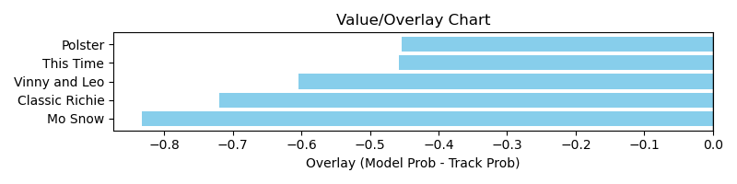

NOTE: GCSF - Global Combined Speed Figure

# Race: MVR | 2025-04-08 | Race #5 | Post: 14:07 | Track: MAHONING VALLEY RACE COURSE

Track: MAHONING VALLEY RACE COURSE

|  |  |  |  |  |  |
| --- | --- | --- | --- | --- | --- |
| Program # | Horse Name | Morn Odds | GCSF | Model Score | Win Prob (%) |
| 1 | Ivory Sky | 9-2 | 91.2 | 0.62 | 11.22 |
| 2 | Factum's Star | 5-2 | 97.2 | 0.75 | 16.13 |
| 3 | Lone Boy | 20-1 | 94.7 | 0.48 | 6.55 |
| 4 | Whiskey Helps | 20-1 | 98.6 | 0.50 | 7.25 |
| 5 | Goldstriker | 8-1 | 100.0 | 0.65 | 12.07 |
| 6 | Lotsa Matcha | 15-1 | 100.0 | 0.59 | 9.83 |
| 7 | Party Pooper | 2-1 | 100.0 | 0.69 | 13.81 |
| 8 | Rollin My Way | 6-1 | 100.0 | 0.69 | 13.75 |
| 9 | One Step Aside | 15-1 | 100.0 | 0.57 | 9.38 |

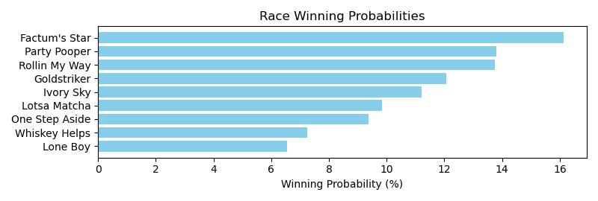

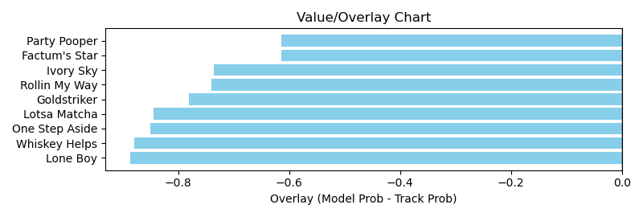

NOTE: GCSF - Global Combined Speed Figure

# Race: MVR | 2025-04-08 | Race #6 | Post: 14:35 | Track: MAHONING VALLEY RACE COURSE

Track: MAHONING VALLEY RACE COURSE

|  |  |  |  |  |  |
| --- | --- | --- | --- | --- | --- |
| Program # | Horse Name | Morn Odds | GCSF | Model Score | Win Prob (%) |
| 1 | Princesstapiture | 15-1 | 121.8 | 0.61 | 9.62 |
| 2 | Shewearsmyring | 9-2 | 100.0 | 0.73 | 13.91 |
| 3 | Army Kitten | 13-8 | 98.4 | 0.90 | 21.14 |
| 4 | Late Nite Lizzie | 5-2 | 97.4 | 0.68 | 11.80 |
| 5 | Q Bond | 10-1 | 93.4 | 0.60 | 9.28 |
| 6 | Wildcat Dream | 6-1 | 101.6 | 0.91 | 21.60 |
| 7 | One Night Stand | 8-1 | 96.8 | 0.70 | 12.65 |

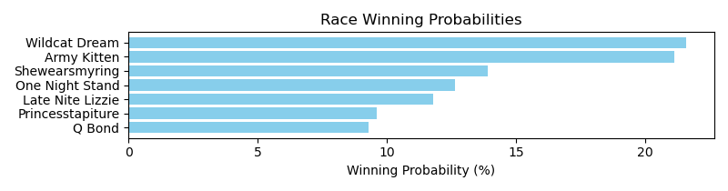

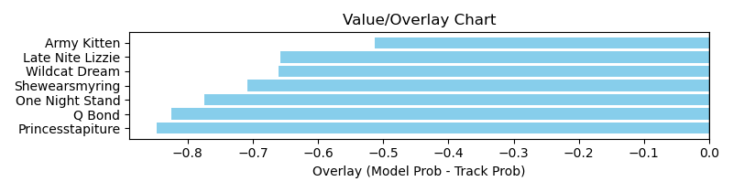

NOTE: GCSF - Global Combined Speed Figure

# Race: MVR | 2025-04-08 | Race #7 | Post: 15:03 | Track: MAHONING VALLEY RACE COURSE

Track: MAHONING VALLEY RACE COURSE

|  |  |  |  |  |  |
| --- | --- | --- | --- | --- | --- |
| Program # | Horse Name | Morn Odds | GCSF | Model Score | Win Prob (%) |
| 1 | Divine Fashion | 8-1 | 99.0 | 0.83 | 12.44 |
| 2 | Gracie Dance | 20-1 | 91.0 | 0.69 | 8.67 |
| 3 | Red Hot Lass | 3-2 | 101.4 | 0.96 | 16.92 |
| 4 | Needed | 15-1 | 89.3 | 0.70 | 8.97 |
| 5 | Sheisthehero | 12-1 | 110.5 | 0.89 | 14.44 |
| 6 | dh-Liberty Belle | 6-1 | 95.9 | 0.78 | 10.96 |
| 7 | Flower Mound | 9-2 | 114.8 | 0.90 | 14.91 |
| 8 | Lucky Cougar | 3-1 | 94.1 | 0.83 | 12.70 |

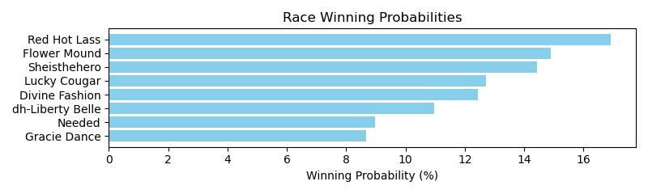

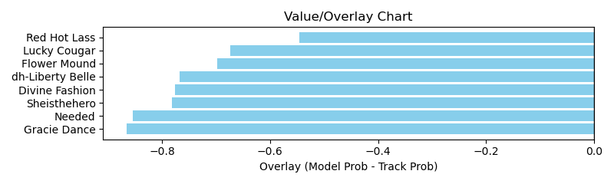

NOTE: GCSF - Global Combined Speed Figure

# Race: MVR | 2025-04-08 | Race #8 | Post: 15:31 | Track: MAHONING VALLEY RACE COURSE

Track: MAHONING VALLEY RACE COURSE

|  |  |  |  |  |  |
| --- | --- | --- | --- | --- | --- |
| Program # | Horse Name | Morn Odds | GCSF | Model Score | Win Prob (%) |
| 1 | Secret Trouble | 12-1 | 106.6 | 0.75 | 14.06 |
| 2 | Gut Instinct | 6-1 | 106.6 | 0.75 | 14.01 |
| 3 | Judge Rules | 8-1 | 111.8 | 0.86 | 18.57 |
| 4 | Gamboling Ghost | 13-8 | 100.0 | 0.89 | 19.95 |
| 5 | Verbier | 4-1 | 99.6 | 0.80 | 15.79 |
| 6 | Runwithheart | 2-1 | 104.2 | 0.84 | 17.61 |

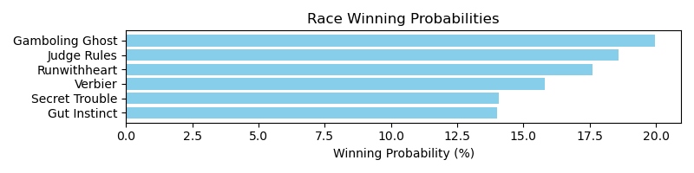

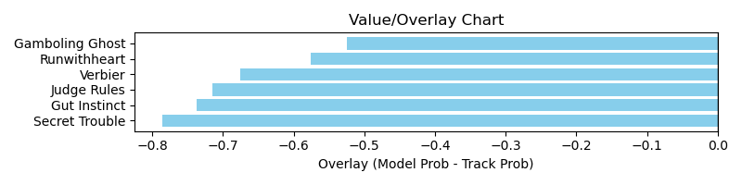

NOTE: GCSF - Global Combined Speed Figure

# Race: TOP | 2025-04-05 | Race #1 | Post: 12:40 | Track: OAKLAWN PARK

Track: OAKLAWN PARK

|  |  |  |  |  |  |
| --- | --- | --- | --- | --- | --- |
| Program # | Horse Name | Morn Odds | GCSF | Model Score | Win Prob (%) |
| 1 | String Theory | 3-1 | 112.2 | 1.19 | 22.62 |
| 2 | Principal Anita | 5-1 | 94.5 | 0.66 | 6.70 |
| 3 | Great Barrier | 5-2 | 116.7 | 1.30 | 26.98 |
| 4 | dq-Where's Randy | 9-2 | 112.0 | 0.78 | 9.44 |
| 5 | Outlaw Run | 30-1 | 90.9 | 0.60 | 5.60 |
| 6 | Butchy Boy | 30-1 | 100.0 | 0.45 | 3.10 |
| 7 | Stuck N Snow | 15-1 | 91.3 | 0.71 | 7.80 |
| 8 | Point Blank | 8-1 | 92.2 | 0.66 | 6.75 |
| 9 | Clear Echo | 15-1 | 111.4 | 0.58 | 5.25 |
| 10 | Doublecheck | 8-1 | 112.2 | 0.61 | 5.75 |

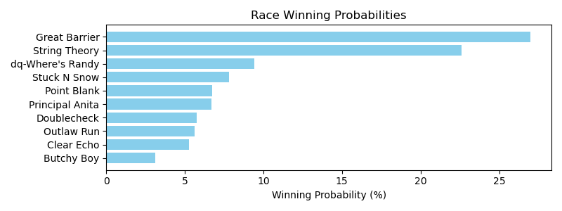

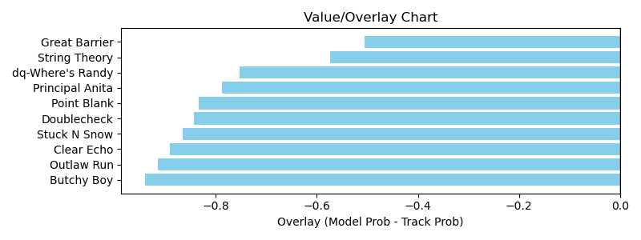

NOTE: GCSF - Global Combined Speed Figure

# Race: TOP | 2025-04-05 | Race #2 | Post: 13:12 | Track: OAKLAWN PARK

Track: OAKLAWN PARK

|  |  |  |  |  |  |
| --- | --- | --- | --- | --- | --- |
| Program # | Horse Name | Morn Odds | GCSF | Model Score | Win Prob (%) |
| 1 | Chupapi Munyayo | 12-1 | 96.0 | 0.70 | 7.73 |
| 2 | Arkansas Zong | 15-1 | 100.0 | 0.56 | 4.96 |
| 3 | Blame J D | 3-1 | 94.6 | 0.83 | 11.02 |
| 4 | Classy Socks | 10-1 | 98.0 | 0.71 | 8.02 |
| 5 | Reef's Destiny | 20-1 | 96.5 | 0.64 | 6.37 |
| 6 | Hightail Cowboy | 10-1 | 97.8 | 0.83 | 10.81 |
| 7 | Dalton's Rutrow | 8-1 | 88.8 | 0.72 | 8.26 |
| 8 | Strike Ridge | 2-1 | 96.4 | 1.42 | 32.69 |
| 9 | Citrus Bay | 4-1 | 98.1 | 0.80 | 10.13 |

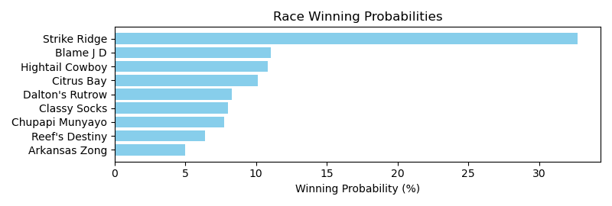

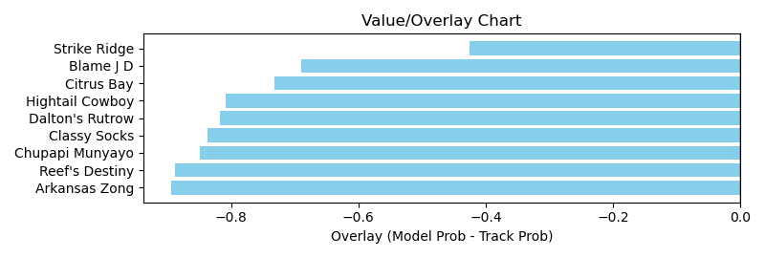

NOTE: GCSF - Global Combined Speed Figure

# Race: TOP | 2025-04-05 | Race #3 | Post: 13:44 | Track: OAKLAWN PARK

Track: OAKLAWN PARK

|  |  |  |  |  |  |
| --- | --- | --- | --- | --- | --- |
| Program # | Horse Name | Morn Odds | GCSF | Model Score | Win Prob (%) |
| 1 | Copper Echo | 15-1 | 92.4 | 0.69 | 7.88 |
| 2 | Remember the Fear | 10-1 | 100.3 | 0.69 | 7.75 |
| 3 | Air It Out | 10-1 | 104.8 | 0.75 | 9.22 |
| 4 | Goodtimejustice | 30-1 | 93.2 | 0.50 | 4.12 |
| 5 | Ryno Wrecker | 20-1 | 100.7 | 0.62 | 6.29 |
| 6 | Museum Quality | 12-1 | 99.2 | 0.78 | 10.10 |
| 7 | Devilish Desire | 9-5 | 98.4 | 1.04 | 18.14 |
| 8 | Unbridled Pleasure | 20-1 | 100.0 | 0.46 | 3.39 |
| 9 | Chick Command | 15-1 | 99.9 | 1.00 | 16.75 |
| 10 | Improbable First | 30-1 | 108.8 | 0.46 | 3.48 |
| 11 | Ceepeegee | 7-5 | 97.3 | 0.88 | 12.89 |

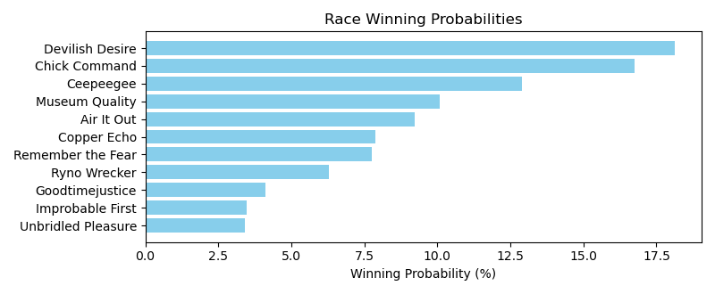

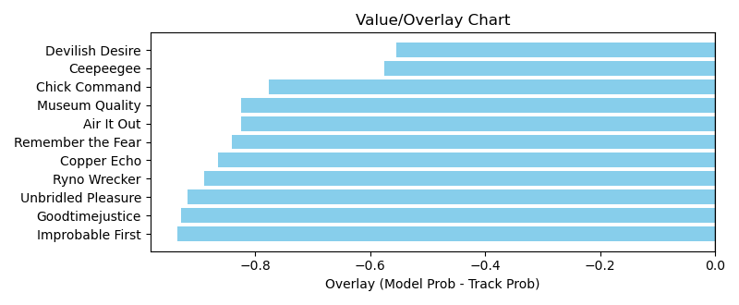

NOTE: GCSF - Global Combined Speed Figure

# Race: TOP | 2025-04-05 | Race #4 | Post: 14:18 | Track: OAKLAWN PARK

Track: OAKLAWN PARK

|  |  |  |  |  |  |
| --- | --- | --- | --- | --- | --- |
| Program # | Horse Name | Morn Odds | GCSF | Model Score | Win Prob (%) |
| 1 | Principe Carlo | 8-1 | 92.8 | 0.84 | 8.39 |
| 2 | Mr Puk | 6-1 | 93.5 | 1.25 | 18.99 |
| 3 | El Diablo Rojo | 7-2 | 92.8 | 0.89 | 9.49 |
| 4 | Espionage | 3-1 | 95.5 | 1.09 | 14.37 |
| 5 | Without Objection | 9-2 | 99.0 | 0.91 | 9.87 |
| 6 | Russian to Win | 10-1 | 102.8 | 0.97 | 11.39 |
| 7 | Eye Dee Kay | 4-1 | 99.3 | 1.28 | 20.01 |
| 8 | Express Cruiser | 15-1 | 94.6 | 0.79 | 7.48 |

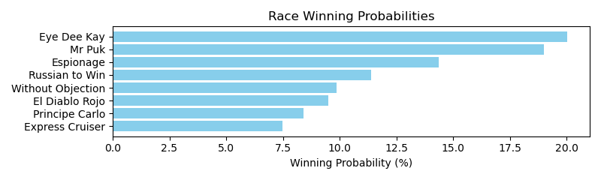

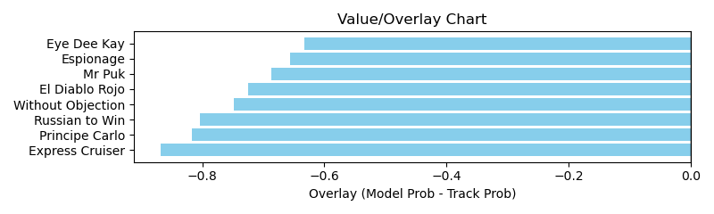

NOTE: GCSF - Global Combined Speed Figure

# Race: TOP | 2025-04-05 | Race #5 | Post: 14:50 | Track: OAKLAWN PARK

Track: OAKLAWN PARK

|  |  |  |  |  |  |
| --- | --- | --- | --- | --- | --- |
| Program # | Horse Name | Morn Odds | GCSF | Model Score | Win Prob (%) |
| 1 | Ducale | 2-1 | 94.5 | 1.15 | 15.50 |
| 2 | Dance Man | 12-1 | 103.4 | 0.72 | 5.97 |
| 3 | Algebra | 8-1 | 102.7 | 0.89 | 9.29 |
| 4 | Go the Distance | 9-2 | 107.5 | 0.85 | 8.30 |
| 5 | K C Rocket | 20-1 | 93.4 | 0.67 | 5.08 |
| 6 | Go West | 6-1 | 101.4 | 0.87 | 8.72 |
| 7 | Quick Buck | 30-1 | 95.9 | 0.57 | 3.72 |
| 8 | Guided Arrow | 20-1 | 104.8 | 0.72 | 5.88 |
| 9 | Vulcan | 5-1 | 106.6 | 0.91 | 9.56 |
| 10 | Ben Dreaming | 20-1 | 90.6 | 0.66 | 4.98 |
| 11 | Dual Monarchy | 12-1 | 90.4 | 0.75 | 6.55 |
| 12 | Easy Action | 8-1 | 101.7 | 0.88 | 9.07 |
| 13 | Worth Looking | 20-1 | 103.8 | 0.80 | 7.37 |

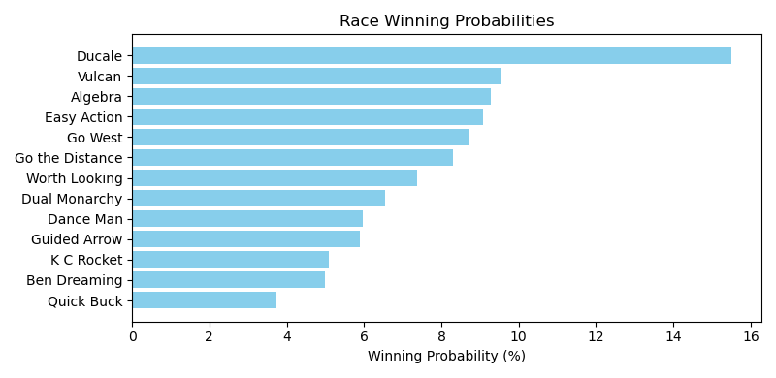

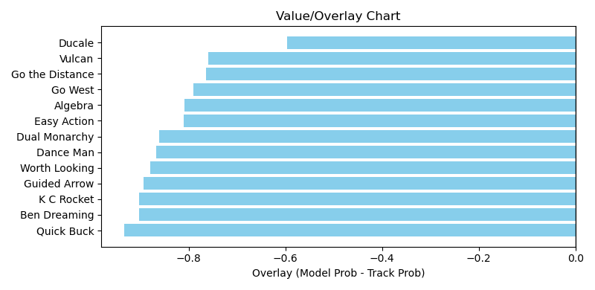

NOTE: GCSF - Global Combined Speed Figure

# Race: TOP | 2025-04-05 | Race #6 | Post: 15:22 | Track: OAKLAWN PARK

Track: OAKLAWN PARK

|  |  |  |  |  |  |
| --- | --- | --- | --- | --- | --- |
| Program # | Horse Name | Morn Odds | GCSF | Model Score | Win Prob (%) |
| 1 | Gypsy Mischief | 10-1 | 93.4 | 0.62 | 9.44 |
| 2 | Safford | 30-1 | 100.0 | 0.43 | 4.47 |
| 3 | Getty's Revenge | 30-1 | 100.0 | 0.40 | 3.86 |
| 4 | Bad Boy for Life | 15-1 | 94.7 | 0.47 | 5.35 |
| 5 | Great Day for Vino | 20-1 | 100.0 | 0.44 | 4.75 |
| 6 | Affixed | 6-1 | 102.0 | 0.56 | 7.48 |
| 7 | Safe Bet | 8-1 | 97.7 | 0.69 | 11.82 |
| 8 | Winter Creek | 12-1 | 100.0 | 0.51 | 6.37 |
| 9 | Skibidi Rizz | 4-1 | 100.0 | 0.60 | 8.87 |
| 10 | Lucky Destiny | 30-1 | 100.0 | 0.45 | 4.93 |
| 11 | Jon's Street Band | 5-1 | 93.4 | 0.81 | 16.30 |
| 12 | Handsome Herb | 2-1 | 96.6 | 0.81 | 16.35 |

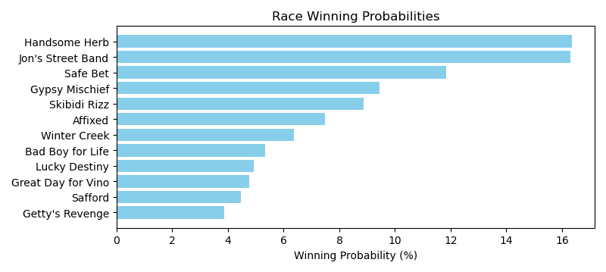

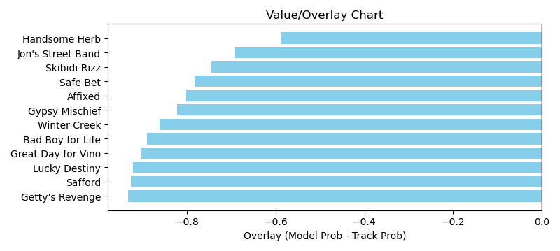

NOTE: GCSF - Global Combined Speed Figure

# Race: TOP | 2025-04-05 | Race #7 | Post: 15:55 | Track: OAKLAWN PARK

Track: OAKLAWN PARK

|  |  |  |  |  |  |
| --- | --- | --- | --- | --- | --- |
| Program # | Horse Name | Morn Odds | GCSF | Model Score | Win Prob (%) |
| 1 | Euclid Avenue | 30-1 | 98.2 | 0.68 | 5.64 |
| 2 | J T's Imagination | 20-1 | 117.5 | 0.72 | 6.23 |
| 3 | Deflater | 20-1 | 95.1 | 0.71 | 6.04 |
| 4 | Sittin On Go | 7-2 | 95.7 | 0.89 | 9.61 |
| 5 | Hello Hot Rod | 6-1 | 120.2 | 0.76 | 7.01 |
| 6 | Kattath | 3-1 | 97.7 | 0.88 | 9.43 |
| 7 | Candy for Carmel | 12-1 | 97.6 | 0.79 | 7.50 |
| 8 | Jay Vee Bee | 9-2 | 105.9 | 0.96 | 11.28 |
| 9 | Mighty Message | 15-1 | 96.2 | 0.71 | 5.99 |
| 10 | Patch O'Brien | 20-1 | 95.7 | 0.77 | 7.15 |
| 11 | Logical Myth | 6-1 | 95.8 | 0.84 | 8.47 |
| 12 | Southern Sunset | 15-1 | 105.3 | 0.75 | 6.76 |
| 13 | Sonneman | 5-1 | 95.1 | 0.86 | 8.89 |

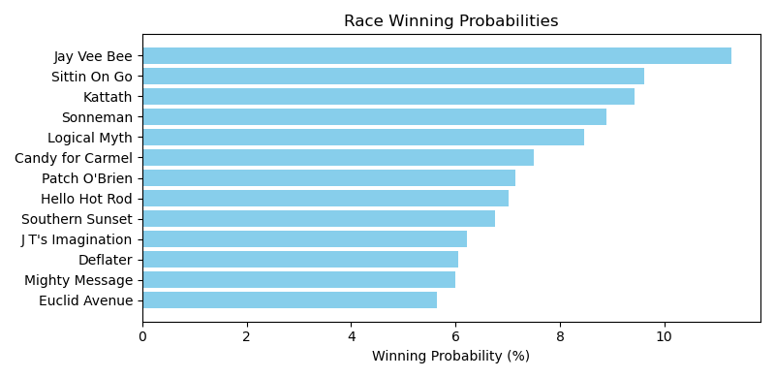

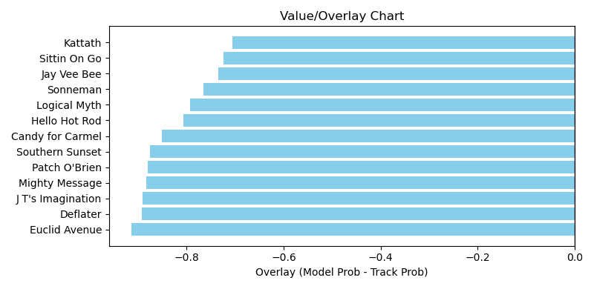

NOTE: GCSF - Global Combined Speed Figure

# Race: TOP | 2025-04-05 | Race #8 | Post: 16:27 | Track: OAKLAWN PARK

Track: OAKLAWN PARK

|  |  |  |  |  |  |
| --- | --- | --- | --- | --- | --- |
| Program # | Horse Name | Morn Odds | GCSF | Model Score | Win Prob (%) |
| 1 | Majestic Oops | 2-1 | 92.0 | 1.01 | 14.44 |
| 2 | Honor Cat | 8-1 | 102.2 | 1.32 | 25.16 |
| 3 | She Makes a Point | 3-1 | 117.8 | 0.96 | 13.19 |
| 4 | Under the Palms | 4-1 | 91.0 | 1.03 | 15.22 |
| 5 | Lemon Muffin | 9-2 | 92.5 | 0.94 | 12.54 |
| 6 | Key to Success | 20-1 | 110.5 | 0.68 | 6.37 |
| 7 | Perfect Shot | 5-1 | 98.0 | 0.96 | 13.08 |

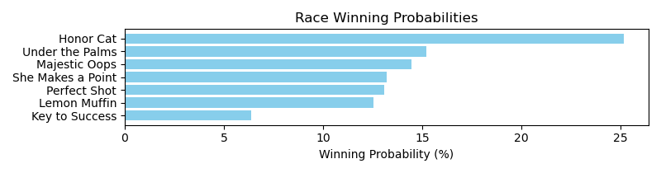

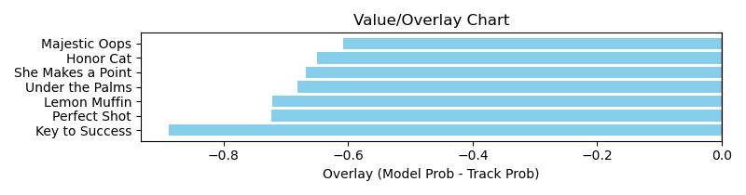

NOTE: GCSF - Global Combined Speed Figure

# Race: TOP | 2025-04-05 | Race #9 | Post: 16:58 | Track: OAKLAWN PARK

Track: OAKLAWN PARK

|  |  |  |  |  |  |
| --- | --- | --- | --- | --- | --- |
| Program # | Horse Name | Morn Odds | GCSF | Model Score | Win Prob (%) |
| 1 | CANNON | 6-1 | 100.0 | 0.74 | 11.70 |
| 2 | Tap Me a Song | 20-1 | 100.0 | 0.54 | 6.19 |
| 3 | TROJAN PRIDE | 20-1 | 100.0 | 0.59 | 7.54 |
| 4 | Putting Eagle | 9-5 | 97.0 | 0.94 | 19.23 |
| 5 | We Need a Favor | 12-1 | 94.6 | 0.63 | 8.49 |
| 6 | Montana Cafe | 15-1 | 93.4 | 0.61 | 8.01 |
| 7 | Tip Toe Joe | 5-1 | 92.5 | 0.67 | 9.70 |
| 8 | dh-Asleep At Eight | 12-1 | 96.7 | 0.69 | 10.18 |
| 9 | Lottery Win | 6-1 | 100.0 | 0.57 | 6.84 |
| 10 | Tom Cat Tuesday | 9-2 | 89.5 | 0.75 | 12.11 |

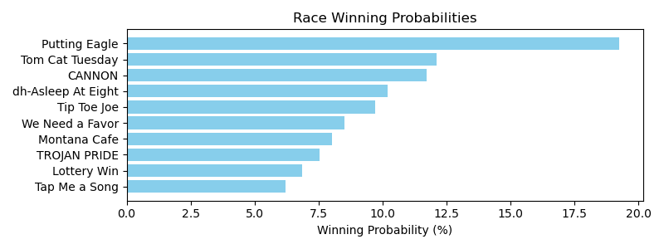

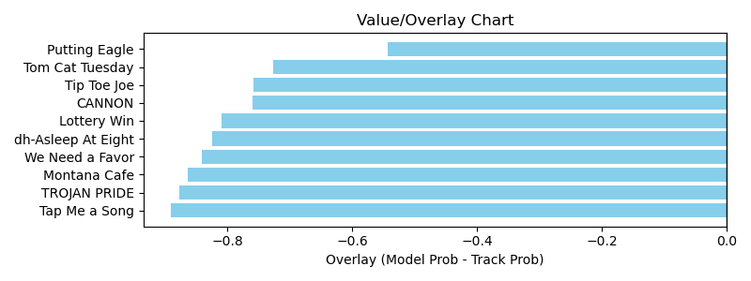

NOTE: GCSF - Global Combined Speed Figure

# Race: TOP | 2025-04-05 | Race #10 | Post: 17:35 | Track: OAKLAWN PARK

Track: OAKLAWN PARK

|  |  |  |  |  |  |
| --- | --- | --- | --- | --- | --- |
| Program # | Horse Name | Morn Odds | GCSF | Model Score | Win Prob (%) |
| 1 | Sky High Angel | 30-1 | 100.0 | 0.46 | 3.44 |
| 2 | Ministry's Destiny | 20-1 | 100.0 | 0.58 | 5.56 |
| 3 | Plinko Chip | 15-1 | 88.2 | 0.86 | 12.18 |
| 4 | Strong Like Sara | 9-5 | 105.4 | 0.85 | 11.84 |
| 5 | Very Cosmopolitan | 15-1 | 91.6 | 0.68 | 7.57 |
| 6 | Morally Complex | 15-1 | 93.4 | 0.71 | 8.31 |
| 7 | Caliente Star | 13-8 | 100.0 | 1.25 | 26.24 |
| 8 | She's a Dreamer | 3-1 | 93.4 | 1.09 | 20.05 |
| 9 | Millie's Stardust | 30-1 | 93.6 | 0.54 | 4.81 |

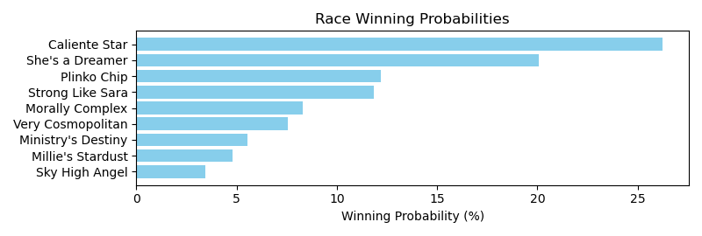

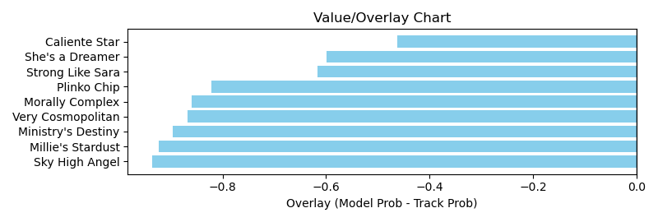

NOTE: GCSF - Global Combined Speed Figure

# Race: TOP | 2025-04-05 | Race #11 | Post: 18:10 | Track: OAKLAWN PARK

Track: OAKLAWN PARK

|  |  |  |  |  |  |
| --- | --- | --- | --- | --- | --- |
| Program # | Horse Name | Morn Odds | GCSF | Model Score | Win Prob (%) |
| 1 | Santos Dumont | 3-1 | 83.9 | 1.48 | 21.79 |
| 2 | Lundberg | 8-1 | 108.3 | 0.95 | 8.75 |
| 3 | Vale | 20-1 | 99.7 | 0.84 | 6.82 |
| 4 | Congrats On Fifty | 12-1 | 107.4 | 0.87 | 7.30 |
| 5 | Unpredictable Bay | 20-1 | 101.5 | 0.80 | 6.12 |
| 6 | Sweet as Sin | 20-1 | 102.3 | 0.70 | 4.76 |
| 7 | Bettys Cash | 20-1 | 102.7 | 0.74 | 5.26 |
| 8 | Midnight Pranks | 15-1 | 103.7 | 0.82 | 6.46 |
| 9 | Bron and Brow | 15-1 | 100.6 | 0.94 | 8.67 |
| 10 | Magia Nera | 5-2 | 89.8 | 0.95 | 8.69 |
| 11 | Macron | 4-1 | 103.1 | 0.99 | 9.50 |
| 12 | Vodka Martini | 10-1 | 106.6 | 0.78 | 5.85 |

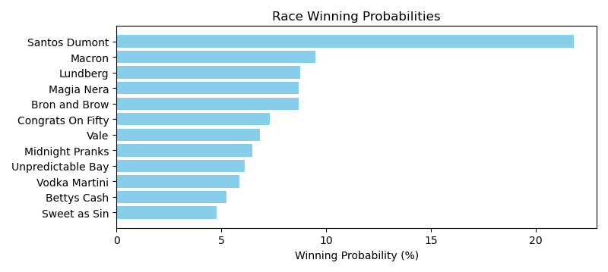

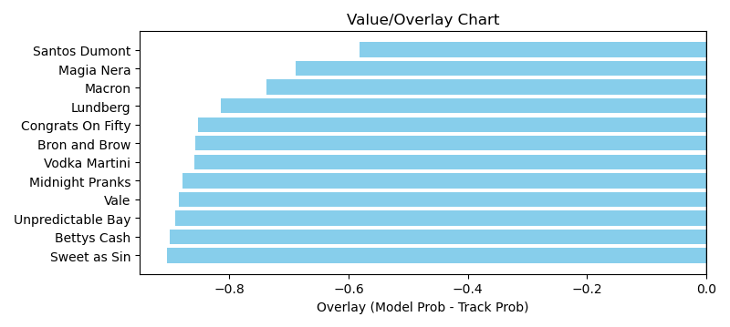

NOTE: GCSF - Global Combined Speed Figure

# Race: TOP | 2025-04-06 | Race #1 | Post: 12:45 | Track: OAKLAWN PARK

Track: OAKLAWN PARK

|  |  |  |  |  |  |
| --- | --- | --- | --- | --- | --- |
| Program # | Horse Name | Morn Odds | GCSF | Model Score | Win Prob (%) |
| 1 | Greers Ferry | 12-1 | 99.2 | 0.69 | 13.91 |
| 2 | Awol | 15-1 | 105.4 | 0.60 | 10.22 |
| 3 | Sir Gallivant | 9-5 | 108.7 | 0.88 | 22.49 |
| 4 | Mintastic | 15-1 | 96.7 | 0.73 | 15.30 |
| 5 | Winning Song | 9-2 | 100.0 | 0.60 | 10.34 |
| 6 | Speechless | 15-1 | 97.1 | 0.55 | 8.61 |
| 7 | Box Office | 6-5 | 93.4 | 0.81 | 19.12 |

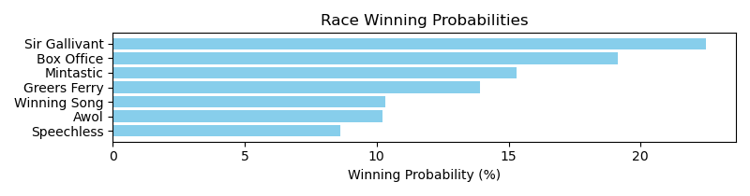

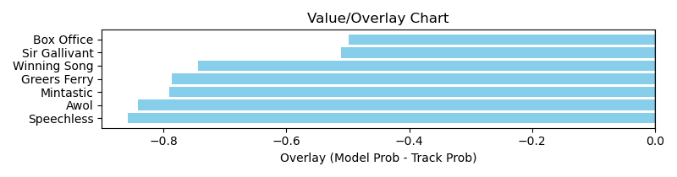

NOTE: GCSF - Global Combined Speed Figure

# Race: TOP | 2025-04-06 | Race #2 | Post: 13:20 | Track: OAKLAWN PARK

Track: OAKLAWN PARK

|  |  |  |  |  |  |
| --- | --- | --- | --- | --- | --- |
| Program # | Horse Name | Morn Odds | GCSF | Model Score | Win Prob (%) |
| 1 | Classically | 8-1 | 96.2 | 0.81 | 12.26 |
| 1A | Humor Me Now | 8-1 | 117.6 | 0.68 | 8.57 |
| 2 | Touch Of Glam (ARG) | 7-2 | 93.4 | 0.75 | 10.34 |
| 3 | Haskelled | 15-1 | 98.2 | 0.72 | 9.61 |
| 4 | Mischelof (CHI) | 3-1 | 94.3 | 0.90 | 15.09 |
| 5 | Tiz Wicked Strong | 9-5 | 103.0 | 0.91 | 15.55 |
| 6 | Wicked Melody | 12-1 | 98.0 | 0.62 | 7.12 |
| 7 | Mount Craig | 15-1 | 100.4 | 0.70 | 8.98 |
| 8 | Big Gain | 8-1 | 96.0 | 0.82 | 12.47 |

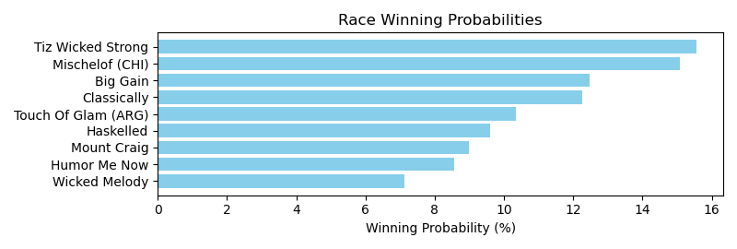

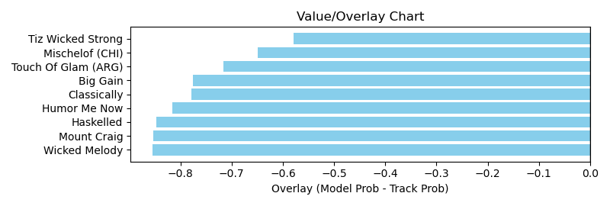

NOTE: GCSF - Global Combined Speed Figure

# Race: TOP | 2025-04-06 | Race #3 | Post: 13:54 | Track: OAKLAWN PARK

Track: OAKLAWN PARK

|  |  |  |  |  |  |
| --- | --- | --- | --- | --- | --- |
| Program # | Horse Name | Morn Odds | GCSF | Model Score | Win Prob (%) |
| 1 | Actin' Up | 15-1 | 93.4 | 0.48 | 6.38 |
| 2 | Flightning Bolt | 5-2 | 100.0 | 0.76 | 16.60 |
| 3 | Moenchanted | 10-1 | 115.0 | 0.61 | 10.44 |
| 4 | Union Dame | 12-1 | 112.0 | 0.63 | 11.12 |
| 5 | Open Flame | 4-1 | 93.2 | 0.67 | 12.93 |
| 6 | Frosted Miracle | 6-1 | 93.4 | 0.60 | 10.35 |
| 7 | Acousticat | 2-1 | 100.0 | 0.72 | 14.91 |
| 8 | I'd Be Honored | 20-1 | 100.0 | 0.43 | 5.03 |
| 9 | Southern Speight | 20-1 | 110.4 | 0.47 | 6.20 |
| 10 | Take It to Court | 20-1 | 100.0 | 0.46 | 6.03 |

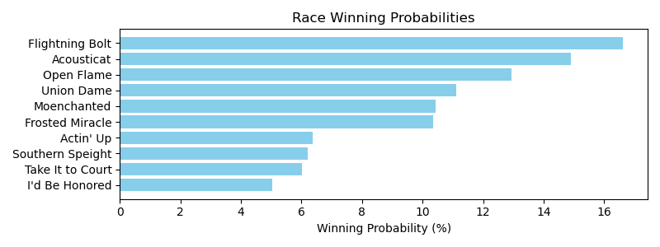

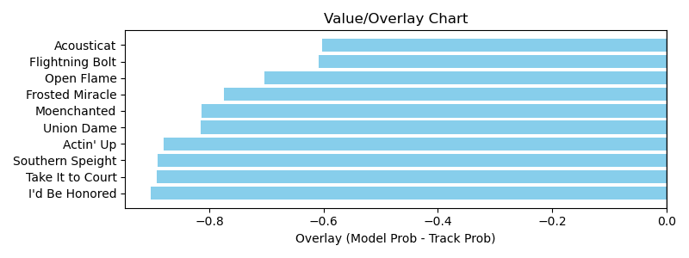

NOTE: GCSF - Global Combined Speed Figure

# Race: TOP | 2025-04-06 | Race #4 | Post: 14:25 | Track: OAKLAWN PARK

Track: OAKLAWN PARK

|  |  |  |  |  |  |
| --- | --- | --- | --- | --- | --- |
| Program # | Horse Name | Morn Odds | GCSF | Model Score | Win Prob (%) |
| 1 | Palace Kitten | 20-1 | 101.8 | 0.67 | 6.88 |
| 2 | Axton | 2-1 | 108.5 | 0.92 | 13.16 |
| 3 | Lemon Drop Shot | 12-1 | 102.0 | 0.81 | 10.21 |
| 4 | Life Is Hard | 15-1 | 93.4 | 0.79 | 9.54 |
| 5 | Family Tradition | 15-1 | 95.4 | 0.76 | 8.78 |
| 6 | Super Brady | 20-1 | 102.2 | 0.78 | 9.29 |
| 7 | Ian Glass | 5-1 | 112.2 | 0.90 | 12.62 |
| 8 | Atomic Tone | 3-1 | 88.7 | 1.03 | 16.52 |
| 9 | Cost Basis | 5-2 | 90.2 | 0.92 | 12.98 |

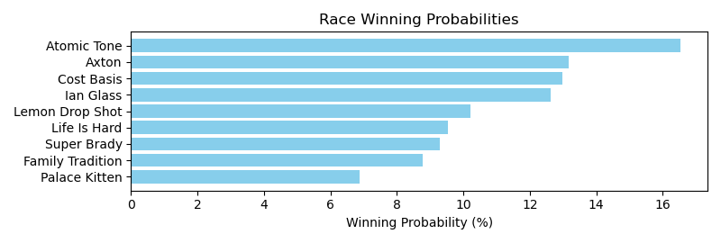

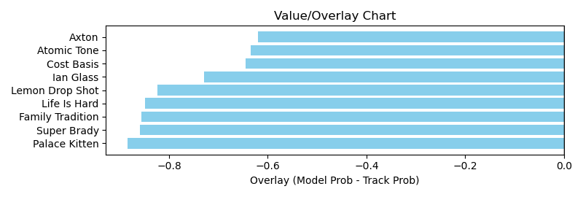

NOTE: GCSF - Global Combined Speed Figure

# Race: TOP | 2025-04-06 | Race #5 | Post: 14:57 | Track: OAKLAWN PARK

Track: OAKLAWN PARK

|  |  |  |  |  |  |
| --- | --- | --- | --- | --- | --- |
| Program # | Horse Name | Morn Odds | GCSF | Model Score | Win Prob (%) |
| 1 | Nullify | 3-1 | 95.5 | 0.97 | 13.93 |
| 2 | Neon Nights | 7-2 | 99.1 | 0.91 | 12.21 |
| 3 | Palm Tree | 15-1 | 97.7 | 0.81 | 9.64 |
| 4 | Special Dispatch | 9-2 | 113.5 | 0.93 | 12.75 |
| 5 | Maximus Magic | 15-1 | 98.4 | 0.83 | 10.10 |
| 6 | Mendelssohns March | 5-1 | 107.7 | 0.90 | 12.04 |
| 7 | The Thunderer | 5-2 | 101.4 | 1.02 | 15.54 |
| 8 | Lear | 20-1 | 98.0 | 0.96 | 13.79 |

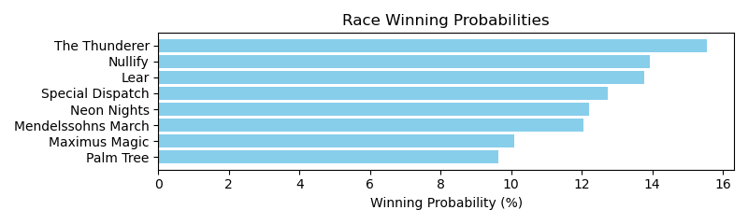

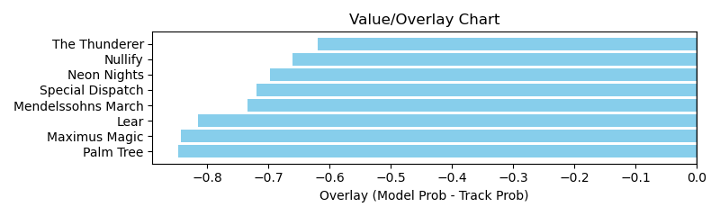

NOTE: GCSF - Global Combined Speed Figure

# Race: TOP | 2025-04-06 | Race #6 | Post: 15:28 | Track: OAKLAWN PARK

Track: OAKLAWN PARK

|  |  |  |  |  |  |
| --- | --- | --- | --- | --- | --- |
| Program # | Horse Name | Morn Odds | GCSF | Model Score | Win Prob (%) |
| 1 | Twas Lola | 5-2 | 106.9 | 0.68 | 10.49 |
| 1A | Texas Hottie | 5-2 | 90.1 | 0.59 | 7.63 |
| 2 | New Woman | 30-1 | 93.6 | 0.55 | 6.81 |
| 3 | Wampus Kitten | 15-1 | 90.2 | 0.59 | 7.66 |
| 4 | Chica Arma | 3-1 | 98.2 | 0.74 | 12.24 |
| 5 | Stealthespotlight | 15-1 | 100.7 | 0.64 | 9.13 |
| 6 | Sthenic | 5-1 | 92.5 | 0.69 | 10.68 |
| 7 | No Pay No Hay | 9-2 | 94.5 | 0.70 | 10.97 |
| 8 | Starlit Sofi | 10-1 | 98.8 | 0.63 | 8.76 |
| 9 | Ready for Wine | 30-1 | 95.8 | 0.45 | 4.45 |
| 10 | Chipotle Pepper | 6-1 | 93.3 | 0.70 | 11.16 |

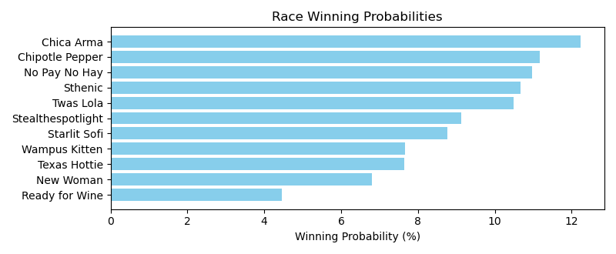

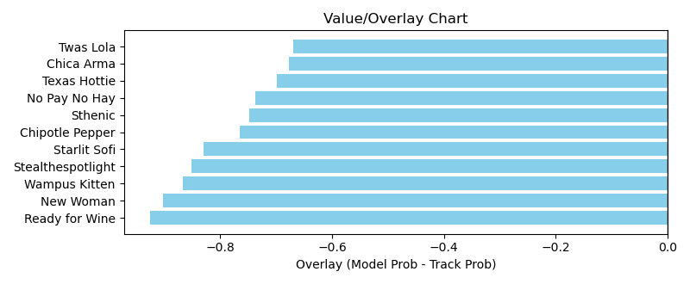

NOTE: GCSF - Global Combined Speed Figure

# Race: TOP | 2025-04-06 | Race #7 | Post: 16:00 | Track: OAKLAWN PARK

Track: OAKLAWN PARK

|  |  |  |  |  |  |
| --- | --- | --- | --- | --- | --- |
| Program # | Horse Name | Morn Odds | GCSF | Model Score | Win Prob (%) |
| 1 | Capo Luca | 15-1 | 92.0 | 0.66 | 6.93 |
| 2 | Rebel Moon | 6-1 | 100.0 | 0.84 | 11.29 |
| 3 | Nacho Bar | 30-1 | 106.6 | 0.67 | 7.15 |
| 4 | Landing Craft | 7-5 | 87.0 | 1.04 | 17.74 |
| 5 | Haunted Flame | 7-2 | 110.5 | 1.37 | 30.81 |
| 6 | Magic Mover | 20-1 | 93.9 | 0.69 | 7.54 |
| 7 | Iron Sharpens Iron | 15-1 | 100.0 | 0.58 | 5.35 |
| 8 | Amor Patriae | 5-2 | 93.4 | 0.90 | 13.19 |

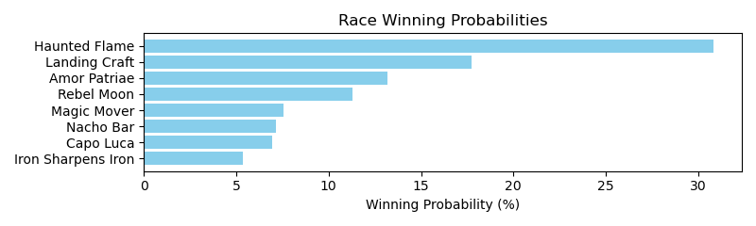

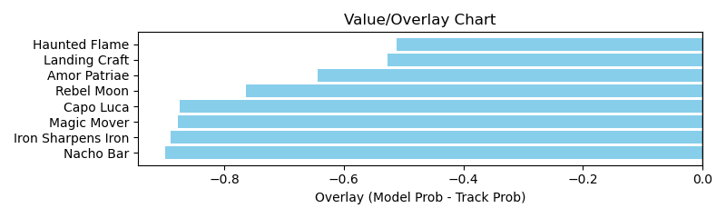

NOTE: GCSF - Global Combined Speed Figure

# Race: TOP | 2025-04-06 | Race #8 | Post: 16:32 | Track: OAKLAWN PARK

Track: OAKLAWN PARK

|  |  |  |  |  |  |
| --- | --- | --- | --- | --- | --- |
| Program # | Horse Name | Morn Odds | GCSF | Model Score | Win Prob (%) |
| 1 | Rock Solo | 5-2 | 98.4 | 0.85 | 12.05 |
| 2 | Sweet Fantasy | 20-1 | 100.2 | 0.61 | 6.21 |
| 3 | Gettinby | 5-1 | 93.4 | 1.27 | 27.39 |
| 4 | Dawson James | 20-1 | 100.0 | 0.51 | 4.20 |
| 5 | HICKO | 6-1 | 100.0 | 0.63 | 6.51 |
| 6 | Lord of Rhymes | 12-1 | 100.0 | 0.61 | 6.05 |
| 7 | A P Ruly | 9-2 | 90.7 | 0.75 | 9.31 |
| 8 | Max Dot Socks | 20-1 | 100.0 | 0.71 | 8.25 |
| 9 | War Mule | 2-1 | 100.0 | 1.09 | 20.03 |

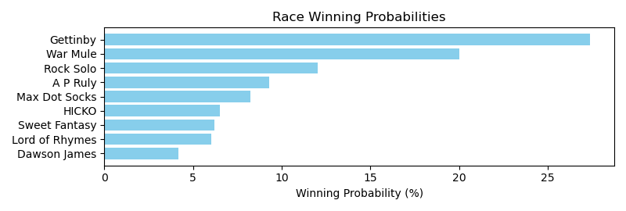

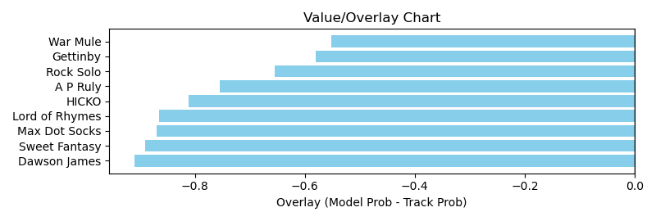

NOTE: GCSF - Global Combined Speed Figure

# Race: TOP | 2025-04-06 | Race #9 | Post: 17:06 | Track: OAKLAWN PARK

Track: OAKLAWN PARK

|  |  |  |  |  |  |
| --- | --- | --- | --- | --- | --- |
| Program # | Horse Name | Morn Odds | GCSF | Model Score | Win Prob (%) |
| 1 | Milliganmikeandme | 12-1 | 103.7 | 0.65 | 9.49 |
| 2 | Pattern Bet | 2-1 | 89.2 | 0.91 | 18.87 |
| 3 | She Be Sheehan | 8-1 | 102.2 | 0.63 | 8.87 |
| 4 | Little Burrito | 20-1 | 98.2 | 0.50 | 5.61 |
| 5 | Magnolia Mae | 15-1 | 97.1 | 0.57 | 7.25 |
| 6 | Summorya | 4-1 | 97.5 | 0.76 | 13.01 |
| 7 | Courageous Cappen | 3-1 | 98.4 | 0.80 | 14.43 |
| 8 | Jeri Dawn | 20-1 | 96.5 | 0.53 | 6.20 |
| 9 | Norma Jean Bling | 20-1 | 100.0 | 0.58 | 7.43 |
| 10 | Lady Astrid | 8-1 | 97.9 | 0.63 | 8.84 |

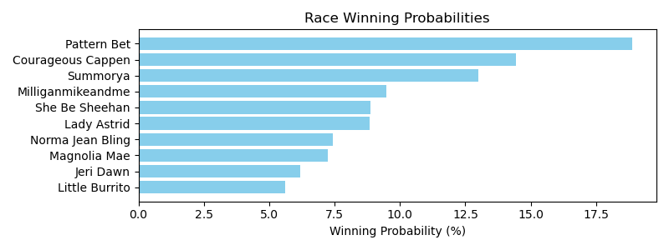

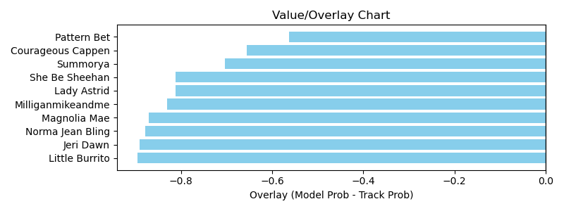

NOTE: GCSF - Global Combined Speed Figure

# Race: HOU | 2025-04-05 | Race #2 | Post: 13:30 | Track: SAM HOUSTON RACE PARK

Track: SAM HOUSTON RACE PARK

|  |  |  |  |  |  |
| --- | --- | --- | --- | --- | --- |
| Program # | Horse Name | Morn Odds | GCSF | Model Score | Win Prob (%) |
| 1 | Cayman Hot | 20-1 | 95.9 | 0.84 | 9.02 |
| 2 | I'm On Edge | 15-1 | 91.2 | 0.57 | 4.02 |
| 3 | Wauneka | 9-5 | 93.4 | 1.35 | 23.59 |
| 4 | Phunk | 8-1 | 100.4 | 1.07 | 14.63 |
| 5 | Evening Edge | 20-1 | 93.4 | 0.56 | 3.91 |
| 6 | The Next Big Bling | 12-1 | 96.8 | 0.70 | 6.13 |
| 7 | Okie Bling | 15-1 | 93.6 | 0.60 | 4.41 |
| 8 | Bill's Queen Jean | 6-1 | 100.0 | 0.83 | 8.73 |
| 9 | Bling It to Me | 7-2 | 94.4 | 1.21 | 18.91 |
| 10 | Citycityblingbling | 10-1 | 97.9 | 0.73 | 6.65 |

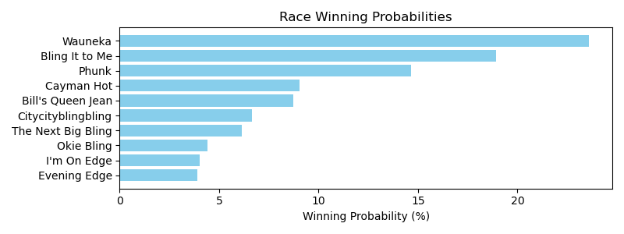

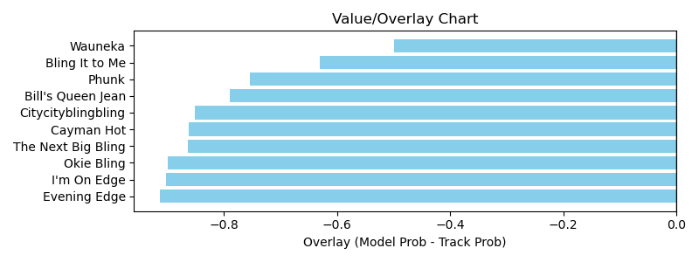

NOTE: GCSF - Global Combined Speed Figure

# Race: HOU | 2025-04-05 | Race #3 | Post: 14:00 | Track: SAM HOUSTON RACE PARK

Track: SAM HOUSTON RACE PARK

|  |  |  |  |  |  |
| --- | --- | --- | --- | --- | --- |
| Program # | Horse Name | Morn Odds | GCSF | Model Score | Win Prob (%) |
| 1 | Mor Peanuts | 4-1 | 109.9 | 0.84 | 18.82 |
| 2 | Just a Sip | 2-1 | 106.6 | 0.87 | 20.05 |
| 3 | Ghostly Night | 3-1 | 105.3 | 0.90 | 21.59 |
| 4 | Regal Rumor | 6-1 | 93.7 | 0.71 | 13.54 |
| 5 | Alamo | 15-1 | 94.6 | 0.65 | 11.05 |
| 6 | Day for the Gray | 7-2 | 100.0 | 0.75 | 14.95 |

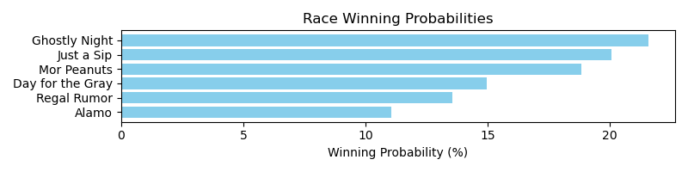

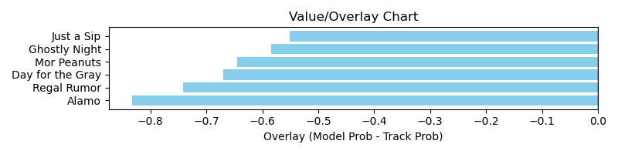

NOTE: GCSF - Global Combined Speed Figure

# Race: HOU | 2025-04-05 | Race #4 | Post: 14:30 | Track: SAM HOUSTON RACE PARK

Track: SAM HOUSTON RACE PARK

|  |  |  |  |  |  |
| --- | --- | --- | --- | --- | --- |
| Program # | Horse Name | Morn Odds | GCSF | Model Score | Win Prob (%) |
| 1 | Sara's Shaman | 4-1 | 108.9 | 1.47 | 22.49 |
| 2 | Classic Rick | 10-1 | 112.6 | 0.86 | 7.51 |
| 3 | Edified | 9-5 | 91.3 | 1.78 | 33.40 |
| 4 | Third Street | 12-1 | 111.0 | 0.89 | 8.08 |
| 5 | Pico d'Oro | 15-1 | 92.0 | 0.81 | 6.56 |
| 6 | Heir to Greatness | 9-2 | 93.7 | 0.96 | 9.47 |
| 7 | Wish Man | 10-1 | 95.9 | 0.80 | 6.48 |
| 8 | Iceatude | 7-2 | 93.1 | 0.77 | 6.01 |

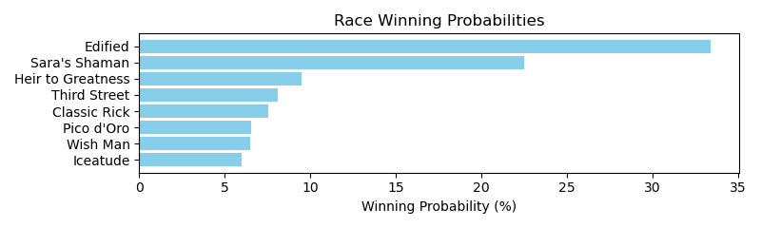

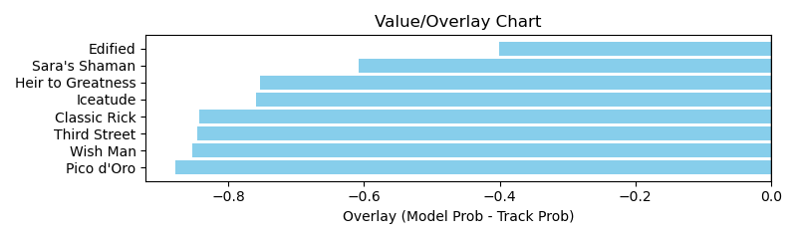

NOTE: GCSF - Global Combined Speed Figure

# Race: HOU | 2025-04-05 | Race #5 | Post: 15:00 | Track: SAM HOUSTON RACE PARK

Track: SAM HOUSTON RACE PARK

|  |  |  |  |  |  |
| --- | --- | --- | --- | --- | --- |
| Program # | Horse Name | Morn Odds | GCSF | Model Score | Win Prob (%) |
| 1 | Undo the Right | 5-2 | 102.7 | 0.72 | 12.46 |
| 2 | Not a Word | 12-1 | 90.1 | 0.59 | 8.30 |
| 3 | Ize a Blast | 9-2 | 107.8 | 0.82 | 16.26 |
| 4 | Spunoutofcontrol | 15-1 | 106.6 | 0.47 | 5.22 |
| 5 | She's Extra | 20-1 | 89.9 | 0.60 | 8.43 |
| 6 | Kinky Moon | 5-1 | 102.8 | 0.66 | 10.55 |
| 7 | Miss Mavis | 20-1 | 97.1 | 0.47 | 5.21 |
| 8 | Don't Touch | 20-1 | 108.9 | 0.56 | 7.35 |
| 9 | Contessa's Song | 8-1 | 91.9 | 0.71 | 12.00 |
| 10 | Hollywoodboulevard | 7-2 | 92.9 | 0.77 | 14.23 |

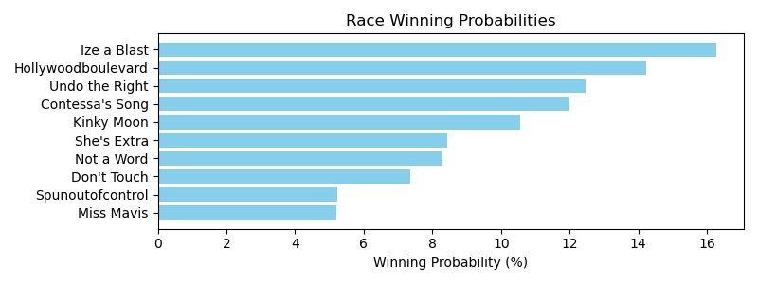

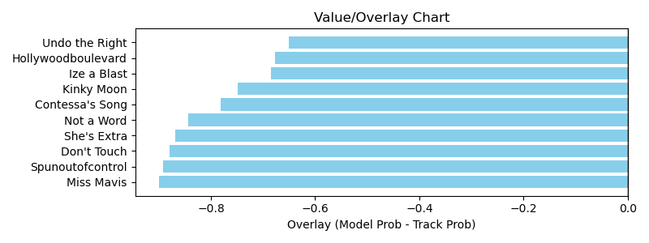

NOTE: GCSF - Global Combined Speed Figure

# Race: HOU | 2025-04-05 | Race #6 | Post: 15:30 | Track: SAM HOUSTON RACE PARK

Track: SAM HOUSTON RACE PARK

|  |  |  |  |  |  |
| --- | --- | --- | --- | --- | --- |
| Program # | Horse Name | Morn Odds | GCSF | Model Score | Win Prob (%) |
| 1 | Otherbrotherdaryl | 20-1 | 100.0 | 0.46 | 5.92 |
| 2 | Famous Tutt | 7-2 | 100.0 | 0.65 | 11.60 |
| 3 | Rocky Rock It | 3-1 | 92.8 | 0.73 | 14.95 |
| 4 | Charlie Dont Surf | 10-1 | 100.0 | 0.54 | 8.14 |
| 5 | Gus Cause | 20-1 | 104.7 | 0.43 | 5.05 |
| 6 | Binary Code | 9-2 | 100.0 | 0.78 | 16.89 |
| 7 | Roman Eagle | 6-1 | 108.9 | 0.68 | 12.88 |
| 8 | Hank Ridge | 30-1 | 106.6 | 0.41 | 4.51 |
| 9 | Cheating Heart | 10-1 | 93.4 | 0.58 | 9.32 |
| 10 | My Golden Calbo | 30-1 | 100.0 | 0.47 | 5.99 |
| 11 | Last Affair | 20-1 | 106.6 | 0.42 | 4.77 |

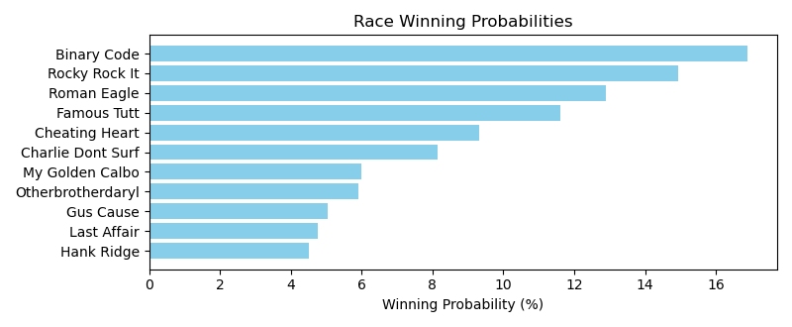

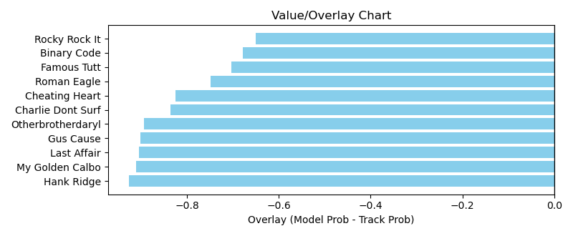

NOTE: GCSF - Global Combined Speed Figure

# Race: HOU | 2025-04-05 | Race #7 | Post: 16:00 | Track: SAM HOUSTON RACE PARK

Track: SAM HOUSTON RACE PARK

|  |  |  |  |  |  |
| --- | --- | --- | --- | --- | --- |
| Program # | Horse Name | Morn Odds | GCSF | Model Score | Win Prob (%) |
| 1 | Moon Crater | 10-1 | 100.7 | 0.68 | 9.71 |
| 2 | Edge Chaser | 3-1 | 100.7 | 0.79 | 13.33 |
| 3 | Love Me Some Candy | 6-1 | 100.0 | 0.77 | 12.56 |
| 4 | Spirit of Veterans | 12-1 | 97.2 | 0.59 | 7.22 |
| 5 | Franny | 8-1 | 91.1 | 0.53 | 5.93 |
| 6 | DOC'S DELIGHT | 10-1 | 93.4 | 0.57 | 6.83 |
| 7 | Holiday Cruise | 20-1 | 88.6 | 0.53 | 5.80 |
| 8 | R S AMERICAN TIDE | 12-1 | 100.0 | 0.56 | 6.56 |
| 9 | Maypearl | 10-1 | 100.0 | 0.57 | 6.73 |
| 10 | Chica Competitiva | 6-1 | 100.0 | 0.61 | 7.75 |
| 11 | Clarisit | 15-1 | 94.5 | 0.57 | 6.72 |
| 12 | SIMPLY GORGEOUS | 20-1 | 100.0 | 0.56 | 6.45 |
| 13 | Checker's Song | 30-1 | 100.0 | 0.46 | 4.41 |

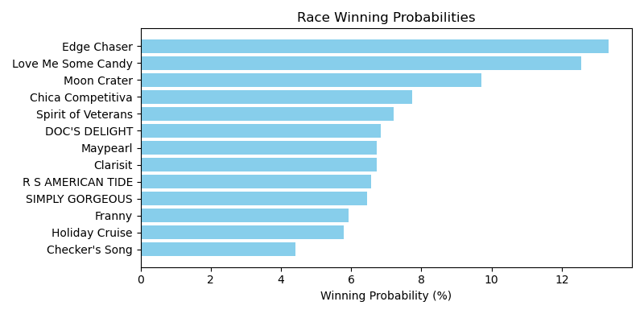

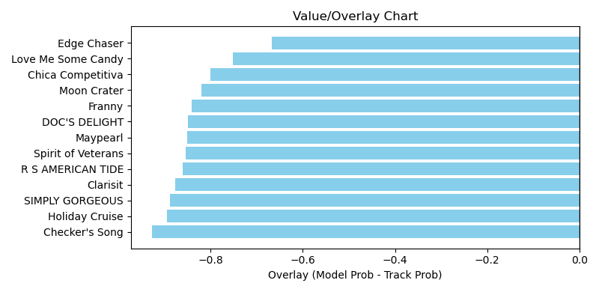

NOTE: GCSF - Global Combined Speed Figure

# Race: HOU | 2025-04-05 | Race #8 | Post: 16:30 | Track: SAM HOUSTON RACE PARK

Track: SAM HOUSTON RACE PARK

|  |  |  |  |  |  |
| --- | --- | --- | --- | --- | --- |
| Program # | Horse Name | Morn Odds | GCSF | Model Score | Win Prob (%) |
| 1 | Walksonwater | 30-1 | 100.0 | 0.63 | 5.00 |
| 2 | Sweet Karat Cake | 12-1 | 101.9 | 1.16 | 17.45 |
| 3 | Mayapretty | 30-1 | 102.0 | 0.56 | 3.90 |
| 4 | Chaton Rouge | 20-1 | 103.2 | 0.64 | 5.18 |
| 5 | Cafezinho | 7-2 | 104.8 | 1.25 | 20.30 |
| 6 | Utsira | 4-1 | 102.3 | 0.80 | 8.10 |
| 7 | Ruby Cantu | 8-1 | 108.5 | 1.14 | 16.90 |
| 8 | Panthera | 6-1 | 108.5 | 0.79 | 7.87 |
| 9 | Girls Got Game | 20-1 | 97.8 | 0.61 | 4.67 |
| 10 | Moonlight Gambler | 2-1 | 108.9 | 0.91 | 10.63 |

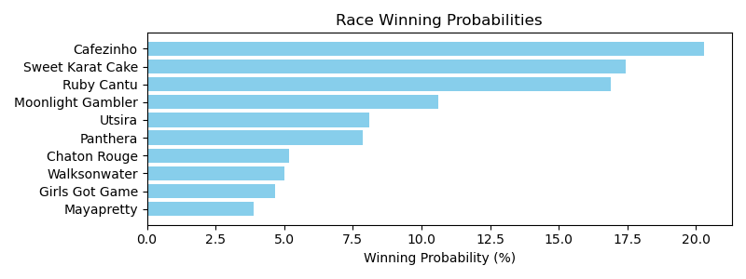

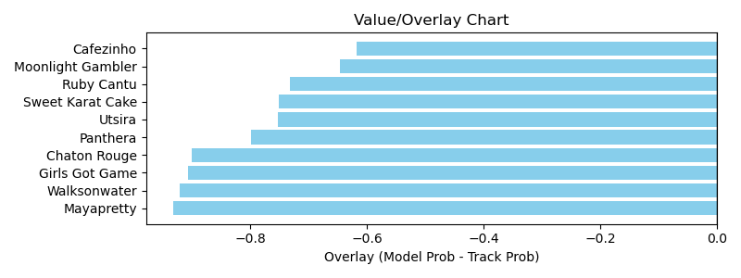

NOTE: GCSF - Global Combined Speed Figure

# Race: HOU | 2025-04-06 | Race #1 | Post: 13:00 | Track: SAM HOUSTON RACE PARK

Track: SAM HOUSTON RACE PARK

|  |  |  |  |  |  |
| --- | --- | --- | --- | --- | --- |
| Program # | Horse Name | Morn Odds | GCSF | Model Score | Win Prob (%) |
| 1 | Lavender Will | 30-1 | 109.7 | 0.41 | 5.47 |
| 2 | Golly Holly | 5-8 | 94.2 | 0.80 | 21.08 |
| 3 | Sherrys Ridge | 20-1 | 99.6 | 0.46 | 6.88 |
| 4 | DIXIE'S HEART | 10-1 | 100.0 | 0.63 | 12.91 |
| 5 | Expect a Patriot | 6-1 | 100.0 | 0.77 | 19.70 |
| 6 | Songerie | 4-1 | 100.3 | 0.77 | 19.68 |
| 7 | A Thousand Sails | 20-1 | 100.0 | 0.43 | 5.87 |
| 8 | Imagoldensong | 15-1 | 110.1 | 0.51 | 8.40 |

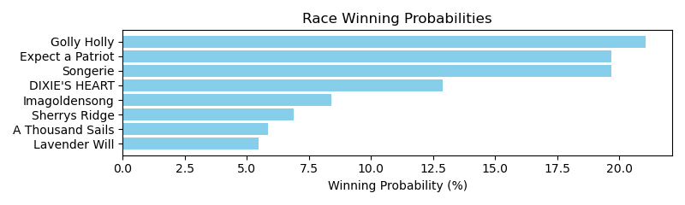

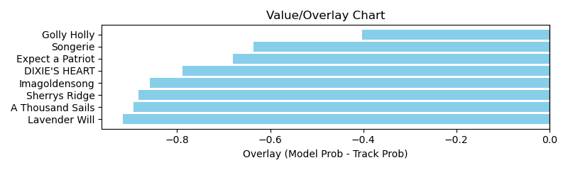

NOTE: GCSF - Global Combined Speed Figure

# Race: HOU | 2025-04-06 | Race #2 | Post: 13:30 | Track: SAM HOUSTON RACE PARK

Track: SAM HOUSTON RACE PARK

|  |  |  |  |  |  |
| --- | --- | --- | --- | --- | --- |
| Program # | Horse Name | Morn Odds | GCSF | Model Score | Win Prob (%) |
| 1 | Callin for Dollars | 13-8 | 99.3 | 1.30 | 28.60 |
| 2 | In Open Court | 9-2 | 105.3 | 0.68 | 7.67 |
| 3 | Factor That | 12-1 | 119.9 | 0.87 | 12.57 |
| 4 | Lexington Diva | 8-1 | 94.5 | 0.68 | 7.51 |
| 5 | Cactus Blossom | 6-1 | 93.8 | 0.80 | 10.54 |
| 6 | Run Witt Run | 20-1 | 102.6 | 0.61 | 6.19 |
| 7 | Keep the Bling | 10-1 | 94.5 | 0.70 | 7.98 |
| 8 | Gypsan | 4-1 | 95.8 | 1.06 | 18.95 |

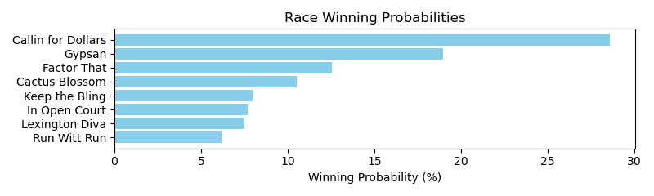

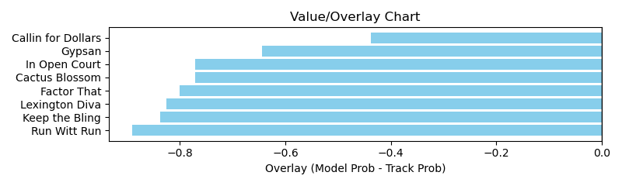

NOTE: GCSF - Global Combined Speed Figure

# Race: HOU | 2025-04-06 | Race #3 | Post: 14:00 | Track: SAM HOUSTON RACE PARK

Track: SAM HOUSTON RACE PARK

|  |  |  |  |  |  |
| --- | --- | --- | --- | --- | --- |
| Program # | Horse Name | Morn Odds | GCSF | Model Score | Win Prob (%) |
| 1 | JAMIE ZEE | 6-1 | 100.0 | 0.61 | 13.65 |
| 2 | Glitters Andie | 9-2 | 92.8 | 0.59 | 12.82 |
| 3 | Maybelly | 1-1 | 93.4 | 0.63 | 14.63 |
| 4 | Charming Leah | 15-1 | 99.5 | 0.60 | 13.13 |
| 5 | DOC'S DELIGHT | 12-1 | 106.6 | 0.58 | 12.27 |
| 6 | Mucho Vapor | 3-1 | 100.0 | 0.79 | 22.83 |
| 7 | Isobela | 20-1 | 100.0 | 0.54 | 10.66 |

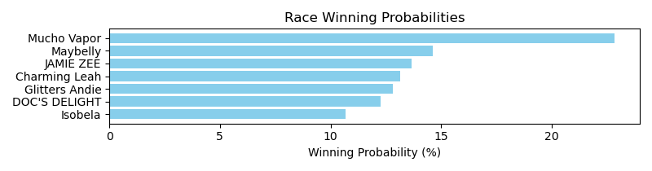

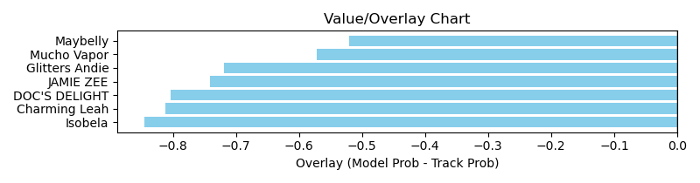

NOTE: GCSF - Global Combined Speed Figure

# Race: HOU | 2025-04-06 | Race #4 | Post: 14:30 | Track: SAM HOUSTON RACE PARK

Track: SAM HOUSTON RACE PARK

|  |  |  |  |  |  |
| --- | --- | --- | --- | --- | --- |
| Program # | Horse Name | Morn Odds | GCSF | Model Score | Win Prob (%) |
| 1 | Its My Money Too | 5-2 | 99.4 | 0.76 | 10.33 |
| 2 | Math Mystery | 8-1 | 107.6 | 0.81 | 11.98 |
| 3 | Wicked Song | 6-1 | 125.6 | 0.76 | 10.46 |
| 4 | Turn On the Bling | 7-2 | 92.8 | 0.77 | 10.77 |
| 5 | Sharp Likeness | 9-2 | 102.2 | 0.75 | 10.22 |
| 6 | Miss Carmen Cibo | 20-1 | 94.6 | 1.03 | 19.48 |
| 7 | Jaded Tiger | 30-1 | 100.0 | 0.61 | 6.58 |
| 8 | Desert Glow | 6-1 | 92.9 | 0.80 | 11.55 |
| 9 | Coinmaker | 8-1 | 102.6 | 0.69 | 8.62 |

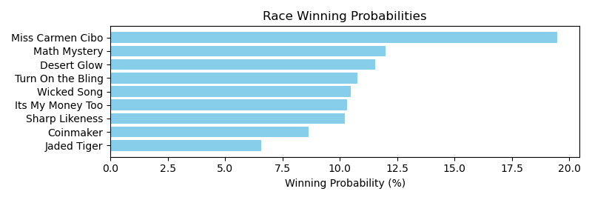

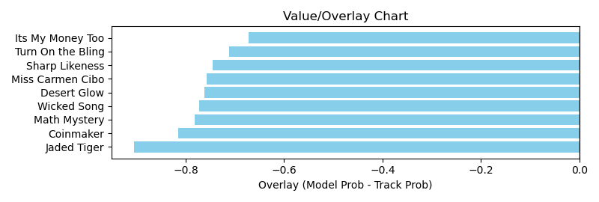

NOTE: GCSF - Global Combined Speed Figure

# Race: HOU | 2025-04-06 | Race #5 | Post: 15:00 | Track: SAM HOUSTON RACE PARK

Track: SAM HOUSTON RACE PARK

|  |  |  |  |  |  |
| --- | --- | --- | --- | --- | --- |
| Program # | Horse Name | Morn Odds | GCSF | Model Score | Win Prob (%) |
| 1 | Good Swimmer | 9-2 | 98.2 | 0.91 | 8.50 |
| 2 | Excaping the Blues | 8-1 | 106.7 | 1.10 | 12.49 |
| 3 | Noble Eagle | 20-1 | 114.9 | 0.67 | 4.49 |
| 4 | Courageously | 30-1 | 95.5 | 0.71 | 5.16 |
| 5 | Coastal Brink | 3-1 | 100.8 | 0.94 | 9.00 |
| 6 | Up Up and Away | 20-1 | 86.0 | 1.06 | 11.63 |
| 7 | Mo Saturdays | 10-1 | 98.2 | 0.84 | 7.27 |
| 8 | Sarge's Sermon | 15-1 | 95.9 | 0.69 | 4.87 |
| 9 | Twenty One Skidoo | 6-1 | 89.6 | 0.91 | 8.52 |
| 10 | News At Nine | 5-1 | 98.5 | 0.83 | 6.97 |
| 11 | My Calante | 50-1 | 104.1 | 1.09 | 12.21 |
| 12 | Moon Cat | 8-1 | 102.5 | 0.93 | 8.87 |

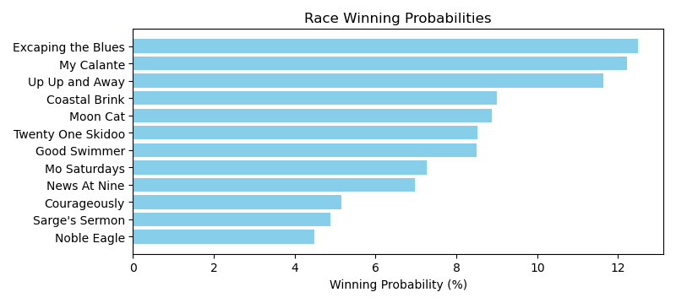

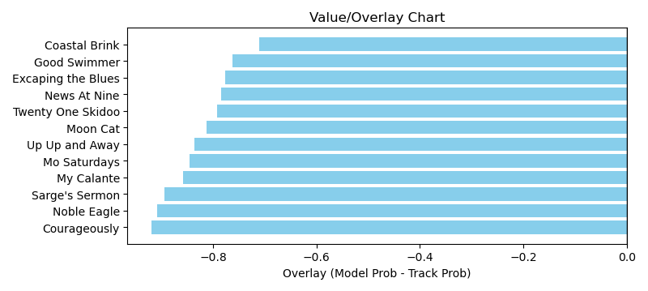

NOTE: GCSF - Global Combined Speed Figure

# Race: HOU | 2025-04-06 | Race #6 | Post: 15:30 | Track: SAM HOUSTON RACE PARK

Track: SAM HOUSTON RACE PARK

|  |  |  |  |  |  |
| --- | --- | --- | --- | --- | --- |
| Program # | Horse Name | Morn Odds | GCSF | Model Score | Win Prob (%) |
| 1 | Chasing the Rush | 20-1 | 90.0 | 0.51 | 6.91 |
| 2 | Berry Mischievous | 9-5 | 93.4 | 0.82 | 18.46 |
| 3 | Bradix | 8-1 | 97.9 | 0.60 | 9.77 |
| 4 | Sippin Scotch | 6-1 | 94.1 | 0.56 | 8.48 |
| 5 | Snowmageddon | 20-1 | 100.0 | 0.47 | 5.80 |
| 6 | Obvious Conclusion | 4-1 | 94.1 | 0.67 | 12.32 |
| 7 | Spiders Revenge | 30-1 | 86.5 | 0.44 | 5.07 |
| 8 | Fly Red Bird Fly | 15-1 | 92.6 | 0.53 | 7.54 |
| 9 | Doc Henry Ridge | 30-1 | 105.0 | 0.44 | 5.16 |
| 10 | Curly's One Thing | 10-1 | 100.0 | 0.52 | 7.27 |
| 11 | Pollito Tito | 20-1 | 93.4 | 0.51 | 7.00 |
| 12 | Super Ekati | 12-1 | 93.3 | 0.48 | 6.22 |

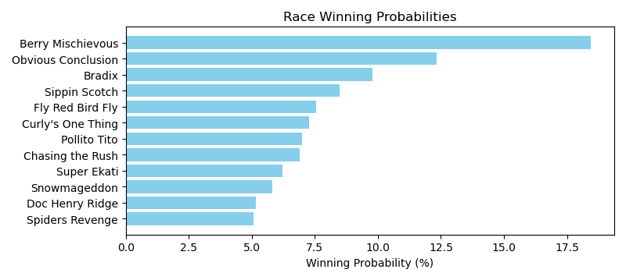

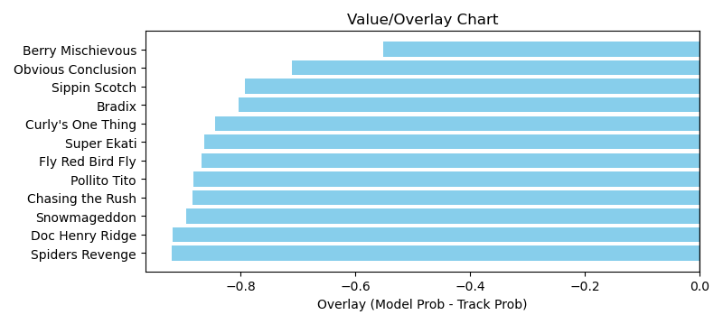

NOTE: GCSF - Global Combined Speed Figure

# Race: HOU | 2025-04-06 | Race #7 | Post: 16:00 | Track: SAM HOUSTON RACE PARK

Track: SAM HOUSTON RACE PARK

|  |  |  |  |  |  |
| --- | --- | --- | --- | --- | --- |
| Program # | Horse Name | Morn Odds | GCSF | Model Score | Win Prob (%) |
| 1 | I'm a Cowboy | 12-1 | 108.6 | 0.75 | 7.67 |
| 2 | Barefoot Samurai | 8-1 | 86.8 | 0.77 | 8.04 |
| 3 | Hard Gold | 10-1 | 95.5 | 0.75 | 7.67 |
| 4 | Pinky Ring Bling | 6-1 | 108.1 | 0.92 | 11.63 |
| 5 | Witt's Taquito | 6-1 | 91.2 | 0.82 | 9.18 |
| 6 | Barbacoa | 20-1 | 88.8 | 0.71 | 6.74 |
| 7 | Veracruzin | 4-1 | 101.2 | 0.87 | 10.31 |
| 8 | Will the Thrill | 15-1 | 92.3 | 0.75 | 7.71 |
| 9 | Talk About Autism | 8-1 | 121.5 | 0.78 | 8.24 |
| 10 | Midnight Hunter | 30-1 | 106.9 | 0.55 | 4.01 |
| 11 | Bandera Bling | 12-1 | 106.3 | 0.71 | 6.73 |
| 12 | Stans Home Run | 9-2 | 89.2 | 0.94 | 12.05 |

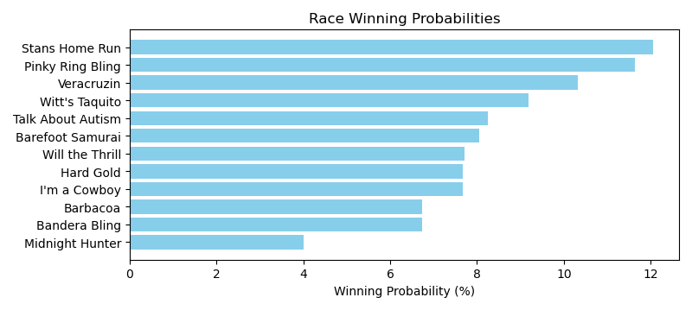

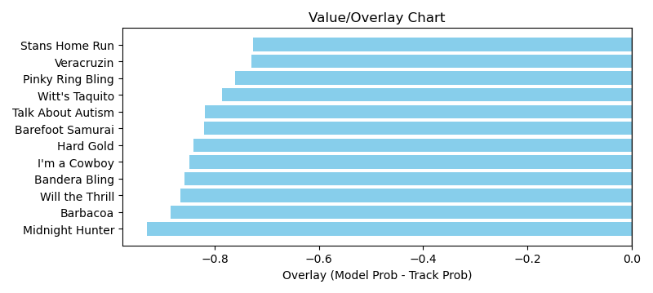

NOTE: GCSF - Global Combined Speed Figure

# Race: HOU | 2025-04-06 | Race #8 | Post: 16:30 | Track: SAM HOUSTON RACE PARK

Track: SAM HOUSTON RACE PARK

|  |  |  |  |  |  |
| --- | --- | --- | --- | --- | --- |
| Program # | Horse Name | Morn Odds | GCSF | Model Score | Win Prob (%) |
| 1 | Imua Kai | 3-1 | 93.4 | 1.56 | 27.09 |
| 2 | Prowling Tiger | 20-1 | 93.7 | 0.81 | 7.11 |
| 3 | Papa Rizzo | 20-1 | 87.2 | 0.67 | 4.73 |
| 4 | Country Caper | 6-1 | 110.4 | 0.86 | 7.99 |
| 5 | From the Heart | 8-1 | 100.0 | 0.95 | 9.88 |
| 6 | Cliff Diver | 30-1 | 97.0 | 0.78 | 6.46 |
| 7 | Sonic Posse | 10-1 | 106.6 | 0.77 | 6.38 |
| 8 | Paintbrush | 30-1 | 97.7 | 0.71 | 5.42 |
| 9 | Cinco Richie | 4-1 | 96.2 | 0.89 | 8.61 |
| 10 | Sharp Spark | 8-1 | 105.3 | 0.86 | 7.90 |
| 11 | A. P.'s Secret | 9-2 | 108.0 | 0.88 | 8.44 |

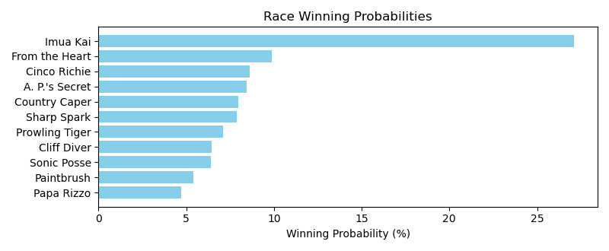

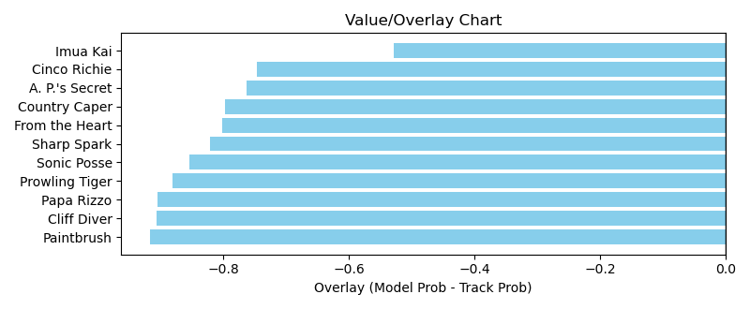

NOTE: GCSF - Global Combined Speed Figure

# Race: TSA | 2025-04-05 | Race #1 | Post: 12:00 | Track: SANTA ANITA PARK

Track: SANTA ANITA PARK

|  |  |  |  |  |  |
| --- | --- | --- | --- | --- | --- |
| Program # | Horse Name | Morn Odds | GCSF | Model Score | Win Prob (%) |
| 1 | Go Cami Oh | 30-1 | 99.1 | 0.56 | 4.93 |
| 2 | DERTIEN | 20-1 | 100.0 | 0.60 | 5.64 |
| 3 | STARSHIP SEDONA | 12-1 | 100.0 | 0.64 | 6.61 |
| 4 | VERY SMART | 6-1 | 100.0 | 0.67 | 7.20 |
| 5 | Guiltyofhavingfun | 5-1 | 93.4 | 0.98 | 15.69 |
| 6 | Miss McKinzie | 15-1 | 106.6 | 0.65 | 6.77 |
| 7 | GOTTA SECRET | 15-1 | 100.0 | 0.62 | 6.17 |
| 8 | KIKURIDE | 12-1 | 100.0 | 0.66 | 6.92 |
| 9 | Miss Practical | 3-1 | 100.0 | 0.86 | 12.08 |
| 10 | Odies Memory Lane | 9-2 | 95.8 | 0.88 | 12.48 |
| 11 | Darlin Tami | 10-1 | 106.6 | 0.81 | 10.62 |
| 12 | Elsa Dutton | 12-1 | 100.0 | 0.55 | 4.87 |

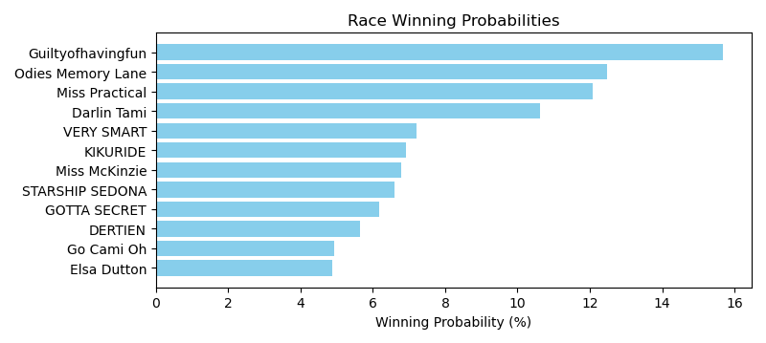

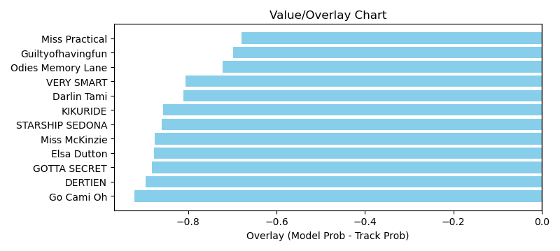

NOTE: GCSF - Global Combined Speed Figure

# Race: TSA | 2025-04-05 | Race #2 | Post: 12:30 | Track: SANTA ANITA PARK

Track: SANTA ANITA PARK

|  |  |  |  |  |  |
| --- | --- | --- | --- | --- | --- |
| Program # | Horse Name | Morn Odds | GCSF | Model Score | Win Prob (%) |
| 1 | Triple Diamonds | 5-1 | 93.4 | 1.26 | 21.77 |
| 2 | I'm a Bad Boy | 5-2 | 90.6 | 1.01 | 13.74 |
| 3 | R Heisman | 6-1 | 94.0 | 0.91 | 11.10 |
| 4 | Mr. Machupicchu | 30-1 | 106.0 | 0.70 | 6.50 |
| 5 | Drop Um | 4-1 | 93.4 | 1.01 | 13.71 |
| 6 | Style Cat | 3-1 | 88.4 | 0.97 | 12.58 |
| 7 | Bro Bro | 8-1 | 100.0 | 1.08 | 15.81 |
| 8 | TITANIC THOMPSON | 12-1 | 100.0 | 0.60 | 4.79 |

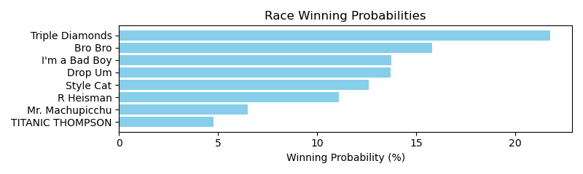

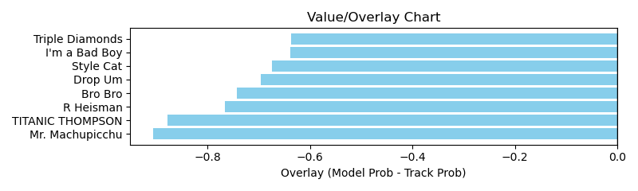

NOTE: GCSF - Global Combined Speed Figure

# Race: TSA | 2025-04-05 | Race #3 | Post: 13:00 | Track: SANTA ANITA PARK

Track: SANTA ANITA PARK

|  |  |  |  |  |  |
| --- | --- | --- | --- | --- | --- |
| Program # | Horse Name | Morn Odds | GCSF | Model Score | Win Prob (%) |
| 1 | Jeweled Shillelagh | 3-1 | 102.9 | 1.64 | 29.04 |
| 2 | Takes Three | 20-1 | 96.6 | 0.87 | 7.97 |
| 3 | Guy Named Joe | 9-2 | 95.6 | 1.00 | 10.58 |
| 4 | Moonlit Sonata | 8-1 | 104.8 | 1.06 | 11.93 |
| 5 | Mystification | 6-1 | 95.4 | 0.86 | 7.74 |
| 6 | dh-Freeport Joe | 30-1 | 104.4 | 0.81 | 6.81 |
| 7 | Packs a Wahlop | 5-1 | 94.0 | 1.01 | 10.78 |
| 8 | Beef Winslow | 2-1 | 107.4 | 1.19 | 15.14 |

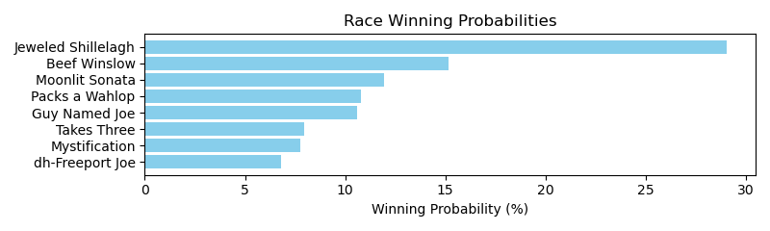

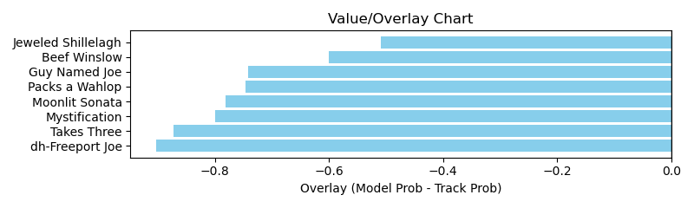

NOTE: GCSF - Global Combined Speed Figure

# Race: TSA | 2025-04-05 | Race #4 | Post: 13:30 | Track: SANTA ANITA PARK

Track: SANTA ANITA PARK

|  |  |  |  |  |  |
| --- | --- | --- | --- | --- | --- |
| Program # | Horse Name | Morn Odds | GCSF | Model Score | Win Prob (%) |
| 1 | Look Forward | 10-1 | 87.1 | 1.39 | 26.18 |
| 2 | Silent Law | 8-1 | 106.6 | 0.84 | 9.18 |
| 3 | Vodka With a Twist | 4-1 | 109.7 | 1.06 | 14.84 |
| 4 | Tenma | 1-1 | 89.5 | 1.00 | 13.40 |
| 5 | No Bad Beats | 7-2 | 113.5 | 1.33 | 23.74 |
| 6 | Madame Secretary | 6-1 | 93.4 | 0.98 | 12.66 |

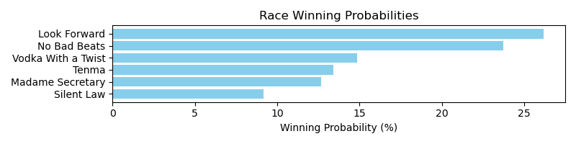

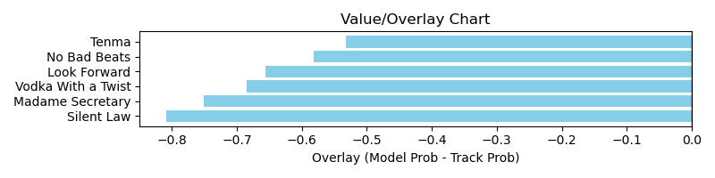

NOTE: GCSF - Global Combined Speed Figure

# Race: TSA | 2025-04-05 | Race #5 | Post: 14:00 | Track: SANTA ANITA PARK

Track: SANTA ANITA PARK

|  |  |  |  |  |  |
| --- | --- | --- | --- | --- | --- |
| Program # | Horse Name | Morn Odds | GCSF | Model Score | Win Prob (%) |
| 1 | Omaha Girl | 20-1 | 89.6 | 0.86 | 7.58 |
| 2 | Safa | 8-1 | 98.8 | 1.00 | 10.27 |
| 3 | Ang N Ash | 15-1 | 96.2 | 0.96 | 9.36 |
| 4 | Queen of the Mud (IRE) | 5-2 | 108.8 | 1.16 | 13.90 |
| 5 | Venganza | 4-1 | 101.9 | 1.63 | 27.67 |
| 6 | Queen Maxima | 4-5 | 97.3 | 1.73 | 31.22 |

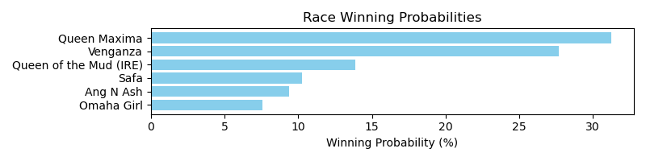

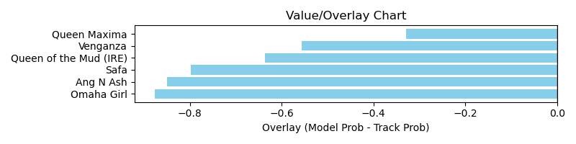

NOTE: GCSF - Global Combined Speed Figure

# Race: TSA | 2025-04-05 | Race #6 | Post: 14:30 | Track: SANTA ANITA PARK

Track: SANTA ANITA PARK

|  |  |  |  |  |  |
| --- | --- | --- | --- | --- | --- |
| Program # | Horse Name | Morn Odds | GCSF | Model Score | Win Prob (%) |
| 1 | Om N Joy | 10-1 | 104.2 | 0.72 | 6.88 |
| 2 | Big Soiree | 30-1 | 100.0 | 0.60 | 4.64 |
| 3 | America's Mark | 5-2 | 106.6 | 1.24 | 20.77 |
| 4 | In the Air Tonight | 7-2 | 94.9 | 0.93 | 11.65 |
| 5 | Going Deep | 6-1 | 106.6 | 1.00 | 13.42 |
| 6 | Hot Girl Walk | 5-1 | 92.8 | 0.72 | 6.90 |
| 7 | Sunset Grazen | 8-1 | 96.5 | 0.78 | 7.97 |
| 8 | Gold Currency | 6-1 | 100.0 | 0.87 | 10.09 |
| 9 | Knightwithlouis | 12-1 | 112.8 | 1.14 | 17.68 |

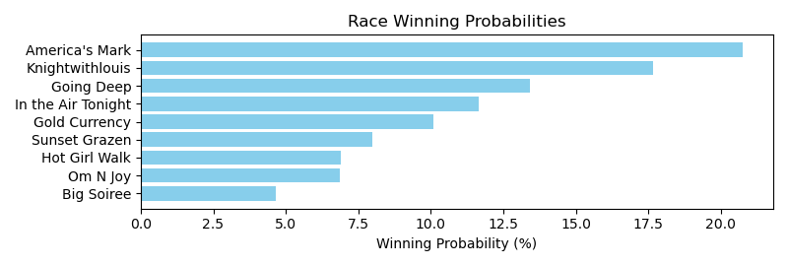

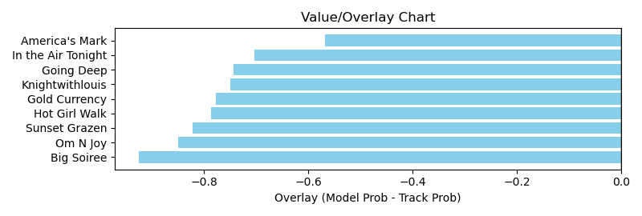

NOTE: GCSF - Global Combined Speed Figure

# Race: TSA | 2025-04-05 | Race #7 | Post: 15:00 | Track: SANTA ANITA PARK

Track: SANTA ANITA PARK

|  |  |  |  |  |  |
| --- | --- | --- | --- | --- | --- |
| Program # | Horse Name | Morn Odds | GCSF | Model Score | Win Prob (%) |
| 1 | Sei Bella | 5-2 | 100.0 | 0.81 | 11.04 |
| 2 | STRAKER | 12-1 | 100.0 | 0.66 | 7.28 |
| 3 | Stubborn | 10-1 | 100.0 | 0.61 | 6.29 |
| 4 | TIGHT SQUEEZE | 8-1 | 100.0 | 0.72 | 8.81 |
| 5 | TIMEKEEPER'S CHARM | 20-1 | 100.0 | 0.60 | 6.09 |
| 6 | Ridegold | 7-2 | 100.0 | 0.75 | 9.51 |
| 7 | Less Is More | 5-1 | 95.2 | 0.93 | 14.93 |
| 8 | ADVERSE SELECTION | 20-1 | 100.0 | 0.60 | 5.98 |
| 9 | WILD CAT DANZING | 30-1 | 100.0 | 0.57 | 5.48 |
| 10 | Maria Tallchief | 6-1 | 106.6 | 0.87 | 12.92 |
| 11 | BABE KELSO | 30-1 | 100.0 | 0.60 | 6.00 |
| 12 | ENJOY | 30-1 | 100.0 | 0.58 | 5.67 |

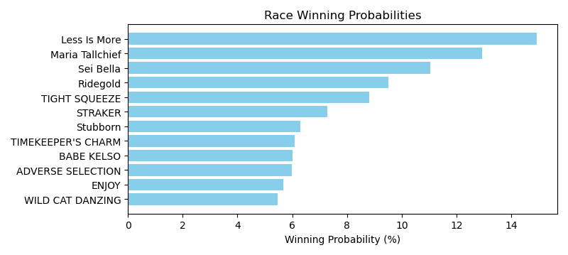

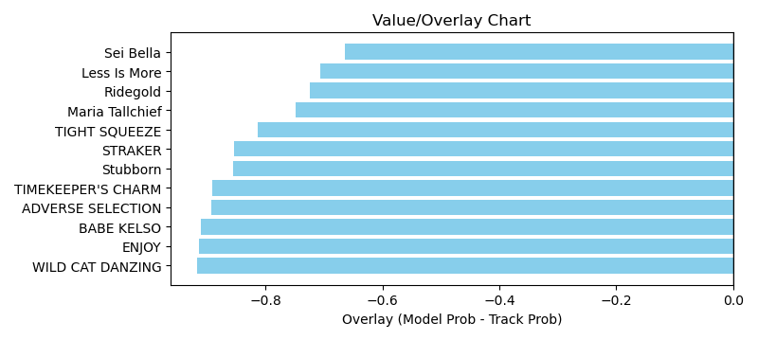

NOTE: GCSF - Global Combined Speed Figure

# Race: TSA | 2025-04-05 | Race #8 | Post: 15:30 | Track: SANTA ANITA PARK

Track: SANTA ANITA PARK

|  |  |  |  |  |  |
| --- | --- | --- | --- | --- | --- |
| Program # | Horse Name | Morn Odds | GCSF | Model Score | Win Prob (%) |
| 1 | OAKLEY'S SMILE | 15-1 | 100.0 | 0.60 | 6.08 |
| 2 | Western Freedom | 5-1 | 100.0 | 0.91 | 14.27 |
| 3 | Outworker | 10-1 | 100.0 | 0.67 | 7.65 |
| 4 | Silver I Am | 12-1 | 100.0 | 0.58 | 5.71 |
| 5 | Drop the Bit | 30-1 | 100.0 | 0.51 | 4.41 |
| 6 | Keithing Thunder | 30-1 | 100.0 | 0.65 | 7.06 |
| 7 | Beer Buzz | 5-2 | 100.0 | 0.78 | 10.37 |
| 8 | NON DOMICILE | 7-2 | 100.0 | 0.66 | 7.42 |
| 9 | Falcon Wings | 30-1 | 105.1 | 0.51 | 4.29 |
| 10 | Fix It Quick | 15-1 | 93.4 | 0.72 | 8.80 |
| 11 | Far Over Loaded | 30-1 | 99.3 | 0.65 | 7.09 |
| 12 | Gemini Buzz | 8-1 | 100.0 | 0.72 | 8.79 |
| 13 | Horizon Wildcat | 15-1 | 93.4 | 0.69 | 8.05 |

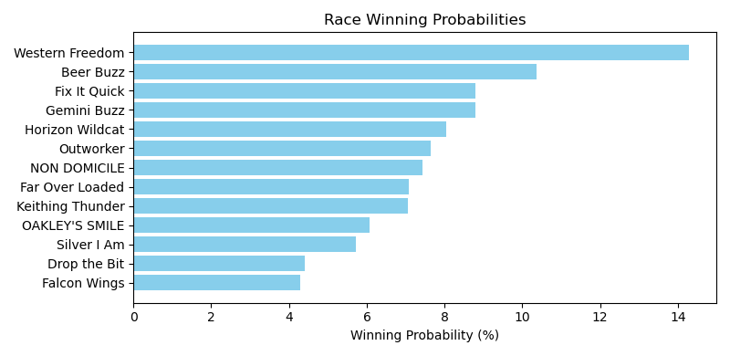

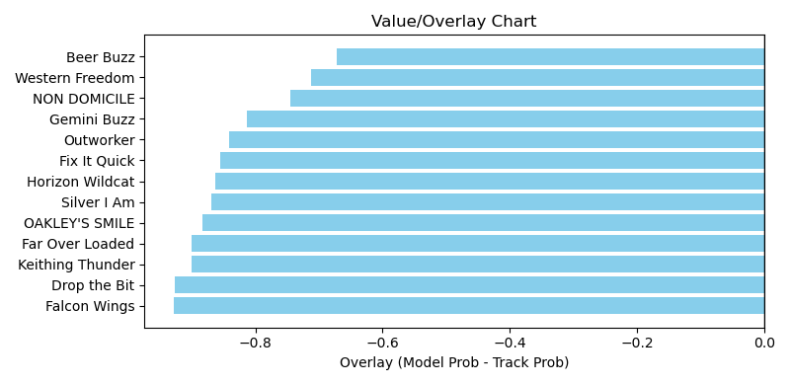

NOTE: GCSF - Global Combined Speed Figure

# Race: TSA | 2025-04-05 | Race #9 | Post: 16:00 | Track: SANTA ANITA PARK

Track: SANTA ANITA PARK

|  |  |  |  |  |  |
| --- | --- | --- | --- | --- | --- |
| Program # | Horse Name | Morn Odds | GCSF | Model Score | Win Prob (%) |
| 1 | Sir Rocket | 10-1 | 100.0 | 1.02 | 8.79 |
| 2 | Razen the Stakes | 30-1 | 93.6 | 0.69 | 3.88 |
| 3 | Cousin Richie | 30-1 | 83.7 | 0.71 | 4.22 |
| 4 | Uncle Chilly | 3-1 | 114.3 | 1.53 | 19.97 |
| 5 | Brazenly | 10-1 | 90.2 | 0.79 | 5.22 |
| 6 | Chromeflash | 10-1 | 96.7 | 0.88 | 6.45 |
| 7 | Smiling Beast | 6-1 | 93.4 | 1.10 | 10.20 |
| 8 | Piper's Causeway | 6-1 | 104.3 | 1.02 | 8.80 |
| 9 | Where's the Loot | 20-1 | 105.9 | 0.81 | 5.44 |
| 10 | Private Gem | 7-2 | 106.6 | 1.03 | 8.93 |
| 11 | Idaho Once | 20-1 | 98.4 | 0.82 | 5.62 |
| 12 | Catmansue | 15-1 | 94.6 | 0.74 | 4.59 |
| 13 | Windribbon | 8-1 | 104.6 | 0.97 | 7.90 |

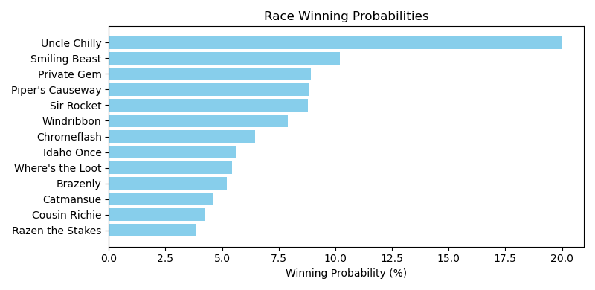

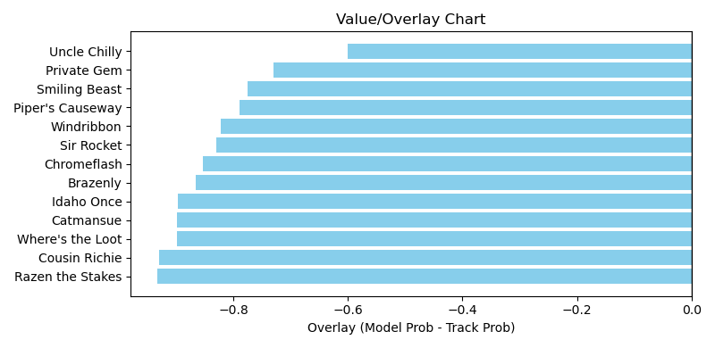

NOTE: GCSF - Global Combined Speed Figure

# Race: TSA | 2025-04-05 | Race #10 | Post: 16:30 | Track: SANTA ANITA PARK

Track: SANTA ANITA PARK

|  |  |  |  |  |  |
| --- | --- | --- | --- | --- | --- |
| Program # | Horse Name | Morn Odds | GCSF | Model Score | Win Prob (%) |
| 1 | Journalism | 6-5 | 106.6 | 1.64 | 30.57 |
| 2 | Citizen Bull | 9-5 | 97.8 | 1.56 | 27.63 |
| 3 | Westwood | 20-1 | 106.6 | 0.89 | 8.75 |
| 4 | Barnes | 3-1 | 106.6 | 1.44 | 23.59 |
| 5 | Baeza | 6-1 | 93.4 | 0.92 | 9.46 |

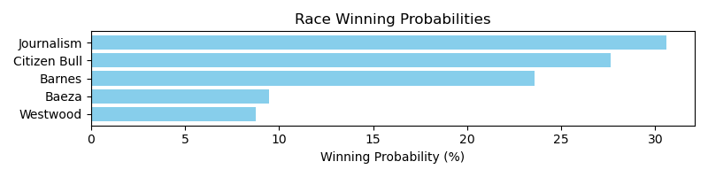

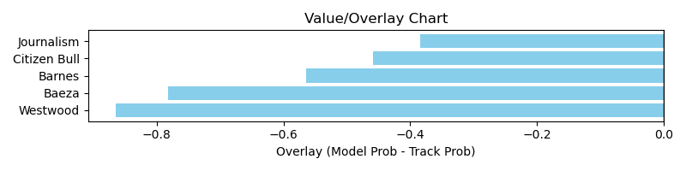

NOTE: GCSF - Global Combined Speed Figure

# Race: TSA | 2025-04-05 | Race #11 | Post: 17:00 | Track: SANTA ANITA PARK

Track: SANTA ANITA PARK

|  |  |  |  |  |  |
| --- | --- | --- | --- | --- | --- |
| Program # | Horse Name | Morn Odds | GCSF | Model Score | Win Prob (%) |
| 1 | Montjica (FR) | 15-1 | 100.0 | 0.65 | 3.32 |
| 2 | Idessia | 30-1 | 105.0 | 0.73 | 4.22 |
| 3 | Miss Mandalay (GB) | 12-1 | 99.5 | 0.90 | 6.46 |
| 4 | Soho | 5-1 | 102.9 | 1.00 | 8.06 |
| 5 | Miss Roberts (GB) | 8-1 | 104.6 | 0.98 | 7.71 |
| 6 | Thermal | 20-1 | 111.1 | 0.83 | 5.50 |
| 7 | Summer Lake | 20-1 | 99.9 | 0.76 | 4.56 |
| 8 | Not A Sinner (GB) | 7-2 | 97.3 | 1.10 | 9.71 |
| 9 | Andiamo Ragazza | 15-1 | 96.6 | 0.75 | 4.39 |
| 10 | Nene Diamond | 3-1 | 99.2 | 1.56 | 19.99 |
| 11 | Shocking Grey | 6-1 | 104.2 | 1.29 | 13.53 |
| 12 | Quick Kate | 30-1 | 95.8 | 0.77 | 4.65 |
| 13 | Shin Jidai (GB) | 20-1 | 93.4 | 0.76 | 4.63 |
| 14 | Needlepoint (IRE) | 15-1 | 100.0 | 0.64 | 3.26 |

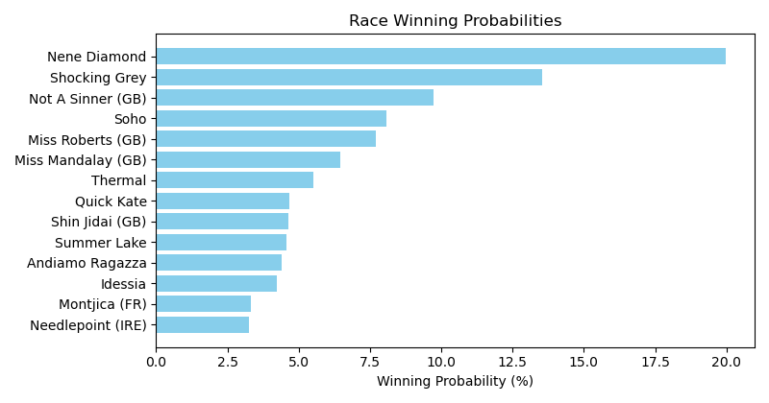

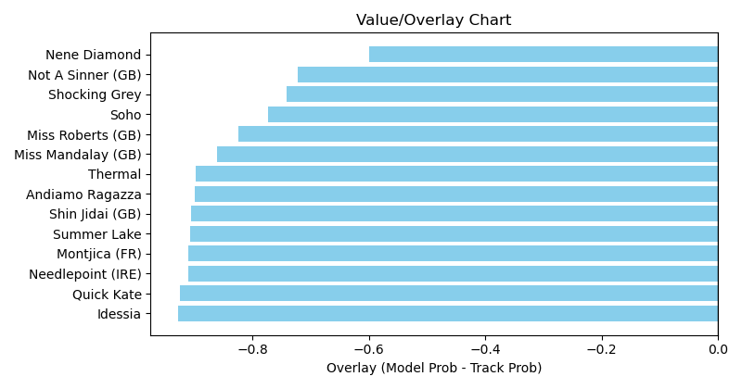

NOTE: GCSF - Global Combined Speed Figure

# Race: TSA | 2025-04-05 | Race #12 | Post: 17:30 | Track: SANTA ANITA PARK

Track: SANTA ANITA PARK

|  |  |  |  |  |  |
| --- | --- | --- | --- | --- | --- |
| Program # | Horse Name | Morn Odds | GCSF | Model Score | Win Prob (%) |
| 1 | Genius Jimmy | 5-1 | 111.3 | 1.47 | 18.48 |
| 2 | Lammas (GB) | 10-1 | 92.1 | 0.95 | 7.59 |
| 3 | Covey (GB) | 12-1 | 100.0 | 0.59 | 2.82 |
| 4 | Eye On Ry | 6-1 | 97.8 | 0.99 | 8.26 |
| 5 | Red Cross Knight | 8-1 | 103.0 | 1.03 | 8.91 |
| 6 | Man Among Men | 20-1 | 97.7 | 0.84 | 5.83 |
| 7 | Irish Prophet | 10-1 | 96.9 | 0.93 | 7.23 |
| 8 | Heart Headed | 6-1 | 101.0 | 1.06 | 9.53 |
| 9 | Cathal (IRE) | 7-2 | 93.6 | 1.18 | 11.67 |
| 10 | City Exile (GB) | 9-2 | 92.1 | 1.52 | 19.68 |

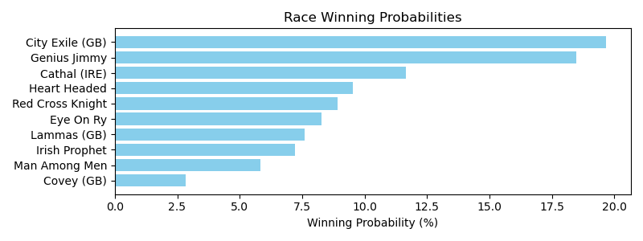

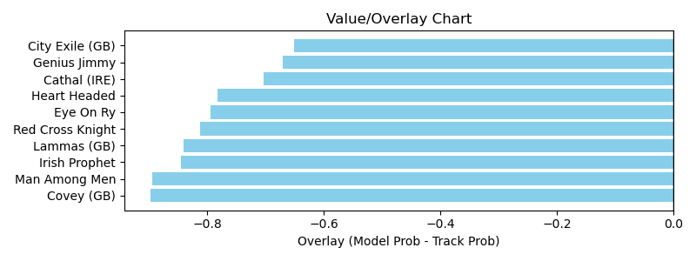

NOTE: GCSF - Global Combined Speed Figure

# Race: TAM | 2025-04-05 | Race #1 | Post: 12:35 | Track: TAMPA BAY DOWNS

Track: TAMPA BAY DOWNS

|  |  |  |  |  |  |
| --- | --- | --- | --- | --- | --- |
| Program # | Horse Name | Morn Odds | GCSF | Model Score | Win Prob (%) |
| 1 | Trophy Collector | 5-2 | 113.0 | 0.75 | 16.90 |
| 2 | Frankie R. | 20-1 | 105.2 | 0.53 | 8.20 |
| 3 | Diffusion | 30-1 | 106.6 | 0.46 | 6.19 |
| 4 | Right On Target | 3-1 | 95.8 | 0.69 | 14.20 |
| 5 | Two Stormy Oceans | 5-1 | 98.5 | 0.56 | 9.22 |
| 6 | Iconic Rock | 3-1 | 96.3 | 0.69 | 14.31 |
| 7 | Protest | 15-1 | 100.0 | 0.49 | 7.12 |
| 8 | Lucky Heart | 30-1 | 100.0 | 0.39 | 4.46 |
| 9 | Snovember | 6-1 | 91.5 | 0.63 | 11.88 |
| 10 | Zimbawee | 20-1 | 100.3 | 0.50 | 7.52 |

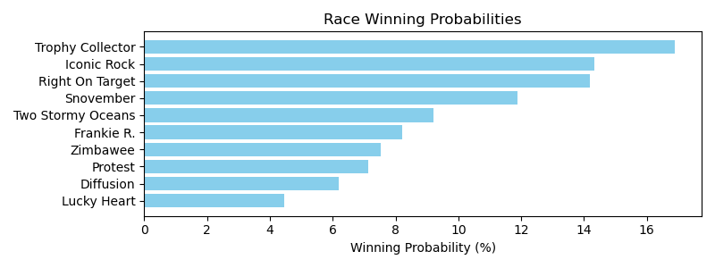

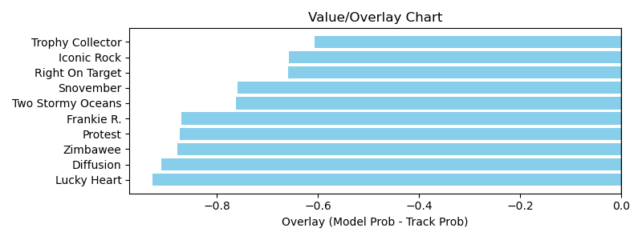

NOTE: GCSF - Global Combined Speed Figure

# Race: TAM | 2025-04-05 | Race #2 | Post: 13:10 | Track: TAMPA BAY DOWNS

Track: TAMPA BAY DOWNS

|  |  |  |  |  |  |
| --- | --- | --- | --- | --- | --- |
| Program # | Horse Name | Morn Odds | GCSF | Model Score | Win Prob (%) |
| 1 | Dorotea Dream | 4-1 | 90.6 | 0.67 | 11.37 |
| 2 | Miss Natasha | 9-2 | 100.0 | 0.60 | 9.23 |
| 3 | Nana Moon | 8-1 | 100.0 | 0.50 | 6.25 |
| 4 | Misspent | 7-2 | 105.7 | 0.77 | 15.21 |
| 5 | Baja de Oro | 30-1 | 90.7 | 0.46 | 5.40 |
| 6 | QUEENS DIPLOMAT | 20-1 | 100.0 | 0.53 | 7.26 |
| 7 | Atomic Habits | 4-1 | 100.0 | 0.62 | 9.85 |
| 8 | Catarina | 30-1 | 110.1 | 0.47 | 5.53 |
| 9 | Mt. d'Oro | 8-1 | 89.0 | 0.64 | 10.31 |
| 10 | Loop of Henle | 15-1 | 110.7 | 0.52 | 6.76 |
| 11 | Derby Effort | 12-1 | 92.1 | 0.55 | 7.70 |
| 12 | Myth Spun | 20-1 | 106.6 | 0.45 | 5.12 |

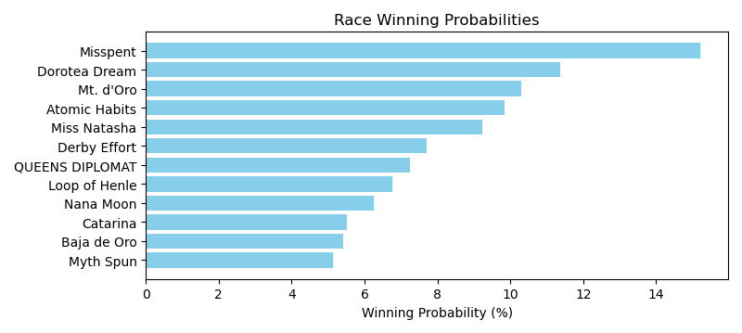

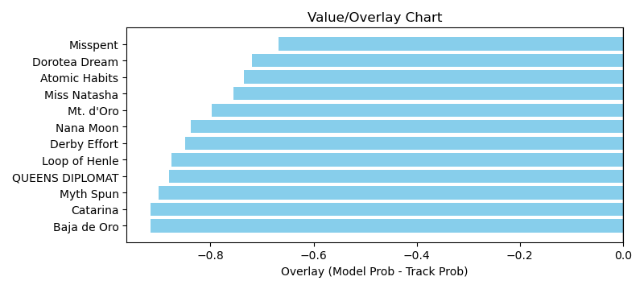

NOTE: GCSF - Global Combined Speed Figure

# Race: TAM | 2025-04-05 | Race #3 | Post: 13:45 | Track: TAMPA BAY DOWNS

Track: TAMPA BAY DOWNS

|  |  |  |  |  |  |
| --- | --- | --- | --- | --- | --- |
| Program # | Horse Name | Morn Odds | GCSF | Model Score | Win Prob (%) |
| 1 | Gambi | 30-1 | 107.9 | 0.55 | 7.52 |
| 2 | Ennereilly (IRE) | 8-1 | 109.1 | 0.61 | 9.29 |
| 3 | Lauriston (IRE) | 5-2 | 99.6 | 0.75 | 14.15 |
| 4 | A Fancy Solution | 20-1 | 95.7 | 0.54 | 7.27 |
| 5 | Terrie T | 3-1 | 100.0 | 0.71 | 12.68 |
| 6 | Include the Munny | 12-1 | 94.5 | 0.59 | 8.61 |
| 7 | No Dough No Go | 7-2 | 100.0 | 0.65 | 10.48 |
| 8 | Tough Dame | 30-1 | 110.6 | 0.43 | 4.54 |
| 9 | Unifieds Princess | 20-1 | 93.8 | 0.57 | 8.10 |
| 10 | Sunnyridge Jaime | 8-1 | 96.8 | 0.64 | 10.30 |
| 11 | Huggin and Lovin | 10-1 | 106.6 | 0.53 | 7.06 |

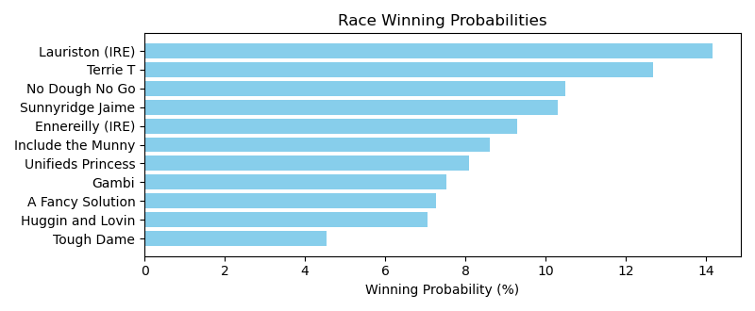

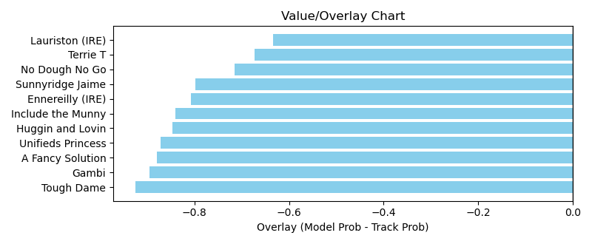

NOTE: GCSF - Global Combined Speed Figure

# Race: TAM | 2025-04-05 | Race #4 | Post: 14:17 | Track: TAMPA BAY DOWNS

Track: TAMPA BAY DOWNS

|  |  |  |  |  |  |
| --- | --- | --- | --- | --- | --- |
| Program # | Horse Name | Morn Odds | GCSF | Model Score | Win Prob (%) |
| 1 | Melody Win | 6-1 | 115.6 | 1.19 | 18.23 |
| 2 | Maptitude | 9-2 | 112.6 | 0.79 | 7.91 |
| 3 | Haberdashery | 12-1 | 90.2 | 0.70 | 6.19 |
| 4 | Papa Katz | 30-1 | 97.3 | 0.67 | 5.60 |
| 5 | Tiz a Beast | 20-1 | 88.1 | 0.66 | 5.49 |
| 6 | Chasentheone | 10-1 | 90.6 | 0.67 | 5.76 |
| 7 | Hap's Victory | 15-1 | 113.2 | 0.60 | 4.49 |
| 8 | Federal Exchange | 15-1 | 98.7 | 0.61 | 4.73 |
| 9 | Likebelivingnmagic | 7-2 | 88.4 | 0.85 | 9.33 |
| 10 | Defiant Malice | 15-1 | 93.3 | 0.63 | 5.07 |
| 11 | Uncaptured Star | 3-1 | 115.1 | 0.78 | 7.70 |
| 12 | Fenwick | 10-1 | 92.0 | 0.66 | 5.46 |
| 13 | Russian Hammer | 4-1 | 102.9 | 0.80 | 8.13 |
| 14 | Leopardi | 10-1 | 107.1 | 0.68 | 5.93 |

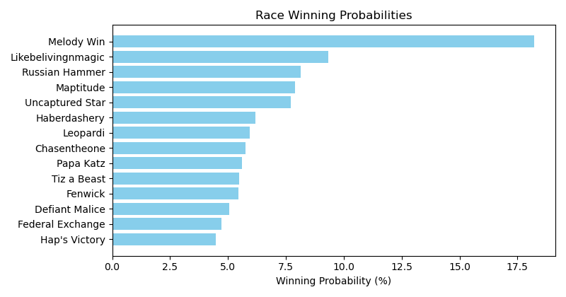

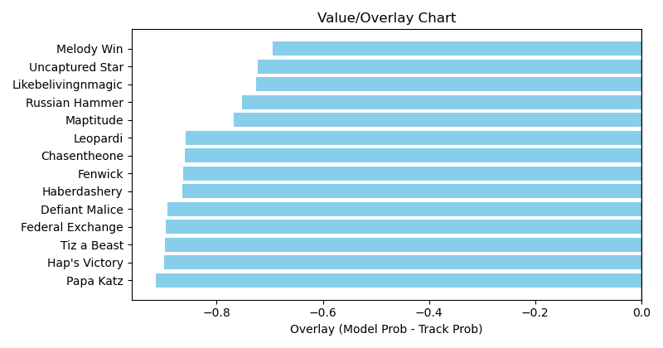

NOTE: GCSF - Global Combined Speed Figure

# Race: TAM | 2025-04-05 | Race #5 | Post: 14:49 | Track: TAMPA BAY DOWNS

Track: TAMPA BAY DOWNS

|  |  |  |  |  |  |
| --- | --- | --- | --- | --- | --- |
| Program # | Horse Name | Morn Odds | GCSF | Model Score | Win Prob (%) |
| 1 | Cocktail Kisses | 13-8 | 91.5 | 0.74 | 14.91 |
| 2 | Authenticate Now | 12-1 | 91.7 | 0.58 | 9.03 |
| 3 | Hit Song | 6-1 | 97.2 | 0.66 | 11.74 |
| 4 | SOMME RIVER | 8-1 | 100.0 | 0.63 | 10.75 |
| 5 | Money Trail | 12-1 | 93.4 | 0.58 | 9.07 |
| 6 | LA CANONICA | 20-1 | 100.0 | 0.55 | 8.08 |
| 7 | Going Streakin | 4-1 | 93.4 | 0.73 | 14.55 |
| 8 | Partly Sunny | 30-1 | 100.0 | 0.55 | 8.23 |
| 9 | Crafty Collector | 7-2 | 93.4 | 0.71 | 13.65 |

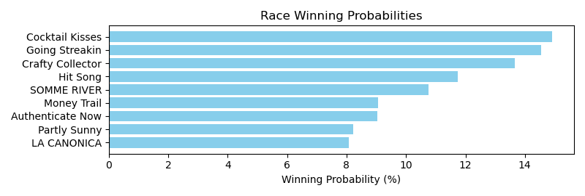

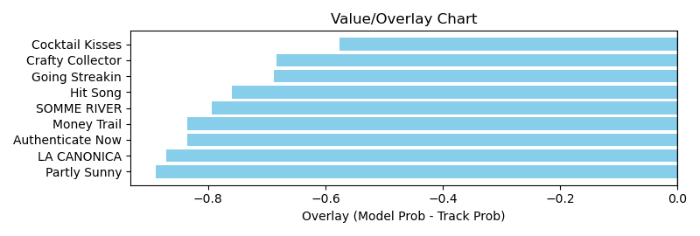

NOTE: GCSF - Global Combined Speed Figure

# Race: TAM | 2025-04-05 | Race #6 | Post: 15:23 | Track: TAMPA BAY DOWNS

Track: TAMPA BAY DOWNS

|  |  |  |  |  |  |
| --- | --- | --- | --- | --- | --- |
| Program # | Horse Name | Morn Odds | GCSF | Model Score | Win Prob (%) |
| 1 | Wheelingndealing | 10-1 | 85.4 | 0.79 | 11.36 |
| 2 | Pretty'n Awesome | 6-1 | 101.0 | 0.83 | 12.51 |
| 3 | Spanish Delight | 12-1 | 98.5 | 0.80 | 11.59 |
| 4 | Yellow Feathers | 5-1 | 92.2 | 0.81 | 11.95 |
| 5 | Easy Come Easy Go | 7-5 | 98.8 | 0.87 | 13.68 |
| 6 | Bunny Hop | 10-1 | 111.6 | 0.79 | 11.18 |
| 7 | Brookmesa | 3-1 | 101.8 | 1.22 | 27.72 |

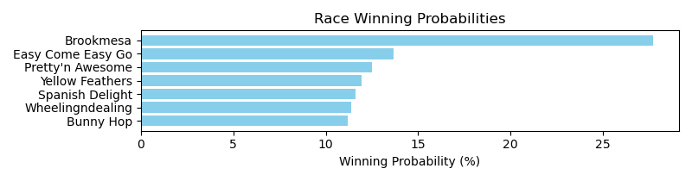

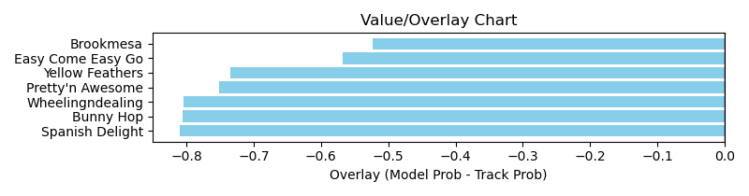

NOTE: GCSF - Global Combined Speed Figure

# Race: TAM | 2025-04-05 | Race #7 | Post: 15:58 | Track: TAMPA BAY DOWNS

Track: TAMPA BAY DOWNS

|  |  |  |  |  |  |
| --- | --- | --- | --- | --- | --- |
| Program # | Horse Name | Morn Odds | GCSF | Model Score | Win Prob (%) |
| 1 | Summer Bee | 12-1 | 99.8 | 0.93 | 12.95 |
| 2 | True Spun | 6-1 | 109.9 | 0.79 | 9.36 |
| 3 | Song Runner | 15-1 | 92.8 | 0.65 | 6.28 |
| 4 | Big Z Og | 3-1 | 94.2 | 0.93 | 13.10 |
| 5 | Rocket Dragon | 6-1 | 87.4 | 0.91 | 12.40 |
| 6 | Breezey Bella | 12-1 | 94.4 | 0.62 | 5.64 |
| 7 | Ee Yah | 8-1 | 115.2 | 0.77 | 8.96 |
| 8 | Jetaros | 9-5 | 107.9 | 0.96 | 13.82 |
| 9 | Far From Home | 30-1 | 93.0 | 0.57 | 4.72 |
| 10 | Tapintoyourbeer | 30-1 | 107.3 | 0.65 | 6.22 |
| 11 | Taprixie | 6-1 | 109.3 | 0.66 | 6.56 |

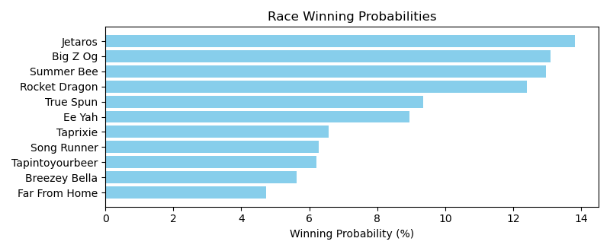

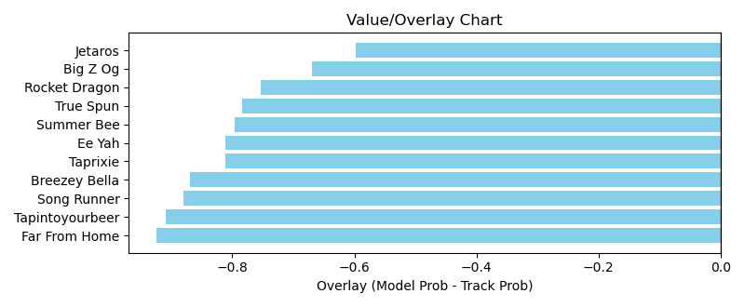

NOTE: GCSF - Global Combined Speed Figure

# Race: TAM | 2025-04-05 | Race #8 | Post: 16:28 | Track: TAMPA BAY DOWNS

Track: TAMPA BAY DOWNS

|  |  |  |  |  |  |
| --- | --- | --- | --- | --- | --- |
| Program # | Horse Name | Morn Odds | GCSF | Model Score | Win Prob (%) |
| 1 | Fivefive Six Champ | 12-1 | 89.8 | 0.79 | 8.74 |
| 2 | Prairie Hawk | 3-1 | 86.1 | 0.94 | 12.40 |
| 3 | Life Is Precious | 2-1 | 110.8 | 1.13 | 17.90 |
| 4 | Timeless Bounty | 6-1 | 98.4 | 0.92 | 11.81 |
| 5 | Hector | 9-2 | 93.4 | 1.37 | 26.64 |
| 6 | Catire Vizcaya | 12-1 | 115.7 | 0.83 | 9.62 |
| 7 | El Principito | 4-1 | 103.7 | 0.96 | 12.88 |

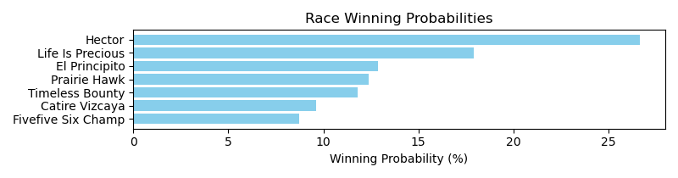

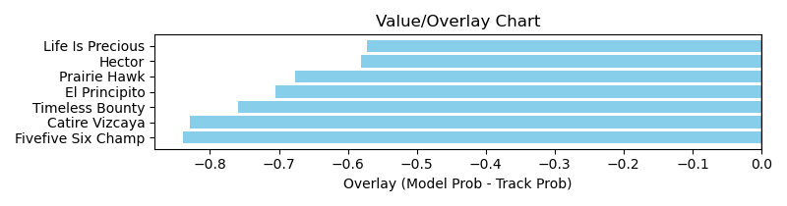

NOTE: GCSF - Global Combined Speed Figure

# Race: TAM | 2025-04-05 | Race #9 | Post: 16:59 | Track: TAMPA BAY DOWNS

Track: TAMPA BAY DOWNS

|  |  |  |  |  |  |
| --- | --- | --- | --- | --- | --- |
| Program # | Horse Name | Morn Odds | GCSF | Model Score | Win Prob (%) |
| 1 | Giftbox Surprise | 20-1 | 88.3 | 0.55 | 6.60 |
| 2 | Bells of Bram | 10-1 | 110.4 | 0.54 | 6.42 |
| 3 | JESS'S VISION | 12-1 | 100.0 | 0.61 | 8.35 |
| 4 | Diferencia | 6-5 | 93.4 | 0.76 | 13.04 |
| 5 | Power Party | 20-1 | 93.4 | 0.54 | 6.45 |
| 6 | Stormy Disco | 5-1 | 95.1 | 0.58 | 7.52 |
| 7 | dq-Mamas Lullabye | 30-1 | 115.1 | 0.57 | 7.22 |
| 8 | Art Nouveau | 10-1 | 93.4 | 0.78 | 13.61 |
| 9 | U Bet Jo's Praying | 30-1 | 110.2 | 0.50 | 5.55 |
| 10 | La Girvina | 4-1 | 107.7 | 0.78 | 13.59 |
| 11 | NEVER ENOUGH | 20-1 | 100.0 | 0.57 | 7.33 |
| 12 | Queenofallmydreams | 30-1 | 100.0 | 0.44 | 4.31 |

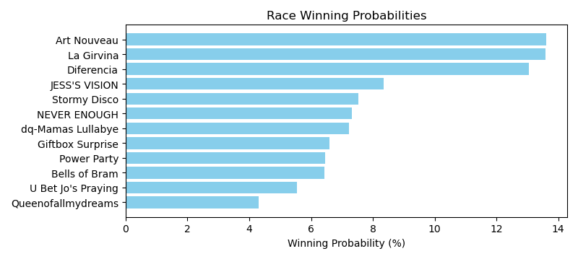

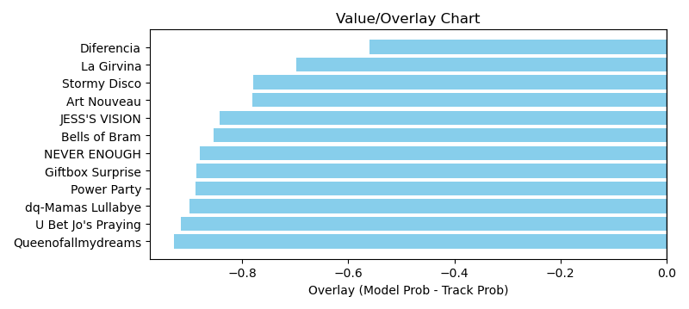

NOTE: GCSF - Global Combined Speed Figure